Forces & Motion Unit
- What is a reference point?

- How can you define displacement?

- On a position time graph what does the slope of the line tell you?

- Draw your own distance time graph using the chart below: DON’T FORGET TO LABEL!
Time | Distance
0 | 0
1 | 5
2 | 10
3 | 15
4 | 15
5 | 15
6 | 30
7 | 45
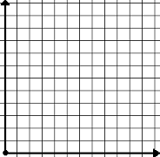
- What is the formula for speed?
- What is the difference between speed and velocity?

- How are force and mass related?

- What is Newton’s First Law of Motion?

- What is the definition of inertia?

- What is net force?

- What is gravity?

- What happens to gravity as the mass increase?

- What is friction?

- Give 2 ways you can increase or decrease friction.

- What is Newton’s Third Law of Motion?

- A student jogs around a park two times, starting and ending at the gate to the park. The jogging stack is square, with 40m on each side. Which of the following statements is true about the student’s distance and displacement?
  - The distance is 320 m and displacement is 160m.
  - The distance is 160 m and displacement is 40 m.
  - The distance is 320 m and displacement is 320 m.
  - The distance is 320 m and displacement is 0m.
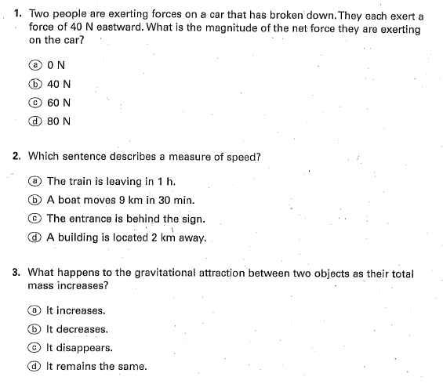
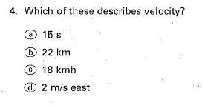
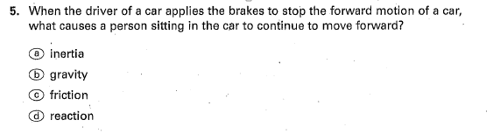
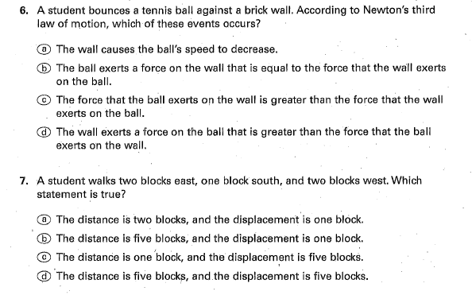
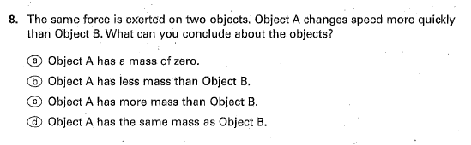
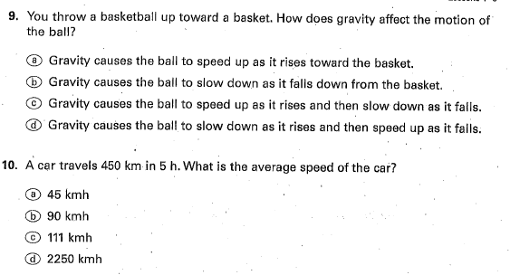
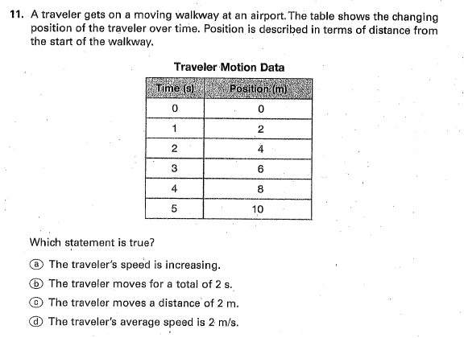
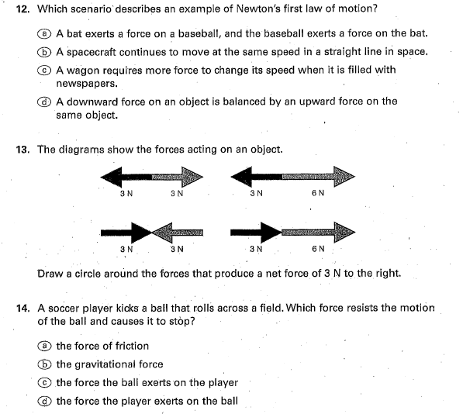
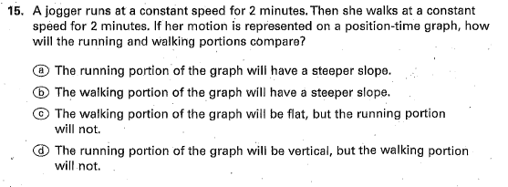

Waves Unit
- What do waves carry?

- Do all waves need a medium?
- Define the following terms:
  - Amplitude

  - Wavelength
- Define the following wave behaviors:
  - Refraction

  - Reflection

  - Transmission
    - Transparent
    - Translucent
    - Opaque

  - Absorption
- Compare constructive and destructive interference.

- How does light travel through the eye? __________ lens ___________ optic nerve
- What happens to color for us to see black?

- What happens to color for us to see white?

- What is happening when we see an object as red?

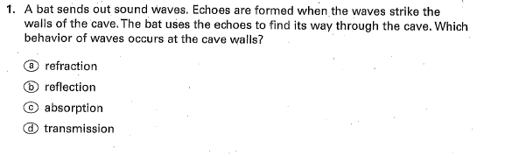
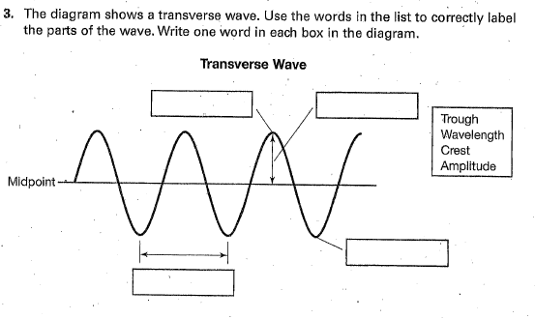
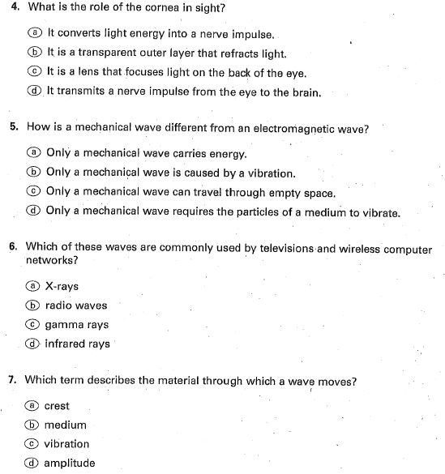
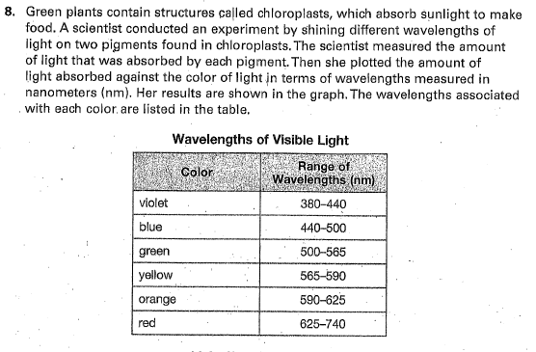
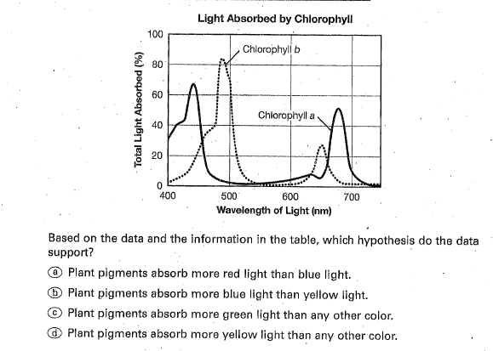
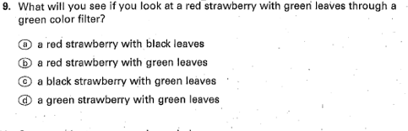
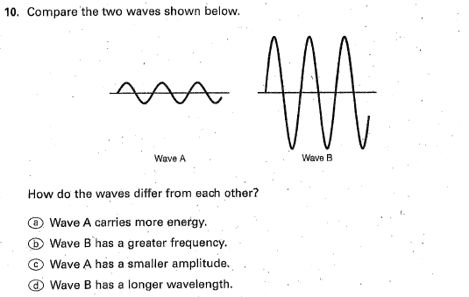
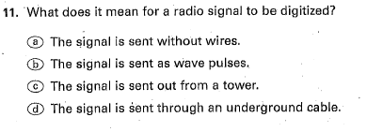
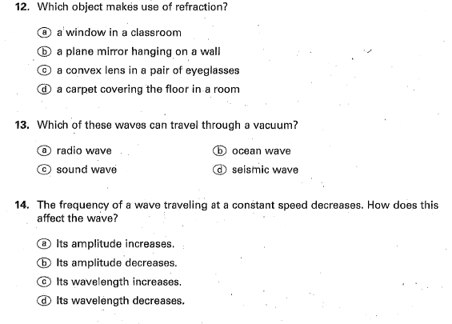
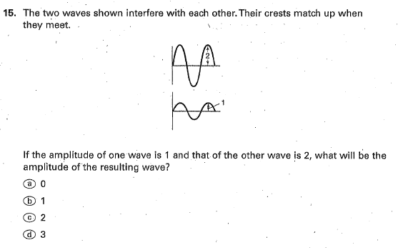
Astronomy Unit

- What galaxy do we live in?
- What is a light year?

- What is the difference between a revolution and rotation?

- What is the difference between a meteor, meteorite and meteoroid?

- What is the difference between a comet and asteroid?

- What is the corona and when can it be seen?
- Why don’t most solar winds reach Earth?

- What is based on 24 hours of Earth rotating?
- What is based on 365 ¼ days of Earth revolving?
- In your own words, tell me the difference between rotate and revolve.

- Why do we see different phases of the moon?

- What are tides and what are they caused by?

- Explain the difference between high and low tide.

- Explain the difference between neap tides and spring tides.

- What causes the different seasons?

- What is a solstice and when does it happen?

- What is an equinox and when does it happen?

- What is the force that pulls all objects in the universe?

- Explain each type of galaxy below:
  - Spiral
  - Elliptical
  - Irregular
- What are galaxies composed of?

- Define the following words:
  - Photosphere
  - Prominence
  - Solar flares

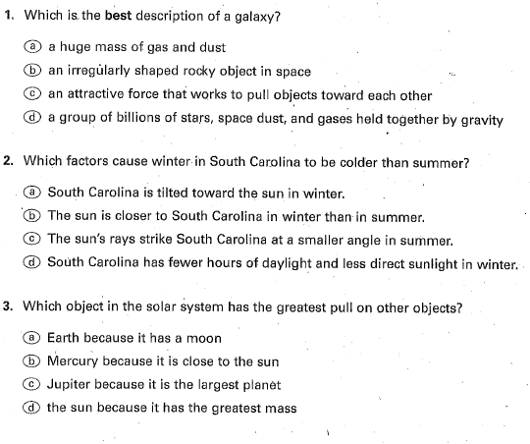
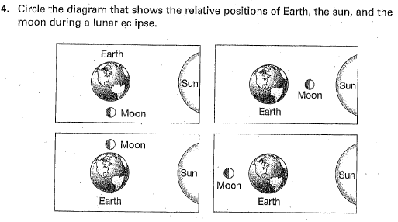
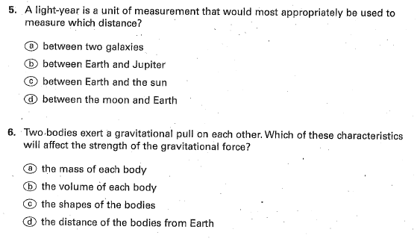
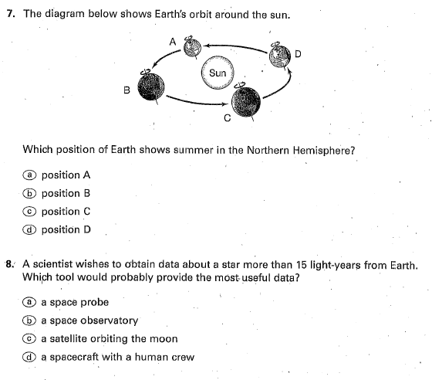
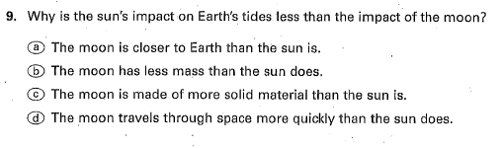
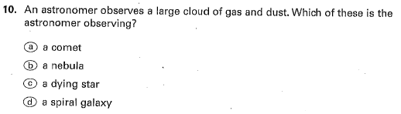
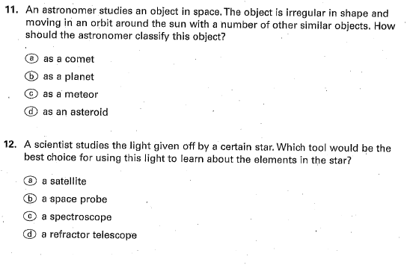
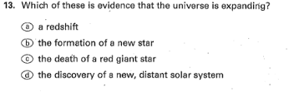
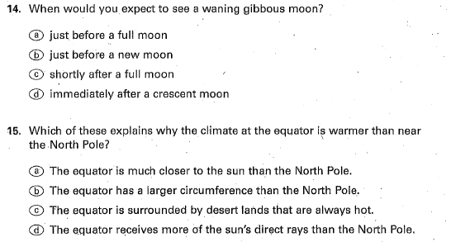
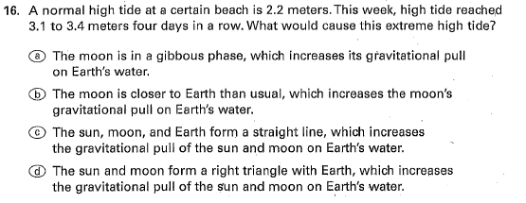
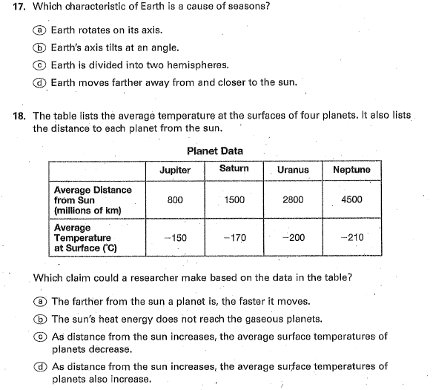
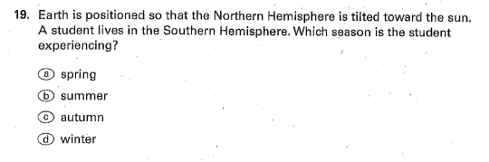
Earth’s Structure & Processes Unit
- Describe the layers of the Earth in the chart below:
Layer | Density | Relative Position | Composition
Crust

 |  | Middle Layer, thickest layer, top portion called asthenosphere
 | Heaviest material, most dense layer
- Which layer of Earth do lithospheric plates float on?

- What 3 things does the motion of the plates change of Earth’s continents and oceans?

- Complete the chart about the 3 types of boundaries below:
Boundary | Movement | Crust | Formation
Convergent |  | Some crust is destroyed
 | Two plates slide past each other |  | Earthquakes
Divergent |  |  | Mid-ocean ridges
- What is the large landmass called from the time when all the continents were joined together?
- In the chart below explain mountain-building forces:
Tension

Forces that cause rocks on either side of faults to push in opposite directions

Compression

- What is a seismogram?

- Why do scientists study and record seismic data? What does this evidence prove?

- What is the Pacific Ring of Fire?

- What causes the movement of lithospheric plates?

- What are some problems associated with earthquakes? How can we prepare for them?

- What are some problems associated with volcanoes? How can we prepare for them?

- Explain the difference between lava and magma.

- How do igneous rocks form? What are some examples?

- What are the two types of igneous rocks?

- How does metamorphic rock form? What are some examples?

- What are two key words in the formation of metamorphic rock?

- How does sedimentary rock form? What are some examples?

- Define Weathering, Erosion, and Deposition. Give some examples.

- What is the difference between chemical and physical weathering?

- Hardness, luster, color, texture, and density are all physical properties of _____________.
- What is an ore?

- What are fossil fuels?

- What do fossil fuels give off when they are burned?
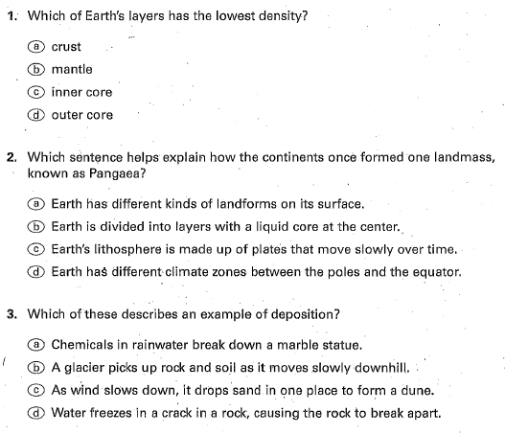
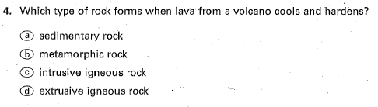
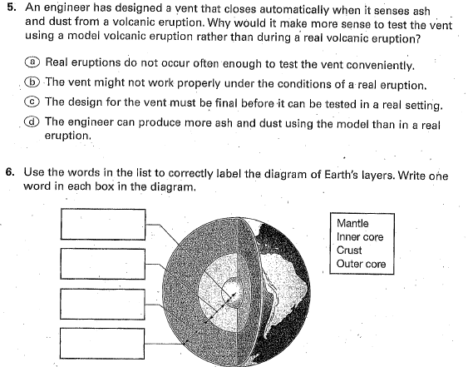
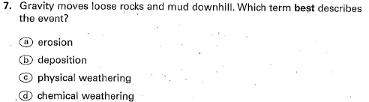
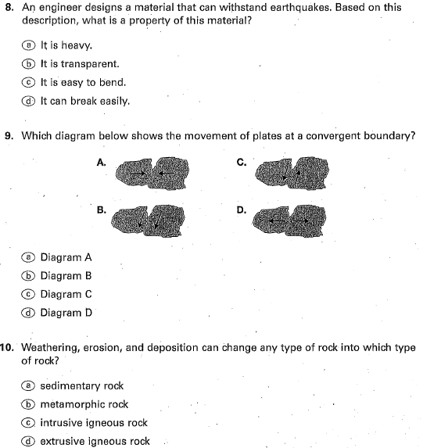
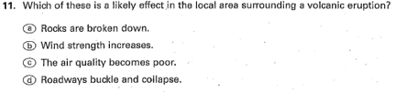
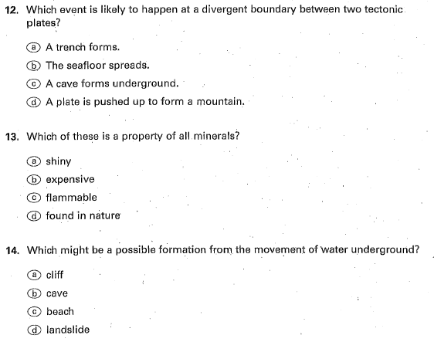
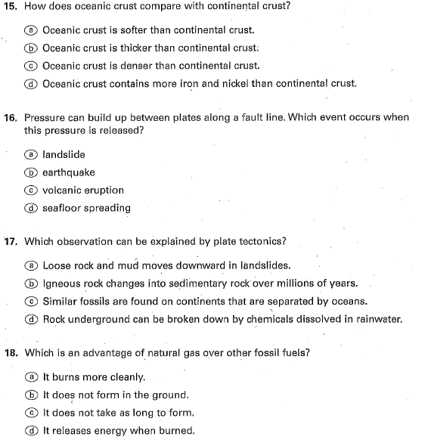
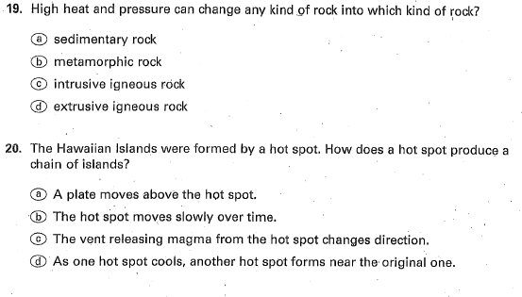
Earth’s Geologic History Unit
- List the units of time for the geologic time scale from biggest to smallest:

- What are eras divided into?
- What are periods divided into?
- What are eons divided into?
- What are the three major eras in Earth’s history?

- Which Eon do we live in?
- Which era and period do we live in?
- Answer each of the following with either Paleozoic, Mesozoic, or Cenozoic
  - Included simple mosses, ferns, cone-bearing plants
  - Small mammals and birds appeared
  - A mass extinction caused marine invertebrates to disappear
  - Flowering plants became common
  - The diversity of life forms increased
  - Reptiles were the dominant animals
  - Human are part of this era
  - Began with early invertebrates such as trilobites and brachiopods
- Complete the chart on fossils below:
Mold Fossil
Forms when a mold is filled with sand or mud that hardens into the shape of the organism
Petrified (permineralized) fossil
Preserved fossil
Forms when organisms or parts, like leaves, stems, flowers, fish, are pressed between layers of soft mud or clay that hardens squeezing almost all the decaying organism away leaving the carbon imprint on the rock
Trace fossil
- What is the fossil record and why do we need it?

- What is the law called that states that each rock layer is older than the one above it?

- What is the difference between relative dating and absolute dating?

- Fill in the blanks:
To be an index fossil:
  - An organism must have lived only during a ________ part of Earth’s history
  - _________ fossils of the organism must be found in rock layers
  - The fossil must be found over a _______ _______ of Earth
  - The organism must be ____________
- What organism is a key example of an index fossil that has a hard shell, three sectioned body, lived in shallow seas and became extinct about 245 million years ago?
- Define the following terms:
  - Variation
  - Adaptation
  - Natural selection
- Circle which is non-life threatening (Variation or adaptation)
- What are two types of adaptations?
- Classify the following as behavioral or structural:
A hawk’s sharp beak
Wolves traveling in packs
A monarch butterfly migrating
A giraffe’s long neck
An elephant’s long trunk
- What are two types of factors that can lead to extinction?

- Classify the factor as either man-made or natural:
Volcanic eruptions
Pollution
Oil spill
Asteroid strike
Changes in oxygen levels in sea water
De-forestation
Over-harvesting
Global cooling during ice ages
