4 TYPES OF CONTEXT CLUES

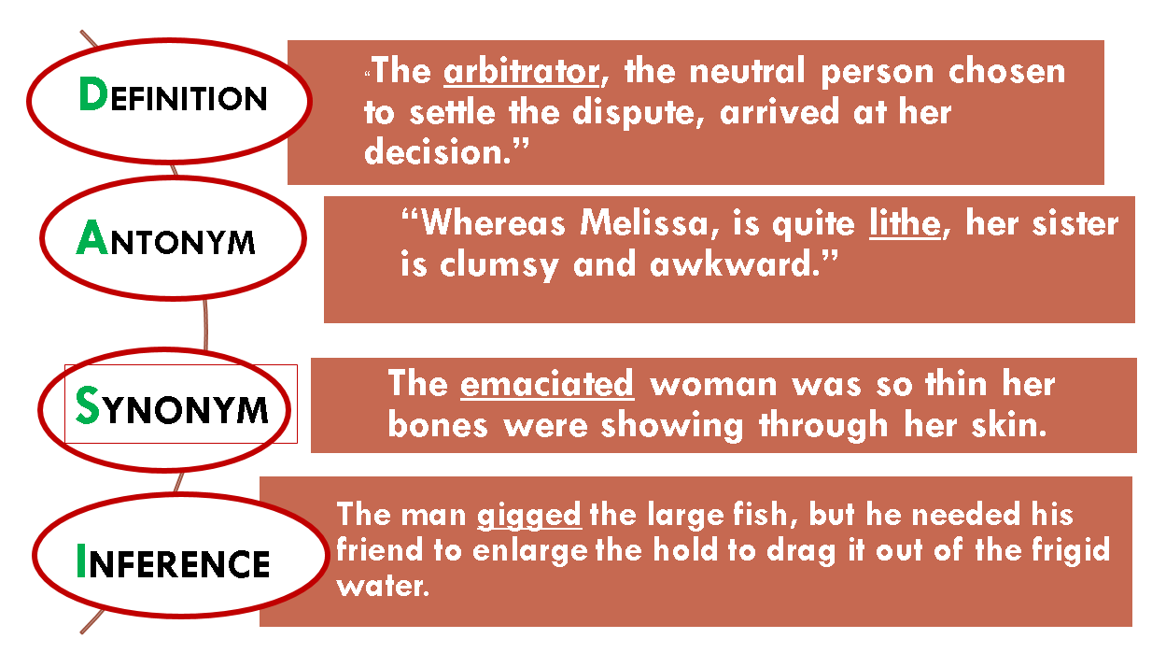

4 TYPES OF CONTEXT CLUES

