

**____________________________**

**Easily reached or entered**

**_________________________**

**Great respect mixed with wonder and amazement**



**_______________________**

**To mention in support of a point; refer to**



**________________________**

**Able to get along well together; combining well**

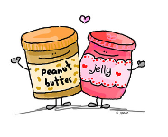

**_______________________**

**Free from some unpleasant duty or situation**



**________________________**

**To win or win out; triumph; defeat (someone)**



**_________________________**

**To provide the force that moves something; to move something forward**



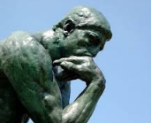

**______________________**

**Reasonable; logical**

**Ver**

**____________________**

**A sharp, clever, or angry reply**

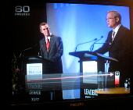

**_____________________**

**To get (something) back**

