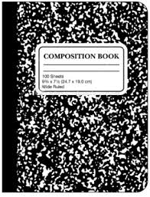
Student Notebook (SN)
Guidelines

Number 1 Rule: You must bring your SN every day!!!
…no excuses!
- Your SN is as important as your book, paper, and pencils.
- Your SN will be used both for NOTES and as your JOURNAL.
Guidelines
- BRING DAILY.
- No going back to locker…sorry!
- So important it’s a QUIZ grade.
- Keep up-to-date.
- Keep up with your things.
- Put them in the right sections.
- Be prepared for random checks.
- Follow format.
- Use front & back of paper.
- Use proper heading.
- Notes: may use pencil or pen.
- Journal: must always write with pen.

Grading of SN’s
- Several times each quarter, you will be given a Checklist for the NOTES section of your SN. You will be graded on the completion of all notes on the Checklist, with points deducted for each lesson note in SN.
- JOURNAL (Writing) sections of SN’s will be graded randomly per writing assignment.
- You will be asked to leave your SN with Mrs. Lackey from time to time…for grading purposes.

