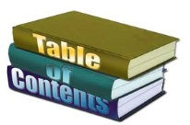
8th ELA Student Notebook (SN) Table of Contents
~Mrs. Lackey’s running list~
Your Personal Guide to ELA this year! Keep up to EXCEL!

Page Number | Lesson
1 | Signature Page
2-10 | Table of Contents

