Ms. Greene
Mrs. Michael
Business Computer Applications – Study Guide
Name:________________ Block:___________________
WORD UNIT A

- Which task does Word NOT give you the ability to accomplish? (Word p.2)

a. | Perform calculations in a spreadsheet.
b. | Format text and paragraphs with fonts and colors.
c. | Copy and move text between documents.
d. | Add graphics and charts to a document.

- The ____ indicates where text appears as you type. (Word p.4)

a. | selection pointer | c. | I-beam pointer
b. | ScreenTip | d. | insertion point

- Word tabs, such as the FILE and HOME tabs, are organized in groups on the ____. (Word p. 4)

a. | Ribbon | c. | title bar
b. | status bar | d. | Quick Access toolbar

- Which Word feature causes red and green wavy lines to appear under words as you type? (Word p. 6)

a. | ScreenTips | c. | spelling and grammar checking
b. | AutoComplete | d. | AutoCorrect

- Which key is used to remove the character before the insertion point? (Word p.6)

a. | [Tab] | c. | [Delete]
b. | [Backspace] | d. | [Enter]

- Which feature in Word automatically corrects typos, minor spelling errors, and capitalization as you type? (Word p. 6)

a. | AutoComplete | c. | AutoCorrect
b. | Spelling and Grammar | d. | AutoType

- When you save a document, what is the name you give it called? (Word p.8)

a. | file extension | c. | filename
b. | document name | d. | document title

- Which button do you click to show formatting marks in a document? (Word p.10)

a. | Formatting button | c. | Show Marks button
b. | Show Formatting button | d. | Show/Hide ¶ button

WORD UNIT B
- Which command is used to insert text that is stored on the Clipboard into a document? (Word p. 26)

a. | Copy | c. | Paste
b. | Drop | d. | Insert

- Where is the Show/Hide ¶ button? (Word p. 26)

a. | in the Paragraph group on the HOME tab
b. | in the Symbols group on the DESIGN tab
c. | in the Symbols group on the INSERT tab
d. | in the Paragraph group on the LAYOUT tab

- What is the keyboard shortcut for saving a document? (Word p. 27)

a. | [Ctrl][A] | c. | [Ctrl][S]
b. | [Ctrl][X] | d. | [Ctrl][C]

- What is the keyboard shortcut for pasting text? (Word p.27)

a. | [Ctrl][C] | c. | [Ctrl][X]
b. | [Ctrl][P] | d. | [Ctrl][V]

- Which feature would you use to correct words that you frequently misspell as you type? (Word p.35)

a. | Spelling and Grammar | c. | Find and Replace
b. | AutoCorrect | d. | AutoComplete

WORD UNIT C
- By default, how is text aligned? (Word p.56)

a. | justified | c. | centered
b. | left-aligned | d. | right-aligned

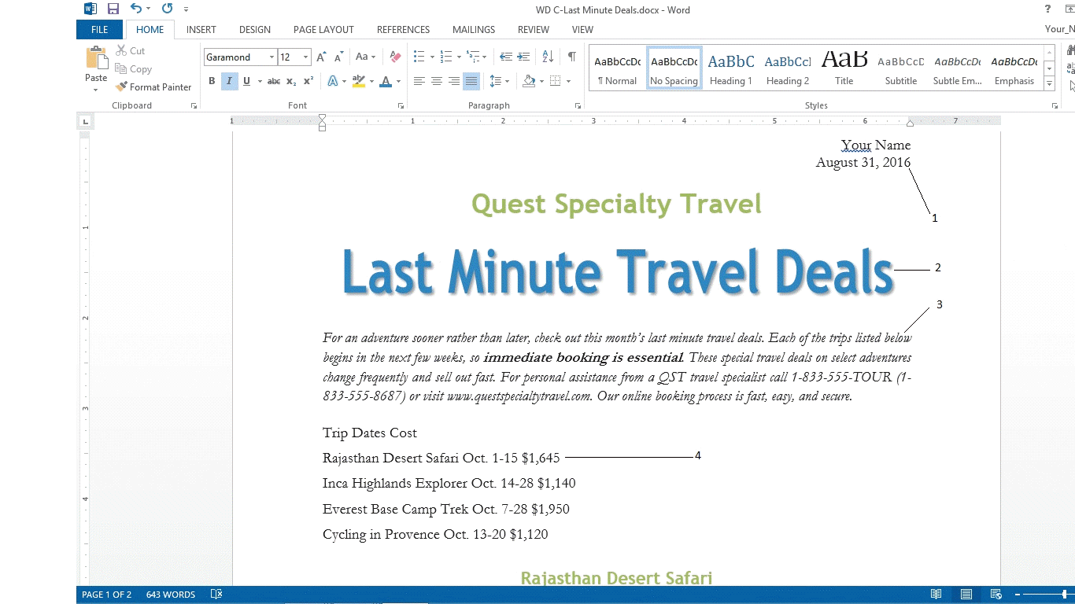

- In the accompanying figure above, the text labeled 1 is ____.(Word p.57)

a. | left-aligned | c. | center-aligned
b. | right-aligned | d. | justified

- In the accompanying figure above, the text labeled 2 is ____. (Word p.57)

a. | left-aligned | c. | center-aligned
b. | right-aligned | d. | justified

- In the accompanying figure above, the text labeled 4 is ____. (Word p.57)

a. | left-aligned | c. | center-aligned
b. | right-aligned | d. | justified

POWERPOINT UNIT A

- Which of the following items can you import into a presentation? (PowerPoint p.2)

a. | photographs | c. | text
b. | numerical data | d. | All of the above.

- With PowerPoint, you can import text, photographs, numerical data, and facts from files created in such programs as ____. (PowerPoint 15)

a. | Microsoft Word | c. | Microsoft Access
b. | Microsoft Excel | d. | All of the above.

ANS: D
- ____ view displays your presentation on the whole computer screen. (PowerPoint p.15)

a. | Slide Sorter | c. | Outline
b. | Slide Show | d. | Notes Page

POWERPOINT UNIT B 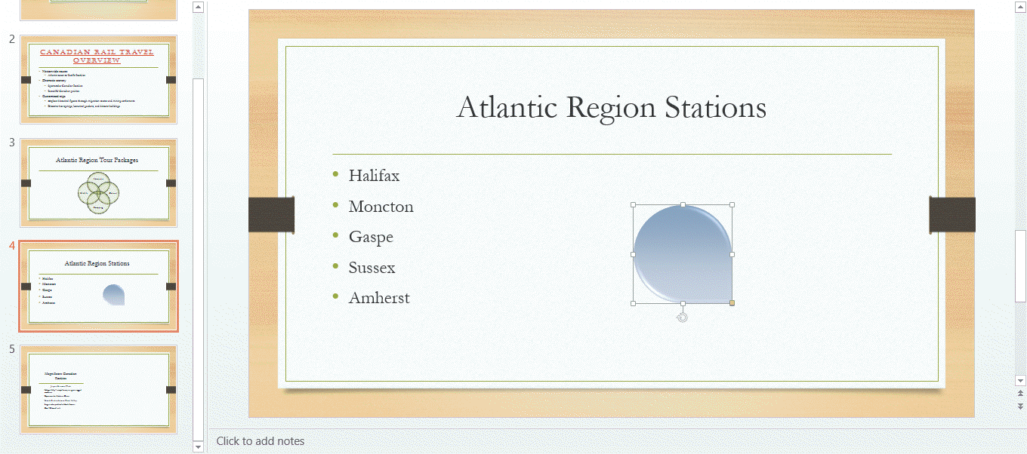

- In the accompanying figure above, the small vertical line that is sticking down from the rectangular graphic is the ____.

a. | adjustment handle | c. | Convert to SmartArt Graphic button
b. | rotate handle | d. | resize handle

- In the accompanying figure above, the yellow circle in the lower-right corner of the rectangular graphic is a(n) ____. (PowerPoint p. 33)

a. | sizing handle | c. | adjustment handle
b. | resizing handle | d. | rotate handle

POWERPOINT UNIT C
- The default 2D chart in the Insert Chart dialog box is the ____ chart. (PowerPoint 56)

a. | Line | c. | Clustered Column
b. | Bar | d. | Pie

- Which key is pressed to go to the last slide in a slide show? (PowerPoint 79)

a. | [End] | c. | [Esc]
b. | [E] | d. | [Enter]

- Entrance and Exit are ____. (PowerPoint 82)

a. | transition settings |  | c. | animation effects
b. | animation categories |  | d. | transitions

- When PowerPoint finds a misspelled word or a word that is not in its dictionary, the ____ pane opens. (PowerPoint p.84)

a. | Glossary | c. | Dictionary
b. | Spelling | d. | Grammar

EXCEL UNIT A
- An electronic ____ is an application you use to perform numeric calculations and to analyze and present numeric data. (Excel p.2)

a. | database | c. | dataform
b. | spreadsheet | d. | project

- In Excel, the electronic spreadsheet you work in is called a ____. (PowerPoint 2)

a. | tablet | c. | numericsheet
b. | databook | d. | worksheet

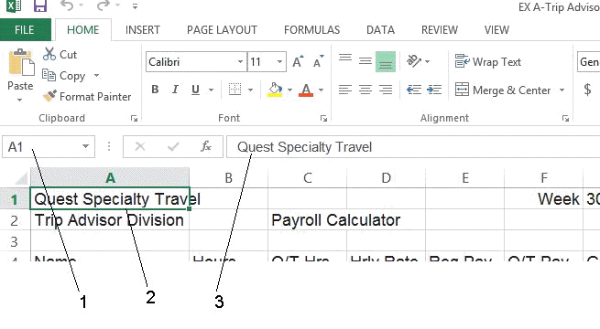
- As shown in the accompanying figure above, item ____ points to the Name box. (Excel p.5)

a. | 1 | c. | 3
b. | 2 | d. | 4

- As shown in the accompanying figure, item ____ points to the formula bar. (Excel p.5)

a. | 1 | c. | 3
b. | 2 | d. | 4

- As shown in the accompanying figure, item ____ points to the cell pointer, which outlines the active cell. (Excel p.5)

a. | 1 | c. | 3
b. | 2 | d. | 4

- All Excel formulas begin with the ____. (Excel p.6)

a. | plus sign (+) | c. | equal sign (=)
b. | asterisk (*) | d. | slash (/)

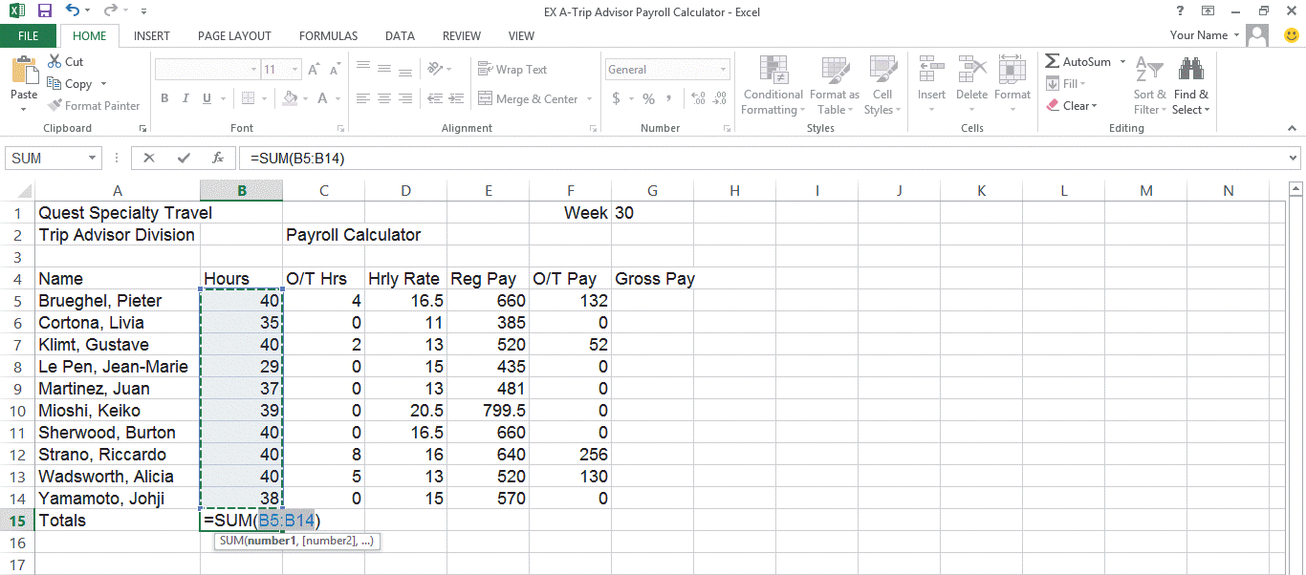

- In the accompanying figure, the entry in cell B15 is a ____. (Excel p.8)

a. | label | c. | calculation
b. | formula | d. | value

- In the accompanying figure, the entry in cell B5 is a ____. (Excel p.8)

a. | label | c. | graphic
b. | formula | d. | value

ANSWER KEY

- A
- D
- A
- C
- B
- C
- C
- D
- C
- A
- C
- D
- B
- B
- B
- C
- A
- D
- D
- B
- B
- C
- C
- A
- B
- B
- B
- D
- A
- C
- B
- C
- B
- D

