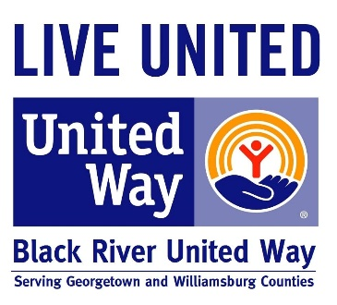
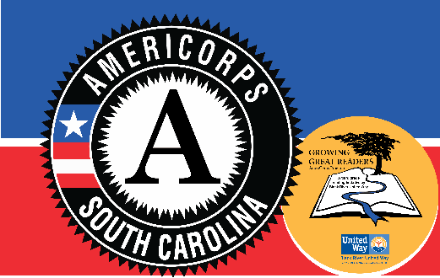
The Black River United Way Growing Great Readers program is recruiting AmeriCorps members to help K-2 students improve reading skills. Positions are available at Andrews, Sampit, Pleasant Hill, McDonald, and Browns Ferry Elementary schools in Georgetown County. In exchange for your service, AmeriCorps Members receive a living allowance, education award and professional development training.
If you are interested in learning more about the AmeriCorps member positions, please call 843-546-6317. You can apply to our program my.americorps.gov. We are looking for individuals who can serve from August 1, 2017 to June 8, 2018.

Qualifications:
- High school diploma, GED or obtain it prior to the end of the service year required
- High School Seniors are encouraged to apply to 300 hr. position
- Age 17 by July 31, 2017
- U.S. citizen, U.S. national, or lawful permanent resident
- Proficient in reading, writing and speaking English.
- Basic understanding of English Language
- Ability to interact with and relate to youth
- Interest in youth academic success
- Commitment to Service and Getting Things Done
- College degree is a plus

Other benefits:
- Professional and Personal Development
- Experience in elementary school environment or with an educational nonprofit
- Opportunity to be a part of a national service movement

