**Art Poster Winners**

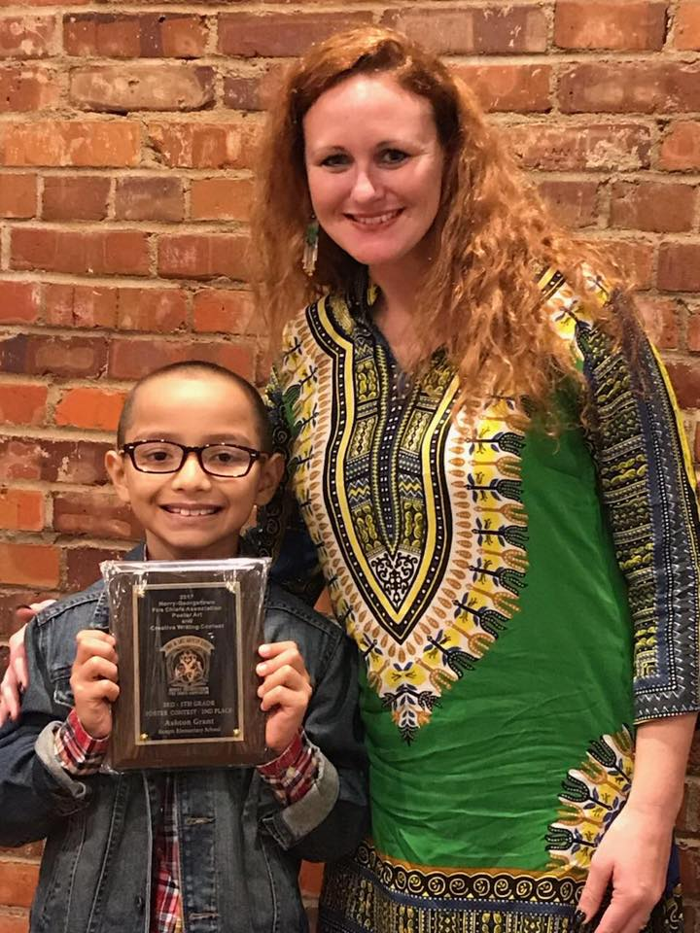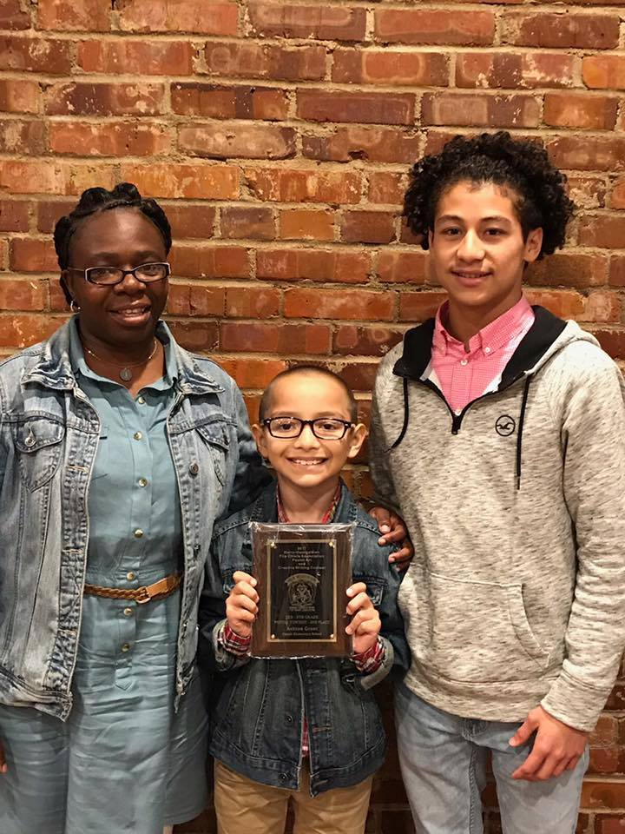

**Congratulations to Georgetown and Horry County’s Fire Chiefs Annual Poster Contestant Winner!**

**2nd Place Winner is Ashton Grant for grades 3-5**

**Principal’s Corner**

Dear Parents

In the spirit of this holiday season, I want to tell you how much we enjoy working with your children. We also want to thank you for the support that you give to your child and our school. Many of you participated in our Student Led Conferences and had the opportunity to share with your child in their learning experiences. Teachers have reported that many of our classes had 100 % participation. Keep up the good work!

As we move into the holiday season and vacation, please remember to spend those precious moments with your child reading to or with them each day. Also encourage your child to continue practicing their basic addition, subtraction, multiplication and division facts over the holiday. Also, please do not forget about the importance of including educational toys and books in your holiday purchases.

Parents, please keep in mind that we have an open door policy. If you have any questions or comments, please stop by my office. I can also be reached at 843-527-4411 or [sgoff-mack@gcsd.k12.sc.us](mailto:sgoff-mack@gcsd.k12.sc.us). Finally, the Sampit Family wishes you and your loved ones a wonderful holiday season filled with lots of love, cheer and good health!

Happy Holidays

Sabrina Goff-Mack

Lost and Found Items

Parents, please encourage your child to look in the lost and found bin in the front office for lost clothing.

**Sampit Elementary Career Day**

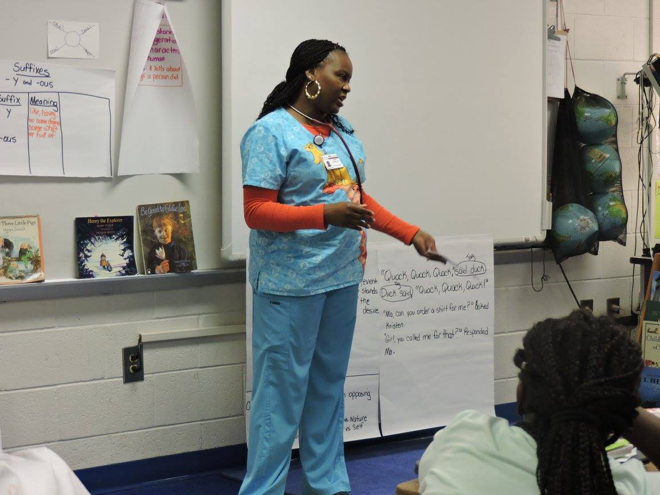 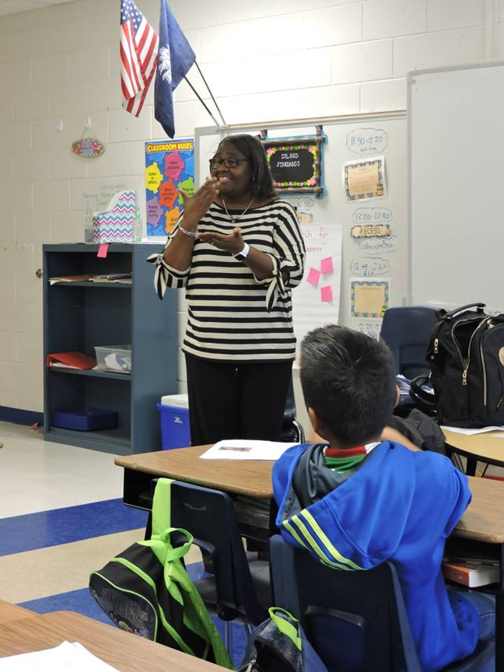 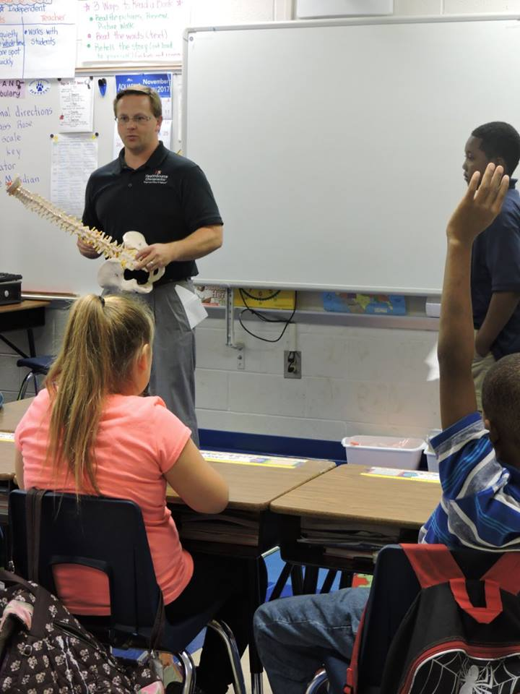 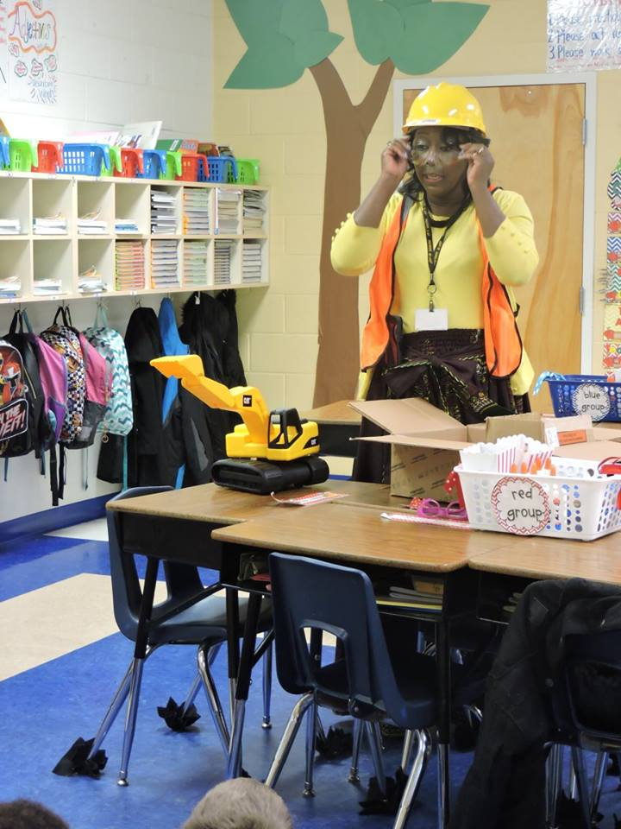

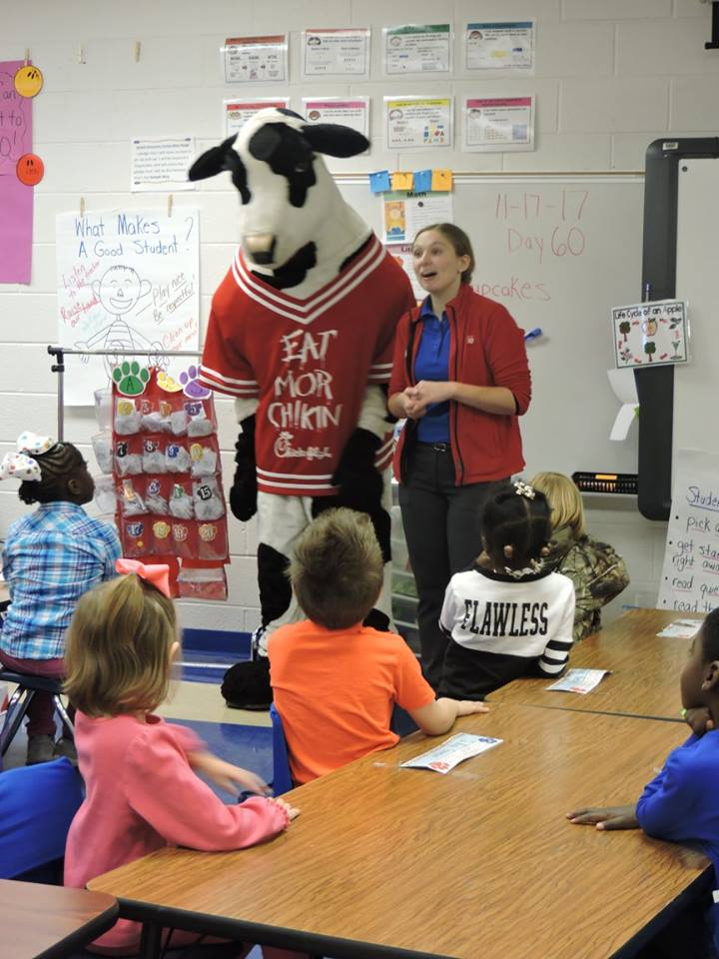 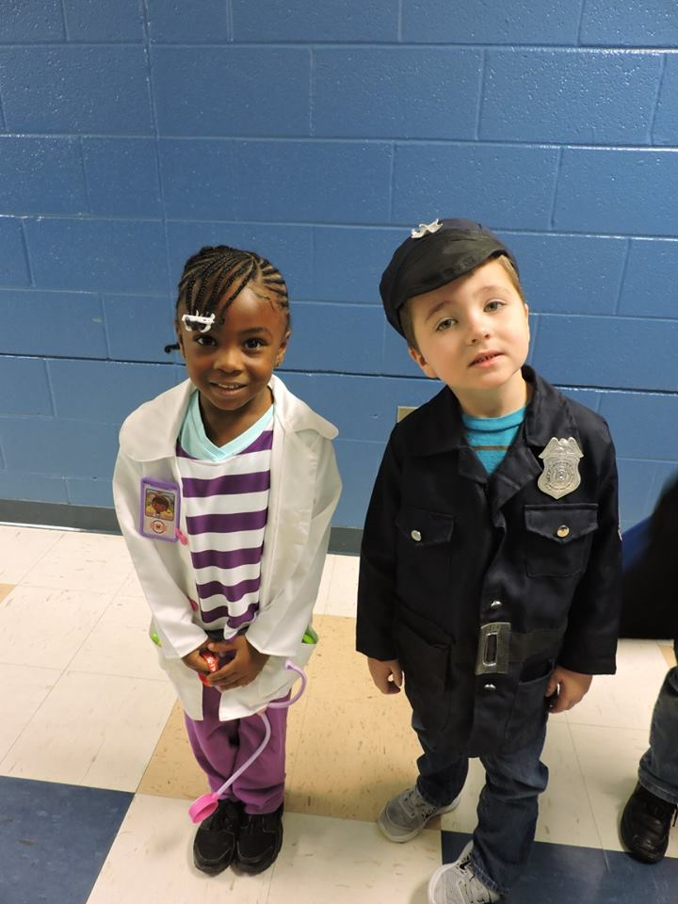 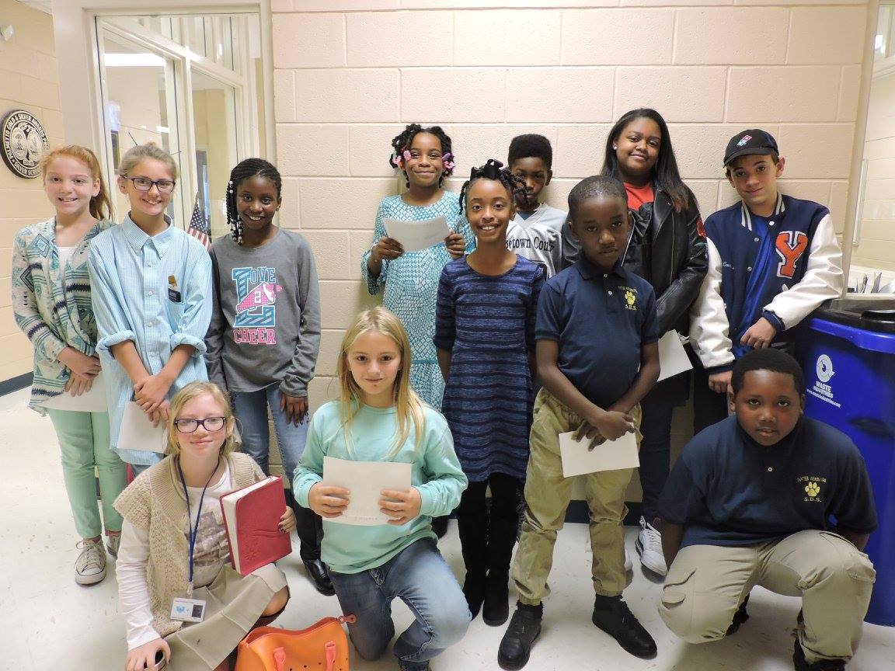 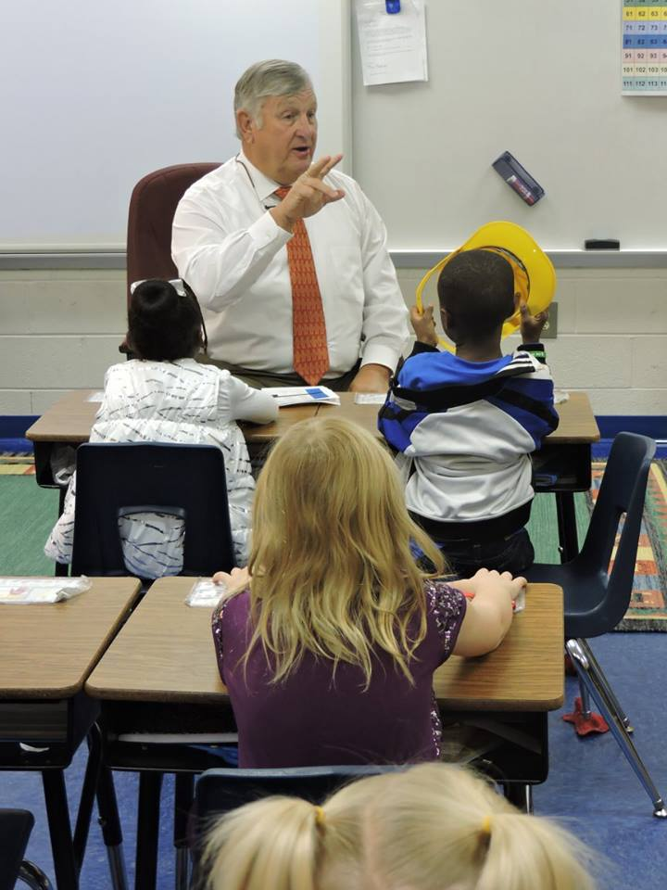

**Sampit held Career Day on Friday, November 17, 2017. We would like to thank everyone that came and shared information about on their career and profession.**

Sampit Elementary is a Title 1 School

The mission of Sampit Elementary School is to provide appropriate learning experiences and to develop positive attributes in our children, enabling them to become productive and responsible citizens in a partnership with the home, school and community

C:\Users\Admin\Downloads\DSC012952.jpgC:\Users\Admin\Downloads\DSC012952.jpg

**Sampit Elementary Panther Connection**

December 2017 Sabrina Goff-Mack, Principal

Volume 3 Issue 4 Maggie Hapeshis, Curriculum Specialist

Like us on Facebook



## Upcoming Events

**December**

**December 4- Y Splash (2nd Grade Only)**

**December 5- School Board Meeting @ 5:30 pm**

**December 6- SIC @ 3:00 pm**

**December 7-December Birthday Lunch Celebration**

**December 8- PBIS Winter Celebration (K-2)**

**GKCU Banking**

**December 11- PBIS Winter Celebration (3-5)**

**December 13- Student of the Month Celebration**

**December 14- Spirit Day- Class Parties**

**Winter Celebration-Pajama Day**

**December 18- Jan. 3- Christmas Break/ No School**

**December 19- School Board Work Session @ 5:30**

**December 25- Christmas Day- *Merry Christmas***

**January**

**January 1- New Year’s Day- Happy New Year**

**January 3- School Resume**

**Afterschool**

**There will be no afterschool during the week of December 11-15, 2017. We will resume our regular schedule on Wednesday, January 3, 2018. Thanking you in advance for your support.**



**Student of the Month**

**November - Responsibility**

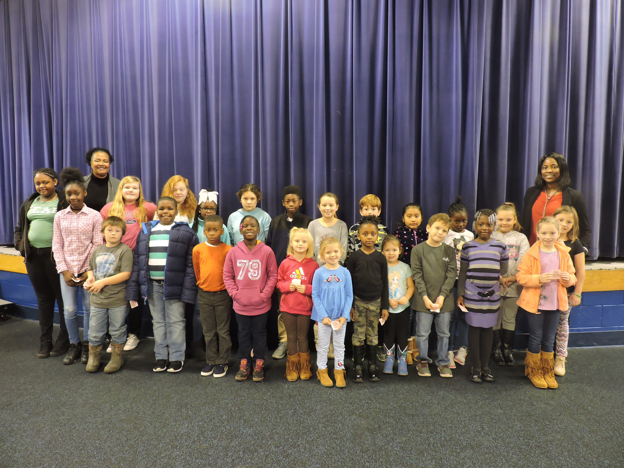

**Ms. Pendergrass – Rivers Wilson**

**Mrs. Tisdale – Mikayla Matthews**

**Ms. McCray – Emree Cooper**

**Mrs. Pagett – JoVoni Richardson**

**Mrs. Poston – Anastyn Street**

**Mrs. Gamble – Ava Hapeshis**

**Mrs. Newton – Imani Dozier**

**Mrs. Wilson – Elisa Dunmore**

**Ms. Brandon – Stephen Driggers**

**Mrs. Goude – Alivia Jones**

**Ms. Terhune – Kambrie Narron**

**Mrs. Cannon – Emma Kennedy**

**Ms. Hicks – Cynthis Chaj-Acosta**

**Mrs. Kennedy – Sullivan Belcher**

**Mrs. Gaskins – Sarah Cannon**

**Mrs. Hawkins – LaMarcus Duncan**

**Mrs. Prince – TaMya Johnson**

**Mrs. Kennington – Savannah Graham**

**Ms. Nicol – Madison Banks**

**Mr. Wilson – Sky Campbell**

**Mrs. Tumang – Jalyn Drinkwine**

**Mrs. Myers – Elijah Cooper**

**Mrs. Crabtree – Markell Smith**

**Mrs. Fox – Holden Inman**

**Mrs. Narron – Gabrielle Geathers**

**Mr. Galatio – Holden Inman**

**Congratulations!!!!**

**Sampit Elementary School**

**1st Nine Weeks Honor Roll**

**2017-2018**

**Principal’s Honor Roll**

**2nd Grade**

Ka’Mira Anderson, Haiden Austin, Jonah Cannon, Jaward Cooper, Elijah Davis, Stephen Driggers, Nicholas Duncan, Brailyn Gary, Jamarion Grant, Jordan Grant, Davin Hammond, Mikalyn Holmes, Caylen Hurell, Amaya Lance, Kambrie Narron, Camille Nesmith, Elayshia Pringle, Alivia White

**3rd Grade**

Taylor Cox, Ashton Grant, Janelle Grant, Miley Harrelson, Kraven Marlow, Qwhadee Robinson, Jerome Simpson, Yareliz Vereen, Keeley Ward

**4th Grade**

Sarah Cannon, Marcus Doiley, Jaden Gaskins, TaMya Johnson, Aaron Keller, A’Marianna King, Aundrea Simpson, Gavin Smith, Jaydin Stevens

**5th Grade**

Celeste Barnes, Sky Campbell, Savannah Graham, Addy Hapeshis, Thelien Nass, Michaela Prince, Iris Reyes- Mezquite

**Honor Roll**

**2nd Grade**

Jesiah Coakley, Paige Cox, Laiden Floyd, Kevondra Gibson, Nayomi Giles, Ja’Chi Grant, Elise Greene, Emily Hammond, Alivia Jones, Jaiden Maybank, Prince Pelcastre, Sarah Shipman, Ethan Smith, Markell Smith, Janaya Smith-Bryant, CaZion Walker

**3rd Grade**

Skylar Ackerman, Cynthia Acosta, Carter Barnes, Sullivan Belcher, Eduardo Binzha, Christopher Davis, Charity Deas, Anthony Drayton, Hannah Geathers, Jeremiah Grant, Ky’Leiki Grant, Qunashia Grant, Shavari Grant, ShayEssence Greene, Brileigh Harrison, Taylor Holmes, Jeremiah Humes, Emma Kennedy, Matthew Lambert, Madelynn Lambert, Maggie Lambert, ShanNique Lawrence, Zacarra Porter, King Savage, Peyton Shannon, JaMauri Shaw, KaMauri Shaw

**4th Grade**

Daniel Baez, Rylan Brandon, Hayden Bryant, Jaleik Chattine, Jaydun Collins, Madisson Cromedy, Aryanna Curtain, Jalyn Drinkwine, LaMarcus Duncan, Tynajia Evans, Elivia Frasier, Khamiya Gasque, Amaya Grant, Zoey Harrison, Bryce Holloway, Rah’Shane Knowlin, Ja’Aire Lawrence, Jakera Sanders, Devin Smith, Kiaheem Smith, Janyra Thompson, Leron Vereen, Al’Jawan White

**5th Grade**

Madison Banks, Cameron Cox, Ethan Gasque, Kishana Gasque, Gabby Geathers, Danasia Grant, Trinity Grant, Makayla Knowlin, Abby Poston, Lauren Smith, TreShawn Stafford, TaiBreicka Vereen, Patelyn Ward