Chapter 3
Electricity & Magnetism Study Guide

- How do we use electrical energy in everyday life?
To operate computers, televisions, and toaster.

- What are some examples of energy being used to move or lift objects?
Riding a bike, carrying a book across the room, running to catch the bus

- A cat stands at the edge of a table. It is about to jump to the floor. At this moment, what kind of energy does the cat have?
Potential energy

- Describe an electromagnet?
A magnet created when electric current flows through wire coiled around an iron bar

- What materials make the best insulators?
Rubber, glass, and plastic

- Why is it important to make sure that electric cords are covered in plastic?
Plastic is a good insulator

- In a closed circuit if you replaced a metal switch with one made of plastic, what would happen when you turn the switch on?
The circuit will stay open and the bulb will not come on

- A material is classified as a _____conductor________ if it can let electric charges flow through it.

- An electric circuit is made from a D-cell battery, two wires, and a light bulb. What flows through the wires? ___Electrons______________

- What purpose does the light bulb serve in the electric circuit shown?
resistor

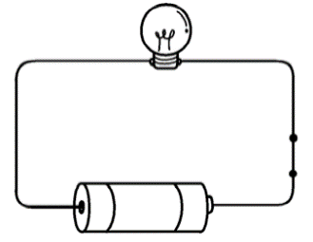

- A switch is connected into an electric circuit. How is the electric current affected when the switch is turned off?
The circuit becomes broken and the current stops flowing

- What parts make up a typical electric circuit?
An energy source, resistor, switch, and wire

- What makes a material a good conductor?
A conductor allows electricity to flow through it

- In order for electricity to flow, it must follow a complete path called an _____closed_______ circuit.

- What characteristic defines an insulator?
Electric charges do not move easily through them

- What is the purpose of including a switch in an electric circuit?
A switch allows the circuit to be open or closed.

- Make a prediction on what would happen if the nails are dropped on top of a horseshoe shaped magnet?
Most of the nails will fall onto the end of the magnet.

- How is Earth like a magnet?
Earth has an invisible magnetic field with many magnetic poles

