Presidential Cartoons
Part Three

Cami Reid
2010-2011
apush
:)

Ulysses S. Grant 1869-1877
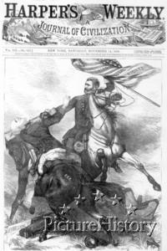
“Victory!”
The above cartoon is of Civil War hero Ulysses S. Grant holding an American flag with the words “Union, Equal, Rights” upon it. Though this was a cartoon used after the Civil War to celebrate Grant’s accomplishments, it put the label “hero” with Grant. This hero persona made Grant famous within the Union and a good candidate for President of the United States simply for his popularity. He is shown pushing down Democratic candidate Horatio Seymour. Seymour represents the harsh, out of control South for his horse is branded with the initials of the white supremacist group known as the Ku Klux Klan. Because I could simply never imagine myself being anything but for equal rights for all races, I would acknowledge this cartoon as a convincing idea if I were a voter during Grant’s first campaign.

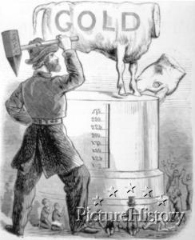

“The American Iconoclast, General Grant Breaking the Golden Calf"

This Ulysses S. Grant cartoon illustrates Grant holding mallet mid-swing that is labeled “army.” He has cut the head off of the Golden Cow. This is an allusion to the Hebrew Bible in which the cow was intended to be a gift towards God, but ironically was classified as a sin of idolatry. One can observe that Grant is characterized as ten times the size of the people gathered around the Golden Cow. This represents him being above average citizens, or a hero of some sort. Through this I concluded that the Golden Cow represents the corrupted South, and his decapitation of it symbolized his great victories in the Civil War. Though I don’t find this cartoon especially captivating, I do understand the point the author was attempting to make. I doubt it would sway my vote either way in the election. In fact, I don’t like the idea of our president being violent in a war or decapitating a cow.

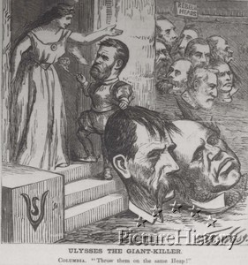

“Ulysses the Giant-Killer”

The cartoon above involves Ulysses S. Grant casually smoking a large cigar as he brings the two oversized heads of his opposing Democratic candidates to Columbia, a representation of America. Columbia orders Grant to place the heads of Horatio Seymour and Francis Blair on the pile labeled rebel heads. This cartoon is slightly confusing to me because I can see a certain type of person taking this cartoon as a positive image towards Grants as opposed to the intended use of swaying voters against Grant. The illustrator labels this cartoon as “Ulysses the Giant-Killer” suggesting he is a murderer on a rebel rampage. This would certainly pit Southerners against him seeing their candidates decapitated by the hands of Union hero Grant. Though I would hope to have been on the Union’s side in the Civil War, I would still see this cartoon as one against Grant because his only reason for presidency is his ability to kill. America has always contained very strict, war-like people though, which leads me to ponder if such people would respect a man being able to kill off so many enemies with ease. I would be against Grant with this cartoon, and I wonder about the controversy it may have caused when it was published.

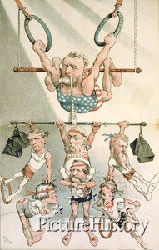
“A Strong Man at the Head of Government”
I absolutely love this cartoon. President Ulysses S. Grant is shown hanging on a bar labeled “third term” representing his candidacy for a third consecutive term. He grasps a “whiskey ring” and a “navy ring,” while holding onto several disrespected politicians by a strap labeled “corruption” in his teeth. Grant’s previous terms had been filled with corruption involving several presidential scandals suggesting he was handing out favors and offices. Two of these were the Whiskey Ring Scandal and the Navy Ring Scandal playfully put as the rings he hangs from. Though the title of this cartoon obviously refers to Grant as a “strong man,” the cartoon itself just as obviously attempts to humiliate Grant by using his scandals against him and putting what should be a formal figure into scantily clad attire. As a whole, this cartoon characterizes Grant and his presidency as a circus. Not only do I fully understand this cartoon, but I also enjoy the colors and humor. It’s quite possible that this could sway my opinion as a voter.
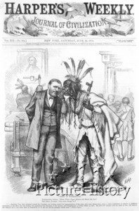
“News in Washington”
The above cartoon of Ulysses S. Grant illustrated by Thomas Nast, a well-known political cartoon, shows Grant involved in a conversation with the Native American Spotted Tail. Spotted Tail whispers to Grant that the news has published lies having to do with Indian affairs. When Grant first came into office, he pledged to resolve a peace agreement with Native Americans. In his inaugural address, he stated that he hoped to moved the Indians onto large reservations close to their cities and eventually allow them to become U.S. citizens. By his second term, however, these plans had been pushed aside and replaced with minute reservations isolated from Americans. Compromise had been replaced with force. I believe this cartoon is trying to convey Grant’s double-sidedness. He listens to the Indians, but he does nothing to help their situation. Because I am part-Native American and all equal rights-supporter, his lack of assistance towards the Native Americans might have created a slight disrespect for Grant and his abandoned ambitions.

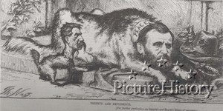
“Dignity and Impudence”
This cartoon, yet another one by Thomas Nast, characterizes Ulysses S. Grant as a large guard dog with a collar that reads “PEACE.” Next to him beckons a small puppy with the head of Democratic candidate Francis Blair. His collar, however, is labeled “WAR.” The intent of this cartoon is to portray Grant as the correct choice for president because he is big, strong, and the way to peace. It discriminates against the Democratic vice-president candidate Blair by portraying him as a whiny puppy sure to bring about war. I find this cartoon ironic because although Grant was known as a strong man, he was in fact a war hero. He wears a collar labeled “PEACE.” A man who is known for war, lived through war, and gained fame through war is likely to want more war. Because of this, I find this cartoon to be unsuccessful in swaying me either way in an election. Viewers who might not have analyzed the cartoon as I personally did would most likely find Grant to be the better candidate of the two in order to protect the Union and keep peace.

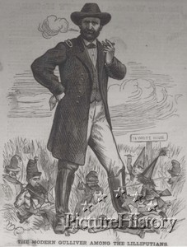

“The Modern Gulliver Among the Lilliputians”

The above cartoon was published in 1868 during Grant’s first of two successful presidential campaigns. It quite simply shows Ulysses S. Grant standing taller than his Democratic opponents. It is the title that helps to explain the simplicity of the illustration. Gulliver and the Lilliputians serve as allusions to Jonathan Swift’s Gulliver’s Travels published over a century before. In such novel, Gulliver is also several feet taller than the Lilliputians which stand only 6” tall. Gulliver and Grant represent modern man with modern morals, and the Lilliputians and Democratic candidates symbolize viciousness and politicking. This cartoon was most likely successful because Gulliver’s Travels was a popular novel at the time, as it is now. It probably grasped the eye of some intellectuals, as well. Though I have not personally read Swift’s novel, I suppose I would like this cartoon because it persuades me to think that Grant has educated people on his side.

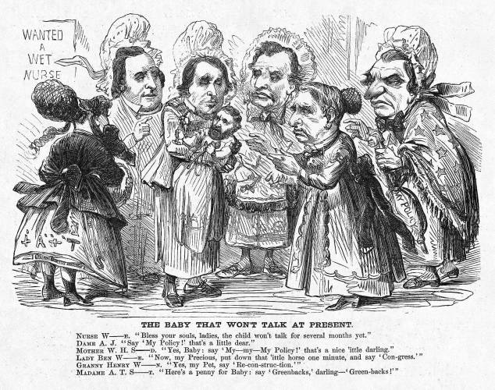

“The Baby That Won’t Talk at Present”

This cartoon is one that I particularly find entertaining. Created as a satirical illustration during Grant’s first presidential campaign, it characterizes Ulysses S. Grant as a baby being carefully cared for by several well-known Republican and Democratic figures. Businessman Stewart, Senator Wilson, former Governor Wise, Congressman Wade, Secretary of State Seward, and President Johnson are all depicted attempting to baby Grant into running under their political party. It is funny because such formal political figures are shown as cartoons with bonnets upon their heads. It has always been comical to see formal figures brought down to civilian level. I feel that although this cartoon is funny, it is not strong enough to sway my vote either way. It does accomplish portraying Grant as not being educated in enough politics to successfully run a country.

Rutherford B. Hayes 1877-1881
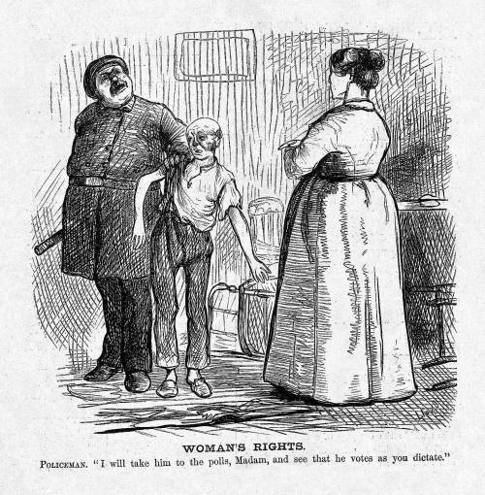
“Women’s Rights”
Though this cartoon is ridiculing women’s rights, I can’t help but enjoy it. During the time of Hayes’ presidency, women were still struggling for equal rights, including that to vote. They had made sufficient progress at the Seneca Falls Convention in 1848, but they were determined to not give up. A policeman is shown escorting a husband to the polls and promising his wife that he votes as she says. This supports the ideas that women did in fact have influence over the political decisions of their husbands. It further represents the concept that women indirectly had a say in politics which should be enough. Those who made these decisions, also known as men, felt that women should be satisfied with their position because giving them equal rights would undercut the strength of a family. This cartoon wouldn’t, however, deter me from supporting women’s rights, for having the right to cast one’s ballot is far from equal to working to persuade one’s husband.

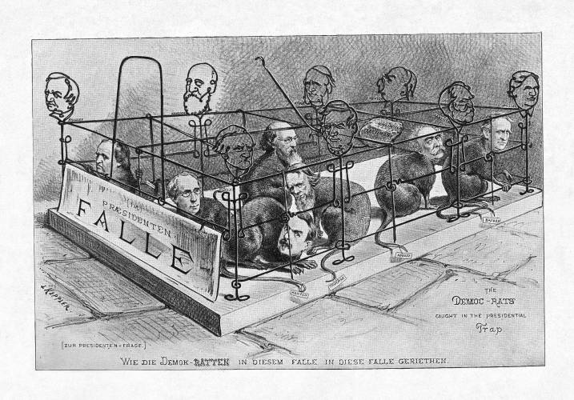
"The 'Democ-Rats' Caught in the Presidential Trap."
The above illustration by Joseph Keppler is a comical interpretation of the Democrats’ situation during the 1876 election. The disputed election between Hayes and Tilden should be settled by the Electoral Commission, as thought by the Democrats. The current justice David Davis would have been the deciding vote which convinced the Democrats they would win this election. Davis, however, resigned to become part of the U.S. Senate and was replaced by Republican partisan Joseph Bradley. The Democrats’ plan had backfired on them and they therefore felt trapped like rats. I particularly like this cartoon because it is witty. The taking of “rats” out of Democrats and comparing them to trapped animals was especially clever. I feel that cartoons like this were quite rare during the time.

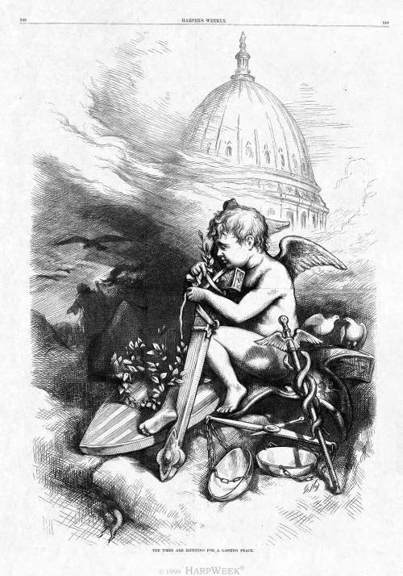
"The Times Are Ripening for a Lasting Peace."
In this cartoon, grand in scale yet subdued in tone, a cherub, representing new beginnings, ties an olive branch of peace around his sheathed sword. His foot rests on the shield of the United States, while behind him perch two doves of peace, perhaps symbolizing reconciliation between the Democratic and Republican parties or the North and South. On the ground in front of them lie the scales of justice, which were used to judge the disputed election returns. Propped up is Caduceus, a rod carried by Roman officers when they negotiated peace terms. In mythology, it became the staff of Mercury (Hermes), messenger to the gods. On the left, a snake slithers under the rocks (foreground), as buzzards follow the retreating angel of death and the dogs of war. In the background, the haze dissipates to reveal the dome of the Capitol building, signifying the permanence of the republic.
I particularly like this illustration because it’s purely beautiful. It is quite different in both style and message from the usual cartoons printed in Harper’s Weekly. The style is elegant and realistic as opposed to boisterous and exaggerated. The message is peaceful as opposed to humor or disgrace. It provides hope to the reader that Hayes will act as the cherub to reconcile America’s problems and keep the Union united.
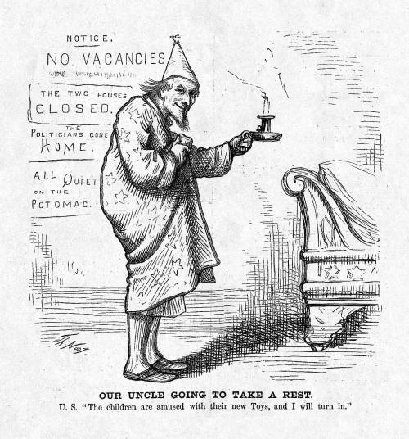
“Our Uncle Going to Take a Rest”
This cartoon was published after the final counting of the Hayes vs. Tilden presidential election. The counting and recounting and use of the Electoral College made the 1876 a long, drawn-out process. For months, officials were handing the crisis all around the Potomac River area. This explains the sentence “All Quiet on the Potomac” printed on the cartoon, which suggests the rest everyone must have felt after the election had finally been awarded to Hayes. Uncle Sam is shown in his pajamas about to take a rest. I like this cartoon because although it is funny, it doesn’t tend to make fun of any one. It reunites the country after a long debate by using the American figure of Uncle Sam. It perfectly characterizes the hard work put into the election and the moment of relaxation when the vote was finally decided. I adore this cartoon.

James A. Garfield/Chester a. Arthur 1881-1885
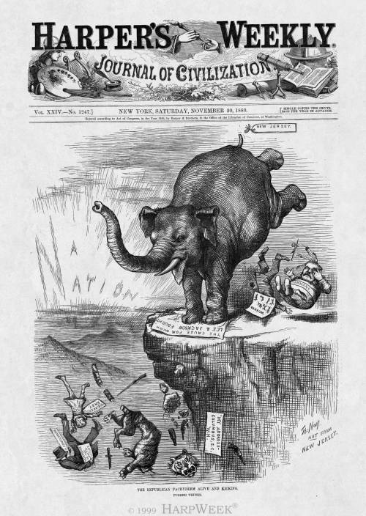
“The Republican Pachyderm Alive and Kicking: Pushed Things”
This cartoon by Thomas Nast celebrates the Republican victory of James A. Garfield. The Republican Elephant is shown kicking the Democratic rebels William Barnum and John Kelly. The purpose of this cartoon is to show the elation involving the domination of Republican nationalism over Democratic states’ rights. This is included in the words “A Nation” depicted by rays of light in the far left background. Several Democratic candidates and figures are also shown being kicked off the side of the cliff. Because Nast was doubtful about president-elect Garfield, he is not included in this cartoon by name. I find it interesting that Nast would support Garfield simply on his Republican status. He actually admired the Democratic candidate, but remained with the Republican Party.
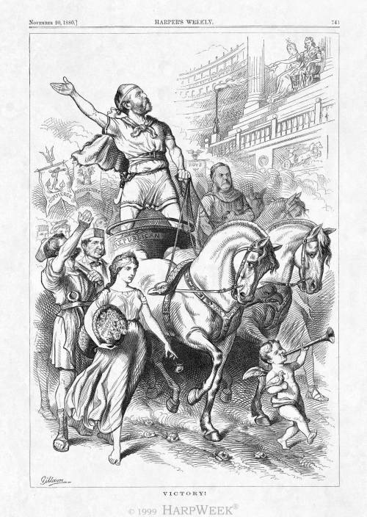
“Victory!”
The rest of the Harper's Weekly art department did not share cartoonist Thomas Nast's aversion to James Garfield, the Republican presidential nominee. Here, Bernhard Gillam showcases President-elect Garfield as a triumphant Roman general, parading past an approving Columbia and Uncle Sam (upper-right). Stamped on the harness of his white steed is the democratic slogan "Vox Populi," meaning "voice of the people." On the right rides a dignified Vice-President-elect Chester Arthur, making a rare appearance in a Harper's Weekly cartoon. On the left march personifications of prosperity and labor, followed by banners celebrating "Commerce"; "Agriculture"; and "Boys in Blue" (Union veterans).
I find this illustration captivating because it contrasts from Thomas Nast’s view of president-elect James A. Garfield. In this cartoon, Garfield is uplifted as a hero, Roman-style. If I were a supporter Garfield, I would have liked this celebratory cartoon because it references ancient history, which I enjoy the most.

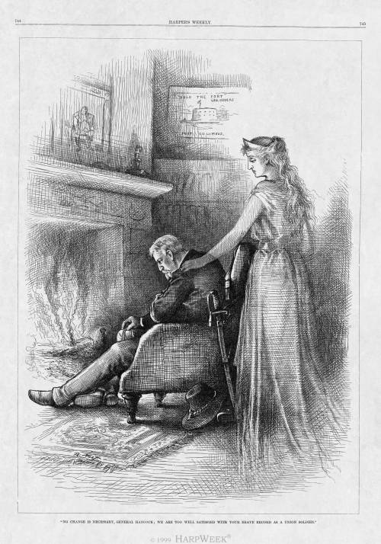
“No Change is Necessary, General Hancock"
The respect that many Americans, including Republicans like artist Thomas Nast, had for Democratic presidential nominee General Winfield Hancock is exemplified in this sympathetic post-election illustration. Sitting before his fireplace, a disappointed Hancock is consoled by Columbia, who tells him of the nation's gratitude for his heroic military service during the Civil War. Dimly visible above the mantel is a portrait of Napoleon. More prominent on the adjoining wall is a picture of Fort Columbus (today, Fort Jay), Governor's Island, New York, where Hancock was stationed as commander of the U.S. Army's Atlantic Division. Following the election, he returned to his post. In 1886, he died while on duty there.
This illustration by Thomas Nash is quite appealing in style, and it does a good job at evoking an emotion in the reader. The shadowing of the picture and the warm fire successfully contribute to the disappointing atmosphere. Although I don’t enjoy the sadness of the illustration, I respect it.

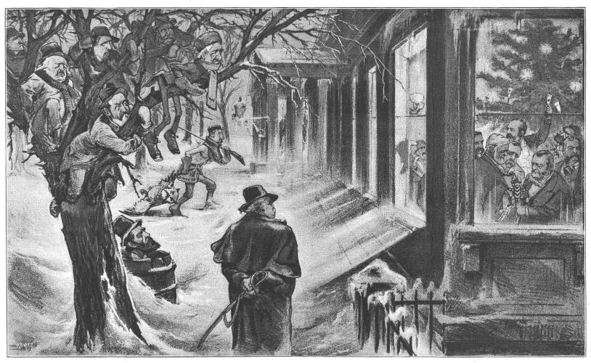
“A Merry Christmas To All”
This cartoon, printed in 1880, shows Keppler’s take on Garfield and his success, which opposes that of Thomas Nast. I personally like the rivaling ideas presented in the different cartoons of the same newspaper. Newly elected James A. Garfield is shown inside celebrating his election and the holidays with fellow Republicans such as outgoing Interior Secretary Carl Schurz, Vice-President-elect Chester Arthur, former president Ulysses S. Grant, Senator James Donald "Don" Cameron of Pennsylvania, Senator James Blaine of Main, Senator John Logan of Illinois, former postmaster general Marshall Jewell, and possibly outgoing treasury secretary John Sherman. As they celebrate inside, the losing General Winfield Hancock and supporters and running mates weep outside in the cold. They hang in trees and watch the Republicans celebrate inside. I don’t like this cartoon for its sadness. If I were a Republican, I would feel bad for those in the cold. If I were a Democrat, I would feel left out and hopeless.

Grover Cleveland 1885-1889
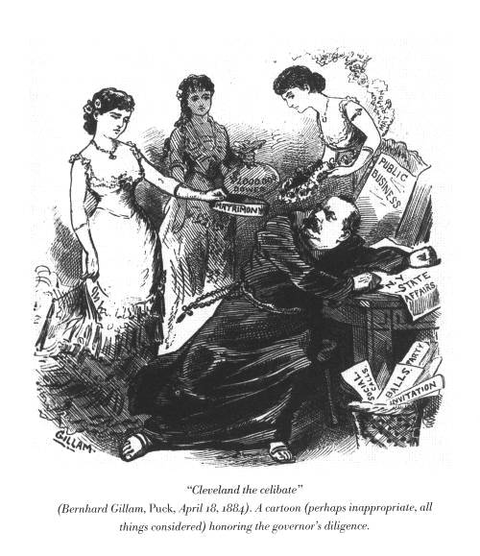
“Cleveland the Celibate”
Bernard Gillam’s illustration portrays Grover Cleveland competing for the Democratic nomination. It honors his celibacy towards possibly corrupting events such as balls, marriage proposals, and parties. Such things are shown in the wastebasket. Women are shown around him bringing gifts, as well. Cleveland remains at his desk characterized as a monk through his clothing. This would turn me away from Cleveland because I wouldn’t want a president who was socially inept. I would rather one who is socially balanced, so that he can handle meeting people. Being social is a good quality when it comes to foreign affairs.
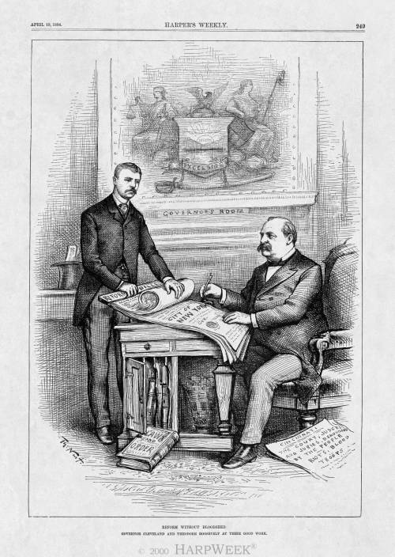
“Reform Without Bloodshed”
This Nast cartoon pictures two future presidents working together for reform. Republican Theodore Roosevelt, then a young state assemblyman, sponsored several reform measures, including changing the municipal charter of New York City (featured here). The bill was aimed at making the city's government more efficient and less corrupt. Roosevelt (left) holds the bills for Governor Cleveland to sign. The theme articulated in the caption, "Reform Without Bloodshed," is reinforced by contrasting documents in the foreground: a "Law and Order" book (left) for New York's reformed government and a newspaper (right) reporting riots against Cincinnati's unreformed government.
I like this cartoon of Nash’s because instead of humiliating the competition, it glorifies the candidate he supports as someone who has the potential to make and keep peace. I may also be a small bit biased because I love Theodore Roosevelt, who is pictured in this illustration. This does, however, lead me to think that people of the time may have also liked jolly ol’ Teddy, and associating him with Cleveland could have been a positive thing for Cleveland.
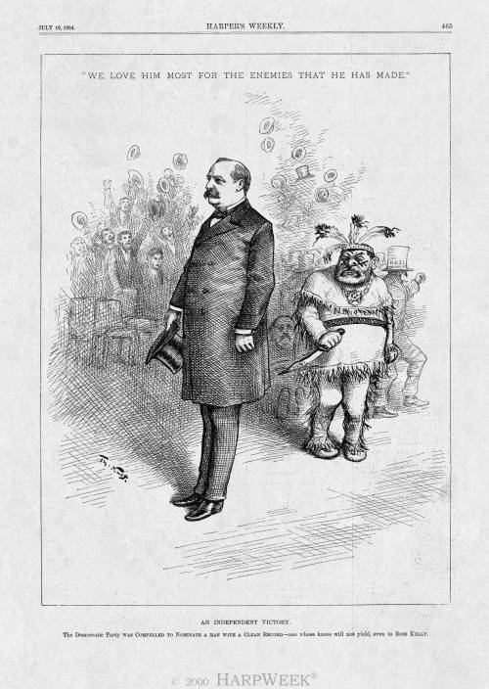
“An Independent Victory”
Standing tall and erect, Cleveland is portrayed as a "clean" politician, who has the backbone to stand up to disreputable pols like Kelly. Cleveland's nomination is not presented as a victory for the Democratic party, but for independent voters of any partisan affiliation. Nast may also be giving credit (largely undue) to Independent Republicans like himself for influencing the Democratic selection process. "Boss" Kelly is pictured as a disgruntled Indian chief, considering whether to stab Cleveland in the back. A forlorn Benjamin Butler, who had desired the Democratic nomination for himself, sits on the ground in the shadows between Cleveland and Kelly.
I find this Nast cartoon interesting because instead of bashing the opposing candidate, it celebrates Cleveland being against certain people that Nast did not care for, as well. I like that Cleveland is shown simply standing away from his enemy characterized as a disgruntled Indian. To me, I see this as a peaceful way to not get along. I enjoy the lack of conflict. This could certainly sway my vote towards Cleveland if I too did not like Kelly and Tammany Hall.
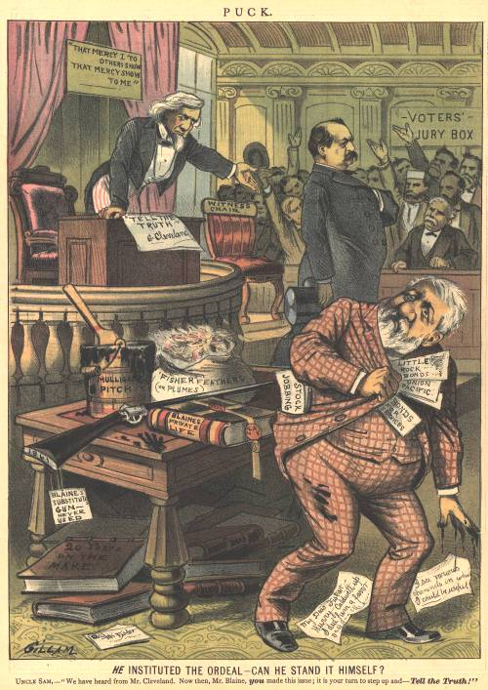
“He Instituted the Ordeal. Can He Stand It Himself?”
This cartoon by Bernhand Gillam was featured in Puck newspaper comparing the scandals of Democratic candidate Grover Cleveland and Republican candidate James Blaine. With Uncle Sam as the judge, Cleve is shown facing his audience, hand in jacket Napoleon-style. This represents the rumor that he had an illegitimate child. He came clean and explained all to the public. On the contrary, Blaine is shown in the corner trying to hide his scandals. He stuffs papers labeled with his various rumors such as “railroad scandals.” Even a gun labeled “never-used” sits on his table representing yet another of his shames. This cartoon is fabulous at swaying me towards Grover Cleveland, for I want a president who will be honest and upfront with America. I mind not that he had an illegitimate child, but certainly mind that Blaine was involved in lies and attempted to cover them up. The honesty displayed by Grover Cleveland alone could have won my vote.

Benjamin Harrison 1889-1893
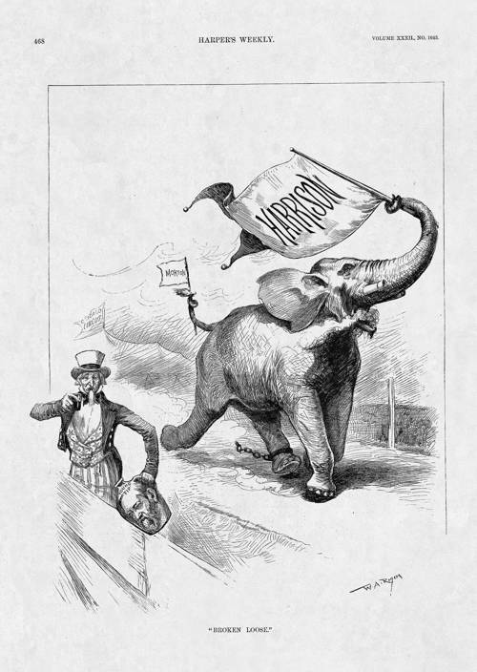
“Broken Loose”
This cartoon acknowledges the selection of the Republican national ticket by portraying the party as a fierce, frothing, stampeding elephant that has broken away from the “Chicago Circus” (the Republican National Convention). An ill-looking Uncle Sam, carefully positioned out of the pachyderm’s path, is about to take a drink from a cider jug with Harrison’s face on it. The jug alludes to the 1840 presidential campaign of Benjamin Harrison’s grandfather, William Henry Harrison, during which an opposing newspaper’s attempt to mock the latter’s frontier pretensions backfired, making hard cider and log cabins beloved symbols of the candidate.
I don’t particularly like this cartoon, but I included it to point out the grandfather-grandson correlation between former president William Henry Harrison and Republican presidential candidate Benjamin Harrison. This cartoon fails to point out any other reason to vote for Harrison other than the fact that his grandfather was a president. I doubt it would sway me either way.
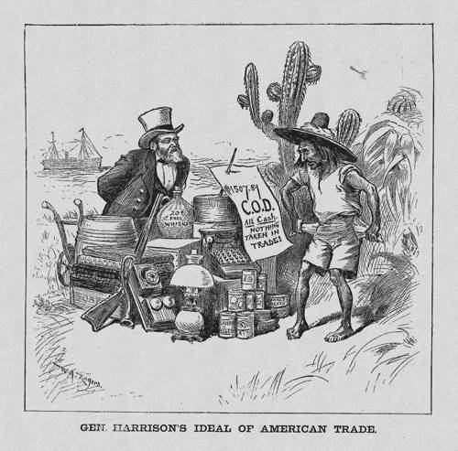
“General Harrison’s Ideal of American Trade”
This cartoon is another critique of the Republican commitment to high tariffs intended to protect American industry from foreign competition. Benjamin Harrison, the Republican presidential nominee, has set up an open-air market somewhere in Latin America. He offers a variety of products for sale—including a typewriter, canned goods, lamp, telephone, gun, box of soap, fabric, and a jug of “free whiskey”—but will only accept cash, which the Latino does not have. The cartoon’s message is that protective tariffs interrupt the normal flow of trade across national borders, leaving (in this case) Latin American countries impoverished and American products unsold.
The above illustration by William Allen Rogers deals with the topic of the Republicans’ stand on tariffs. They were for high protective tariffs to keep American on top in international trade. This cartoon, however, suggests that such a policy would ruin intercontinental trade and cause poverty in Latin America. I feel that I understand protective tariffs enough to understand this cartoon. I also feel that the benefits of America being able to support itself as much as possible outweigh the damage to Latin America. I can see where such an event would happen, but I feel in reality it would be much less dramatic.
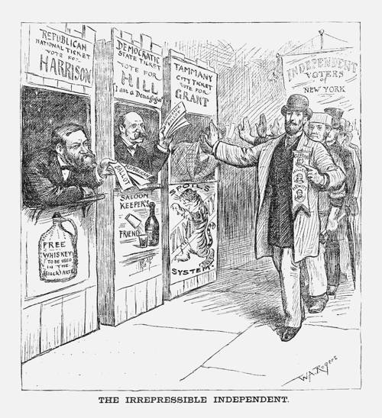
“The Irrepressible Independent”
A man leads a parade of independent voters representing all classes—the attire identifies the main figure as middle class, the man behind him as working class, and the third man as upper class. With a gesture of firm refusal, they march past party ticket booths manned by Tammany Democrat Hugh J. Grant, mayoral candidate; Democrat David B. Hill, gubernatorial candidate; and, Republican Benjamin Harrison, presidential candidate. In this cartoon, Hugh Grant is opposed because he is backed by the political machine of Tammany Hall and would stand against civil service reform at the municipal level. Hill is rejected because of his demagoguery and the New York Democratic Party’s opposition to high license fees for alcohol distributors. Harrison is passed by because of the Republican Party’s national platform plank endorsing repeal of taxes on alcohol used in the arts (here, changed to “black arts”) and its call for the abolition of internal taxes (which would include on all alcohol) rather than dismantling the protective tariff system.
I like this cartoon because instead of focusing on one party being the right or wrong choice, it characterizes the Democratic Party, Republican Party, and Tammany Hall. The Tammany Hall booth has a “spoils system” sign on it, and the Republican booth has the image of whiskey on it. This represents Harrison’s stand on the repeal of taxes on alcohol. Finally, the Democratic booth is characterized by its opposition to high alcohol taxes. This cartoon only encourages me to base my votes on my own opinions.
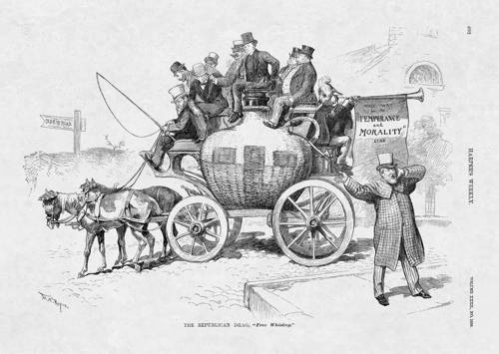
“The Republican Drag: Free Whiskey”
Benjamin Harrison, the Republican presidential nominee and a devout Presbyterian, drives his campaign carriage topped by mostly proper-looking gentlemen as a plumed trumpeter blares the party’s message of “Temperance and Morality.” The riders’ tranquility is interrupted by James Blaine, who is dressed in the garish attire of a “confidence man” (con artist) and acts as a circus barker. His shout from the sidewalk reveals the true nature of the Republican vehicle: it is a whiskey jug on wheels traveling down Old Rye Road. The cartoon reflects the Democratic strategy to win Prohibitionist votes by associating Republicans with “free whiskey” because of the GOP platform call for an end to all internal taxes, including on alcohol. It also reinforces the assumption that Blaine would set policy in any Harrison administration.
This political cartoon by William A. Rogers again deals with the Republican views to end internal taxes on alcohol. It also goes to attract Prohibitionists to the Democratic side. If I were to have been a prohibitionist, this cartoon may have been successful in swaying me against the Republicans. What I feel could have been a better idea is to have illustrated why to vote for the Democratic Party, instead of why not to vote Republican.
Grover Cleveland 1893-1897
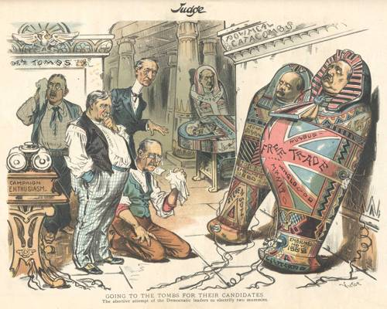
“Going to the Tombs for Their Candidates”
The message of this cartoon is that the 1892 Democratic national ticket is as politically dead as ancient Egyptian mummies, which no amount of electricity from “campaign enthusiasm” can revive. Here, the 1892 presidential nominee, Grover Cleveland (right), and his vice-presidential running mate, Adlai Stevenson (left), are mummies leaning against the “Political Catacombs” wall and connected to electrodes. The respective sarcophagi are dated when they lost elective office: Stevenson failed to retain his congressional seat in 1880 and Cleveland lost his presidential reelection bid in 1888. Decorating the Cleveland case is a British flag labeled “Free Trade Humbug” and “Anglo-Mania” in reference to his stance in favor of tariff reform.
I find this cartoon funny especially because it suggests Grover Cleveland’s chances at winning the election are absolutely dead. He wins. It is the first cartoon that I’ve seen that pokes fun at a candidate’s age, too. I think it’s clever with its “campaign enthusiasm” as electricity that attempts to revive the candidates. I also observe that Cleveland’s tomb is especially large around his stomach. It may be immature humor at parts, but the witty parts make it honorable. If I were a Republican at the time this was published, I would have thoroughly enjoyed seeing this cartoon.
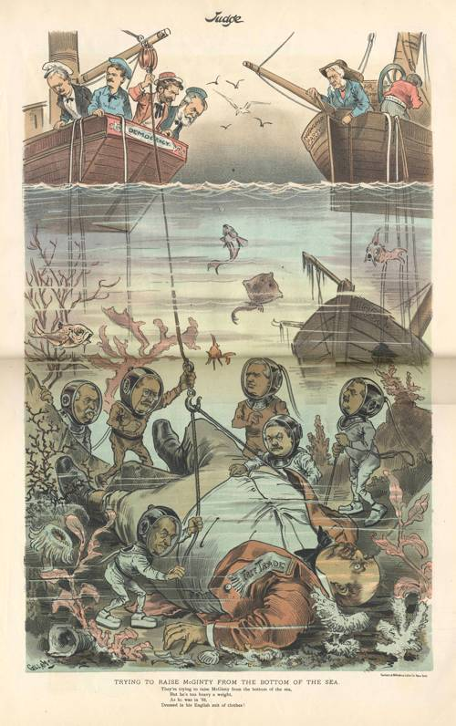
“Trying to Raise McGinty From the Bottom of the Sea”
Here, a combination of Democrats and Mugwumps have found Grover Cleveland at the bottom of the sea, where his ship of state sank in 1888—a reference to his electoral defeat to Republican Benjamin Harrison. However, they are having a difficult time raising the waterlogged presidential nominee of 1892, whose gigantic size lampoons his weight. The sailors aboard the “Democracy” vessel are Adlai Stevenson, Robert Pattison, Calvin Brice. and Leon Abbett. The underwater divers are John Carlisle, Roger Mills,William C. Whitney, Arthur Pue Gorman, Patrick A. Collins, and Charles Fairchild. The “Free Trade” banner on Cleveland’s shirt and the caption’s reference to “his English suit of clothes” both allude to the Democratic nominee and platform’s support of tariff reform.
This is my favorite cartoon yet. It uses allusion, party opposition, the appearance of the candidate, and the failure of past elections. It’s pretty harsh against Cleveland as it mocks his appearance and last failed campaign. This cartoon is just plain funny. It lacks seriousness and any legit reasons to dislike Democrats or to vote towards Republicans, so it wouldn’t sway me to either side. It only serves as entertainment.

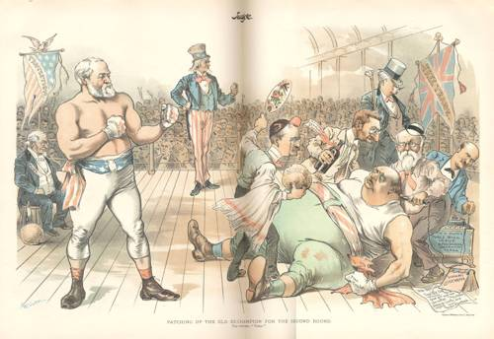
“Patching Up the Old Ex-Champion”
This cartoon uses a traditional motif by depicting the 1892 presidential election as a boxing match between the two parties’ nominees, Republican Benjamin Harrison (left) and Democrat Grover Cleveland (right). However, the title’s reference to “Ex-Champion” and “Second Round” indicate what was unique about the campaign: it was the only election in American history to pit two men who had already been president against each other. Here, Cleveland is still on the floor with a swollen eye from their original match in 1888, when he lost the presidency to Harrison. Democratic leaders try various methods to revive their candidate, but are not having success. The English Bulldog head on Watterson’s cane and the Union Jack “Free Trade” banner emphasize the Democratic call for tariff reform. In contrast, a fit and muscular Harrison wears “Protection” gloves on his clenched fists, while a “Protection” banner modeled on the American flag and topped by the American Eagle stands on the Republican side.
This cartoon was most likely successful because of its use of detail. In every corner, every nook and cranny, one can find a symbol of some sort representing one of the candidates. Once again, Bernhard Gillam uses Cleveland’s weight against him and fails to depict anything negative about Harrison. The characterization of each presidential candidate makes it obvious to the reader that the artist is bias towards Benjamin Harrison. Still, as a logical thinker, this cartoon wouldn’t convince me either way if I were an undecided voter. If I were a Harrison-supporter, I would like to think of my choice as someone strong like the cartoon depicts.
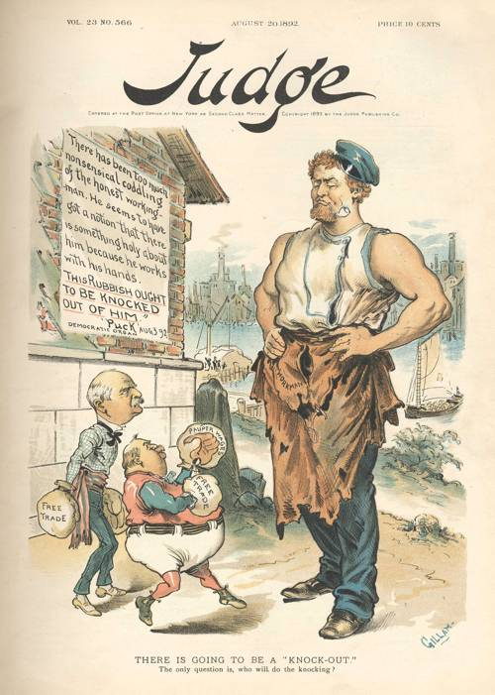
“There is Going to be a ‘Knock-Out’”
Here, Judge artist Bernhard Gillam takes the fighting theme of this cartoon from Puck’s recent criticism of American workers (posted on the wall). A muscular workingman stands tall and confident as the diminutive Democratic national ticket of vice-presidential nominee Adlai Stevenson (left) and presidential nominee Grover Cleveland (right) prepare to assault him. They wear “Free Trade” and “Pauper Wages” boxing gloves, but are no match for the laborer who (implicitly) realizes that trade protectionism provides the economic prosperity apparent in the scene behind him.
I like this cartoon because it combines humor and actual issues, which is what a political cartoon should be. It addresses the issues of free trade and pauper wages and playfully characterizes presidential candidate Grover Cleveland and vice-presidential candidate Adlai Stevenson as tiny people compared to a working man. This political cartoon has the right combination of politics and humor.
William McKinley 1897-1901
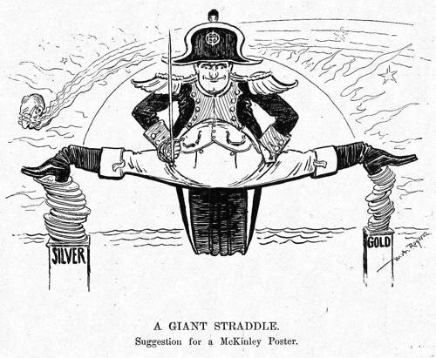
“Frontrunner McKinley: A Defeated Napoleon”
Governor William McKinley of Ohio, the leading candidate for the Republican presidential nomination, is depicted as Napoleon awkwardly straddling the money question. Like most Republicans, McKinley backed the gold standard, but the tariff was his main issue. He skillfully avoided discussing currency topics, referring reporters to his congressional record. However, the candidate blurred his stance somewhat by stating that he would support bimetallism (silver and gold coinage) if an international agreement could be reached.
Though simple and in black and white, this cartoon is entertaining. The comparison to the famous Napoleon may not have been exactly a winner, but it managed to get the issue of McKinley’s tariff across. Putting a political figure in funny garb and an odd position will always be a winner with me, though this simplistic cartoon would fail to get my attention in a newspaper.

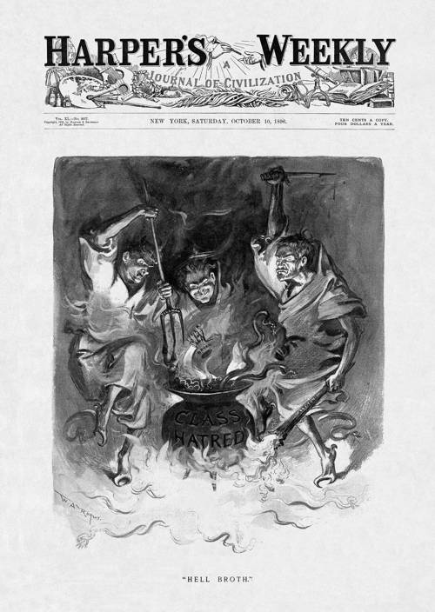
“Hell Broth”
This postdated cartoon conjures an image of the nation’s hellish fate if voters choose the Democratic ticket. Feeding the boiling cauldron of “Class Hatred” are (left-right) Senator “Pitchfork Ben” Tillman of South Carolina, Democratic presidential nominee William Jennings Bryan, and Governor John Peter Altgeld of Illinois holding the “anarchy” torch. The illustration dramatically conveys the message that the most dangerous thing about the Democratic Party in 1896 is its control by radical politicians.
I find this illustration interesting because it is dark, a rarity of the time. It clearly opposes the Democratic Party for its radicalism and directly compares Governor John Peter Altgeld to an anarchist. I admire William Allen Rogers for printing this dark and bold cartoon.
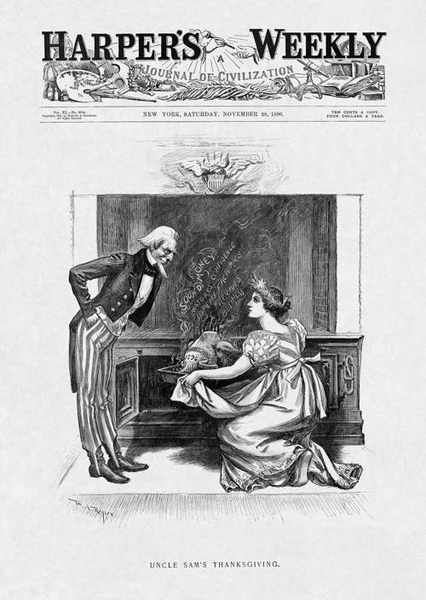
“Uncle Sam’s Thanksgiving”
This post-election cartoon pictures Uncle Sam and Columbia at Thanksgiving. The traditional turkey that she removes from the oven is labeled with the economic blessings that will ensue from the Republican victory in the 1896 election; in all, protection of the gold standard and a return of national prosperity.
This cartoon of William Allen Rogers’ is one in which simplicity works. It connects to the American love of a warm home environment and unites the people with a hope of economic prosperity. The use of America’s most beloved figures was an obvious move, but it worked.
works Cited
***Note: the descriptions colored in deep purple came from the resource listed below
"The Presidential Elections: 1860-1912." HarpWeek | Elections Homepage. Web. 09 Jan. 2011. <http://elections.harpweek.com/default.asp>.

