Jane Doe
Mrs. Chadwell
English 2 Honors
February 3, 2014
Culture and Literature from Antarctica
Throughout history, people convey their stories through literature and music. Images and literary devices are used to connect people to the country. Antarctica is one of those countries that uses its literature and media to convey its culture to the people in and out of the country. Through short stories, poems, and music, writers illustrate the frozen imagery of the country, the religious beliefs of Christianity, and the present-day life of people in Antarctica.
Background of Antarctica
Antarctica is a country that…
Map
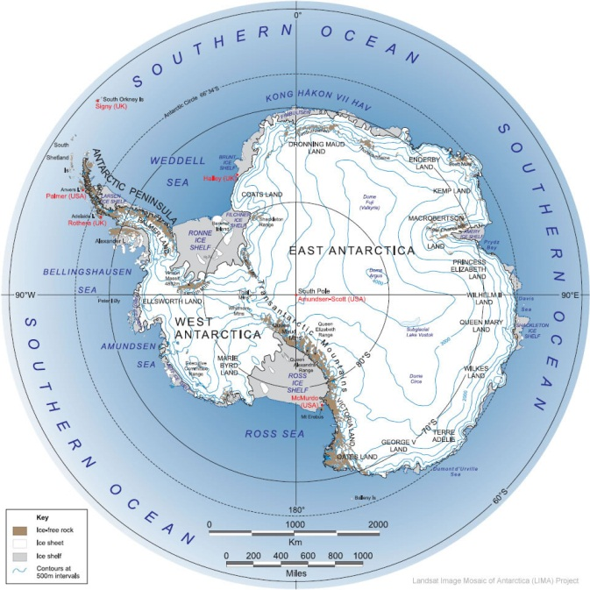
Fig. 1: Map of Antarctica from Geoscience News and Information; “Antarctica Map”; Georgraphy.com; 2014; Web; 04 Feb. 2014.
Geographic Information
Demographics
Daily Life
Culture of Antarctica
Ethnicities
Religion and Beliefs
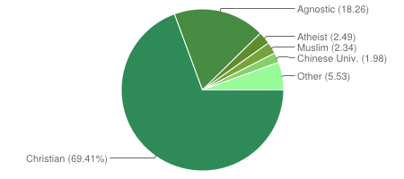
Fig. 2: Pie chart of religions of Antarctica from Association of Religious Data Archives; “Canada”; thearda.com; 2010; Web; 04 Feb. 2014.
Antartica Short Story
Writer’s Background
Summary
Literary Devices
Connection to Antarctica
Poetry from Antarctica
Poet’s Background
Summary
Literary Devices
Connection to Culture
Music from Antarctica
Musician’s Background
Summary
Literary Devices
Connection to Culture
Conclusion
Throughout the study of Antarctica many new connections to culture and country can be made through its literature and music. The short story shows how the author uses imagery to connect the reader to the landscape of the country. The poem illustrates the religion of the country through “prayer to God” and “Heaven above.” The music connects to the present-day culture with its use of “frozen tundra” and “penguins among us.” All types of literature portray different parts of Antarctica and provide a vision of what life is like there.

Works Cited
Association of Religious Data Archives. “Canada.” thearda.com. 2010. Web. 04 Feb. 2014.
"Frequently Asked Questions about the MLA Style Manual." Modern Language Association.
Modern Language Association, 2008. Web. 30 June 2009.
Geoscience News and Information. “Antarctica Map.” Georgraphy.com. 2014. Web. 04 Feb.
2014.
The Purdue OWL. Purdue U Writing Lab, 2010. Web. 01 Jan. 2014.
Russell, Tony, Allen Brizee, and Elizabeth Angeli. "MLA Formatting and Style Guide." The
Purdue OWL. Purdue U Writing Lab, 4 Apr. 2010. Web. 20 July 2010.

