**Cell Division-Chapter 10 Section 2 (H.B.2D)-Notes and Essential Knowledge**

[**https://prezi.com/waucbo7mxj39/biology-chapter-10-section-2-cell-division/**](https://prezi.com/waucbo7mxj39/biology-chapter-10-section-2-cell-division/)

**Cell Division**

1. In _______________________, cell division occurs in two major stages.
   1. The first stage, division of the cell _______________________, is called __________________________.
   2. The second stage, division of the cell _______________________, is called _______________________.

**Chromosomes**

1. _____________________________________________ is passed from one _________________________ to the next on chromosomes.
   1. Before cell division, each chromosome is _____________________________, or ___________________.
   2. Chromosomes are made of _____________ molecules. Draw and label chromosomes below:
      1. One chromosome (unduplicated):
      2. One chromosome (duplicated):

* 1. Each duplicated chromosome consists of two identical ________________________________________.
  2. Each pair of chromatids is ____________________ at an area called the _________________________.
  3. When the cell divides, the ________________________________________________. Each new cell gets one _____________________________.
  4. The four phases of mitosis include:

**The Cell Cycle**

1. The cell cycle is the series of ____________________________________________________________________ __________________________________________________________________________________________.
2. ____________________________________ is the period of ____________________ that occurs between cell divisions.
   1. The three phases of interphase include:
      1. ____________ (40%): ____________________________________________________________
      2. ____________ (39%): ____________________________________________________________
      3. ____________(19%): ____________________________________________________________
   2. Mitosis is also known as the ______ phase and is 2% of the overall cell cycle.
   3. During the cell cycle:
      1. A _________________ grows
      2. _________________________ for division
      3. Divides to form two _______________________________, each of which begins the cycle again

**Events of the Cell Cycle**

1. During G1 (First Gap Phase), the cell:

1. During the S phase:
   1. Once a cell enters the S phase, it usually completes the rest of the cell cycle.
2. The G2 Phase (Second Gap Phase):

**Essential Knowledge (H.B.2D.2)**

* In the development of most multicellular organisms, a single cell (fertilized egg) gives rise to many different types of cells, each with a different structure and corresponding function.
* The fertilized egg gives rise to a large number of cells through *mitotic cell division*, but the process of cell division alone could only lead to increasing numbers of identical cells.
* As cell division (cell division is covered in H.B.2D.2) proceeds, the cells not only increase in number but also undergo *differentiation*, a process through which a cell becomes specialized in order to perform a specific function.
* The various types of cells (such as blood, muscle, or epithelial cells) arrange into tissues which are organized into organs, and, ultimately, into organ systems.
  + Nearly all of the cells of a multicellular organism have exactly the same chromosomes and DNA.
  + During the process of differentiation, only specific parts of the DNA are activated; the parts of the DNA that are activated determine the function and specialized structure of a cell.
  + Because all cells contain the same DNA, all cells initially have the potential to become any type of cell.
* Once a cell differentiates, the process cannot be reversed.
* The cell cycle is a repeated pattern of growth and division that occurs in eukaryotic cells. This cycle consists of two phases. The first phase represents cell growth while the last phase represents nucleic division (mitosis) and cytoplasmic division (cytokinesis).

***Interphase***

• Cells spend the majority of the cell cycle in interphase. The purpose of interphase is for cell growth and preparation for mitosis and cytokinesis. By the end of interphase a cell has two full sets of DNA (chromosomes) and is large enough to begin the division process.

• Interphase is divided into three phases. Each phase is characterized by specific processes involving different structures.

• During the G1 (gap 1) phase, the cell grows and synthesizes proteins.

• During the S (synthesis) phase, chromosomes replicate and divide to form identical sister chromatids.

• During the G2 (gap 2) phase, cells continue to grow and produce the proteins necessary for cell division.



**Mitosis**

1. Mitosis (M Phase)-Biologists divide the events of mitosis into four phases: (__________________): _________________, _______________________, __________________________, and ___________________.
   1. Prophase: Chromatin (_________) condenses into chromosomes and the ____________________ envelope breaks down. Spindle fibers start to form from the centrioles.
   2. Metaphase: The chromosomes _____________ up across the ________________ of the cell. The spindle microtubules _______________________ the ____________________ of each chromosomes.
   3. Anaphase: The sister chromatids _____________________________ into individual chromosomes. Spindle microtubules start to pull chromosomes to opposite ends of the cell.
   4. Telophase: Chromosomes _____________________ at opposite ends of the cell and _____________ their distinct shape. A new ____________________ envelopes forms around each ______________ of chromosomes.
   5. Cytokinesis: The cytoplasm will pinch in _______________. Each NEW daughter cell has an _________________ set of duplicate __________________________________.
      1. In ____________________, a structure known as the ________________________ forms midway between the divided nuclei.

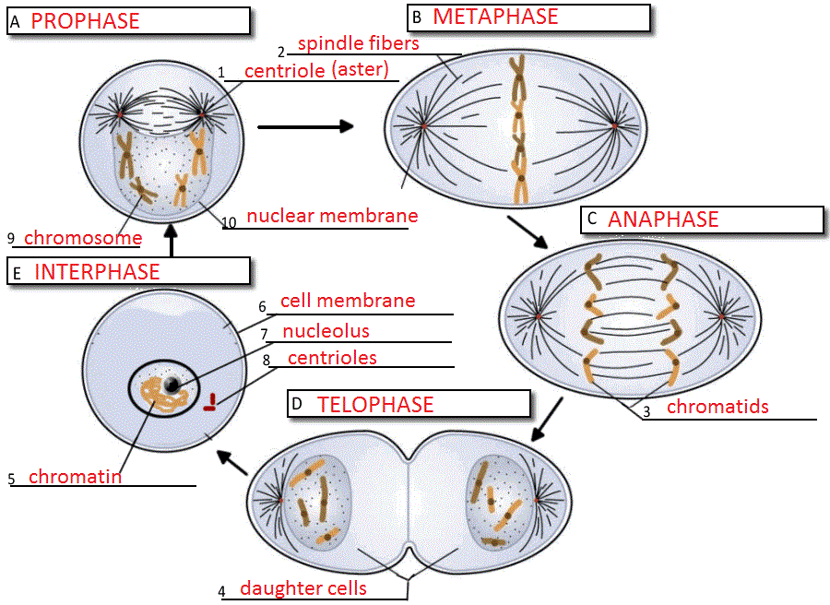

**Essential Knowledge:**

***Mitotic Phase*** (which in includes Mitosis and Cytokinesis)

*Mitosis*

• The purpose of mitosis is the division of the nucleus; making two identical nuclei, each with the same number of chromosomes.

• The result of mitosis is two identical daughter cells. This is a form of asexual reproduction.

• Mitosis, which follows Interphase, is divided into four phases. Each phase is characterized by specific processes involving different structures.

• The characteristics of the phases of mitosis:

*Prophase*

 Chromosomes condense and are more visible.

• The nuclear membrane (envelope) disappears.

• By the end of prophase, the centrosomes (organelles that produce spindle fibers) have separated and have moved to opposite poles of the cell.

• The formation of the spindle apparatus from the centrosomes.

• *Metaphase* (the shortest phase of mitosis)

• Chromosomes line up across the middle of the cell.

• Spindle fibers connect the centromere of each sister chromatid to the poles of the cell.

Chromosome composed of two sister chromatids



Image Source: SC Science Academic Standards Support Document 2005

• *Anaphase*

• Sister chromatids separate.

• Separated chromatids move to opposite poles of the cell.

• *Telophase* (the last phase of mitosis)

• Chromosomes (each consisting of a single chromatid) uncoil.

• A nuclear envelope forms around the chromosomes at each pole of the cell.

• Spindle fibers break down and dissolve.

• Cytokinesis begins.

• *Cytokinesis* is the division of the cytoplasm into two individual cells. The process of cytokinesis differs somewhat in plant and animal cells.

• In animal cells the cell membrane forms a cleavage furrow that eventually pinches the cell into two nearly equal parts, each part containing its own nucleus and cytoplasmic organelles.

• In plant cells a structure known as a cell plate forms midway between the divided nuclei, which gradually develops into a separating membrane. The cell wall forms in the cell plate.

** **

Animal Cell Telophase/ Cytokinesis Plant Cell Telophase/Cytokinesis

Image Source: SC Science Academic Standards Support Document 2005