- Identify if each cell is a Prokaryote or Eukaryote first.
  - Prokaryotes will not have a nucleus.
  - Eukaryotes will have a nucleus (black/dark spot)
(if it is a Eukaryote move on to item #2)

- If it is a Eukaryote identify plant or animal.
  - Plant cells with have a cell membrane and cell wall (square).
  - Animal cells will have ONLY a cell membrane (circle) and no cell wall.

Draw and identify each cell observed under the microscope. Then label all structures (organelles) you can identify.

Image Type
#1

#2

Image Type

# 3

# 4

# 5

Image Type

# 6

# 7

# 8

Label each part of the microscope

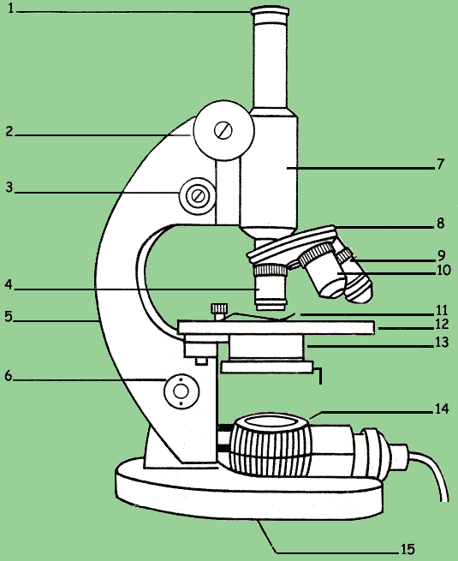

List the steps of using a microscope in your own words:

