Name this protein

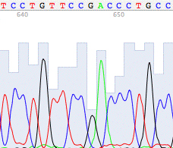

What is this asking? List only what you are told! | What information do we already know about this topic? (use background information to make connections!)
NTKS | NS ( how do you think we should solve)

