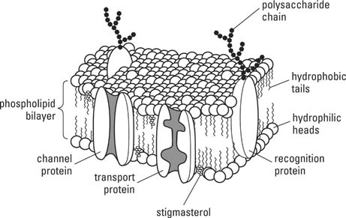

Name | # | Function
Phosphate | 1
Lipid | 2
Layer 1 & 2 | 3
Cytoplasm | 4
Enzymes | 5
Surface Marker | 6
Transport protein  Channel & Carrier | 7

