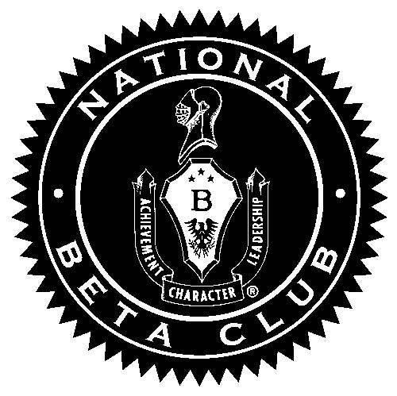
Beta Club
2017-2018
Welcome to a new year with Beta!

Stay connected, with Remind!
Text @215e10c1cf to 81010 for Beta Club reminders.

Requirements for this year:
- To be invited, you had to have a 4.0 GPA
- To remain a member, you must have a 3.75
- You must attend 7 of the 9 scheduled meetings
- You must turn in 15 service hours

Dates for this year:

September 26: Meeting (all members)- 3:30 in auditorium

October 2-5: Officer Voting
October 24: Meeting- 3:30 in auditorium
*First deposit for trip due ($50.00) along with health forms and permission slip

November 2: New Members Induction Ceremony
November 28: Meeting- 3:30 in auditorium
*Second payment for trip due ($50.00)

December 19: Meeting- 3:30 in auditorium

January 23: Meeting- 3:30 in auditorium
*Final payment ($60.00)

February 9-11: Beta Club Convention in Myrtle Beach
February 20: Meeting- 3:30 in auditorium

March 27: Meeting- 3:30 in auditorium

April 24: Meeting- 3:30 in auditorium

May 15: Meeting- 3:30 in auditorium
May 18: Last day to turn in service hours

