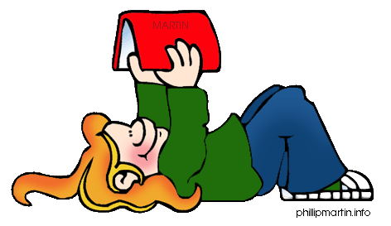

Dear Student,
You are invited to join Crockett County Middle School’s Summer Reading adventure! Summer is a great time to relax and enjoy the magical world of reading. To be a participant in the CCMS 201 Summer Reading Program, just follow some simple guidelines during summer vacation:
- Read a minimum of three books that you have not previously read. Of course, reading more than three books is encouraged! These books should be on an appropriate reading level and are your choice.
- One of the three books must be a “School Pick.” See below for the choice of School Picks.
- As soon as possible after you finish reading each book, take an Accelerated Reader test and score a minimum of 80%.
The AR tests may be taken during the summer at the Crockett County Memorial Library, or you will be given an opportunity during the first week of school in August to test on your summer reads. An event will be held in the fall for students who have completed the above criteria. You will participate in activities and discussion that pertain to the particular School Pick that you chose.
The School Picks may be obtained in several ways. You may check out the book from the public library, or you may purchase your own book from a bookstore. The School Picks selection is below, with a brief summary
of each book, as well as the reading information.
We hope you will join us for a summer of great reads!
--------------------------------------------------------------------------------------------------------------------------

______Rain Reign by Ann Martin RL 4.3 PTS 5.0
Struggling with Asperger's syndrome, Rose shares a bond with her beloved dog, but when the dog goes missing during a storm, Rose is forced to confront the limits of her comfort levels, even if it means leaving her routines in order to search for her pet.

_____A Snicker of Magic by Natalie Lloyd RL 4.7 PTS 10.0
The Pickles are new to Midnight Gulch, Tennessee, a town which legend says was once magic--but Felicity is convinced the magic is still there, and with the help of her new friend Jonah the Beedle she hopes to bring the magic back.

_____The Night Gardener by Jonathan Auxier RL 4.9 PTS 12.0
Irish orphans Molly, fourteen, and Kip, ten, travel to England to work as servants in a crumbling manor house where nothing is quite what it seems to be, and soon the siblings are confronted by a mysterious stranger and secrets of the cursed house.

