West TN All Star Cheerleaders
Team Assignments

Practice your cheers using your team name and color.

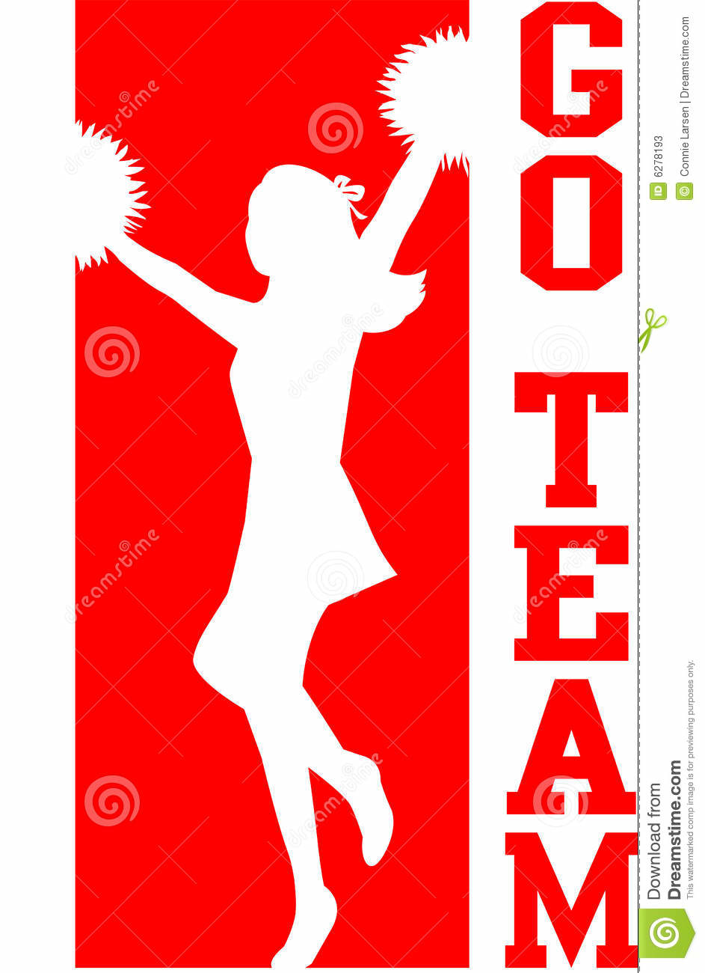
Team North – Red
- Mercedes Scott
- Haylee Petty
- Ashley Pugh
- Sydney Garner
- Kaite Converse
- Madison Brown
- Rianna Farnetti
- Adriana Milholen
- Abbey Fulcher

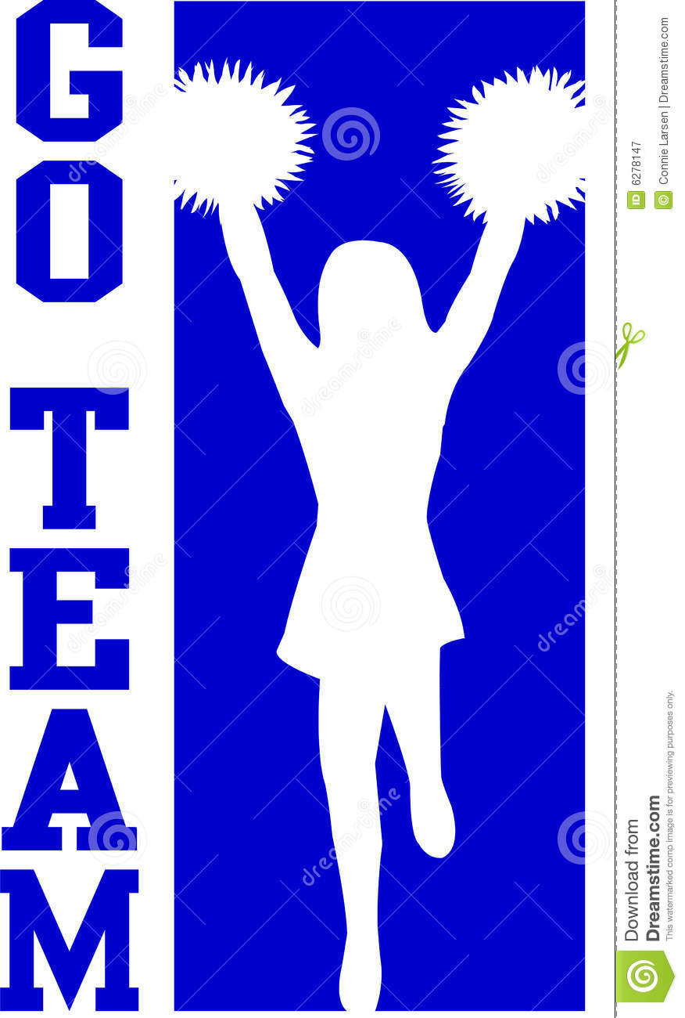
Team South – Blue

- Emily Eades
- Mikayla Strayhorn
- Jessica Ross
- Lakia Moore
- Brittany Goodman
- Haylee Pannell
- Hailey Tole
- Avery Gardner
- Maddie Sills

