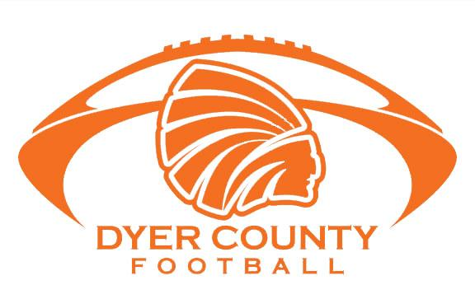

### Session 1: June 8th & 9th

### 8:30 am – 11:00 am

### Entering grades 3rd -5th ONLY

### Session 2: June 10th & 11th

### 8:30 am – 11:00 am

### Entering grades 6th – 8th ONLY

Attn: Rob Phillips

1000 West Main Street  
Newbern, TN, 38059

dchs.dyercs.net

Dyer County High School

**Where will camp take place?**

Everything will take place at Choctaw Stadium near the rear of the school. Sign-in and sign-out will be in the breezeway of the stadium every day starting at 8:30. Sign-out will begin at 11:00 In case of rain, we will move to the main entrance of the school.

**What should my child wear?**

Please come wearing shorts, a T-shirt, and tennis shoes. Bring cleats in hand in case they need to change to go indoors or outdoors due to weather.

**What else is provided?**

Water or Gatorade will be readily available for all athletes throughout the morning. All of our drills will be designed to be non-contact so no equipment is needed.

**Who will be coaching my child?**

The camp staff will include current coaches at DCHS. A few current and/or former players may also assist.

* Individualized Positive Instruction
* Talks on topics important to today’s student athlete
* Division of groups by age
* Camp T-shirt

Cost is $50 per camper. Families with 2 or more siblings attending will be $45 per camper.

Please turn in registration by June 1st. However, walk-ups are welcome!

Please detach the application and mail to the following address with cash or check payable to Dyer County Football.

# Q & A

Dyer County

High School

## Camp Features

Choctaw

Football

Camp

2015

Name: ____________________________

Address: __________________________

__________________________________

Date of Birth: ______________________

Grade Entering: ____________________

Parent/Guardian: ___________________

Home Phone: ______________________

Work Phone: _______________________

Shirt Size (Circle): YL S M L XL

**In case of serious accident or illness, I authorize the school to take emergency measures to protect my child. I request the school to contact me. If the school cannot reach me, I hereby authorize the school to call the physician listed below and follow his/her instructions. I do waive Dyer County High School, its representatives, and/or assigns, from any and all liability or claims arising from this camp.**

Parent Signature: ____________________

Date: ______________________________

Physician Name: ____________________

Physician Number: __________________

## Football Camp Application

Choctaw Football Camp is a camp designed for beginning athletes, as well as those with a basic knowledge of the game. Expert instruction of the basic skills of offensive and defensive football will be given for those entering grades 3rd – 8th in the fall of 2015.

Campers will go through the same stretching routine as our varsity team to show the importance of flexibility and coordination in the game of football. Your child will also receive basic instruction in the art of weight training to understand the proper techniques and fundamentals to improve their understanding of safety in the weight room.

Dyer County prides itself in running the “Tony Franklin Spread” system on offense. We will teach your child the proper skills needed to succeed in our offense. Each camper will receive individual instruction featuring passing, receiving, running, and blocking to help better their skills for junior-pro, middle school, and eventually the high school level.

Football is a team game, and each athlete will be required to run drills in a group setting. This will help individuals learn to cooperate with others, as well as build relationships that will last beyond their football playing years.

If you would like any more information, or have any questions, feel free to email us at rphillips@dyercs.net, or call 615-477-9266. We look forward to seeing your child this summer at Choctaw Football Camp!

# About Choctaw Football Camp: