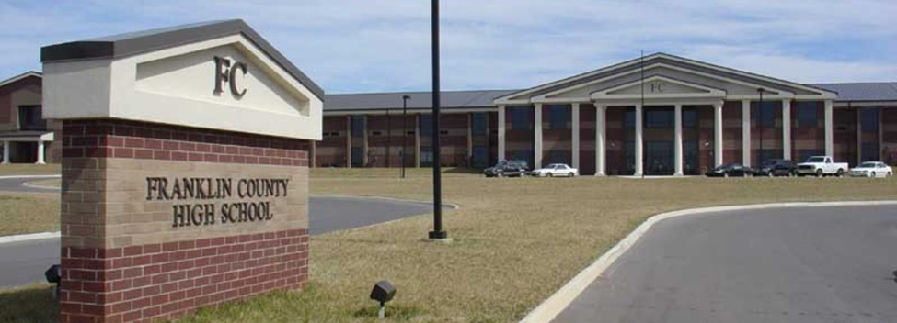

Academic and Technical Skills

Work-Based Learning

College and Career Readiness

Leadership and 21st Century Skills
Vision:
To motivate students to deeper sTudies and keeping them focused on graduating high school; students of all racial and socioeconomic backgrounds will be skilled and prepared for pursing careers in professional, technical, or vocational areas. Guiding values of self-discipline, community, high standards, and perseverance will be emphasized.
CTE OPEN HOUSE
Franklin County HS
March 11, 2019

6:00 p.m. to 8:30 p.m.
Come Out and Meet OUR Teachers While Learning About Career and Technical Programs Available in YOUR County
- Accounting I, II
- Agricultural Science
- Anatomy & Physiology
- Audiovisual Productions
- Auto Mechanics
- Automotive/Collision Repair/Body Shop
- Business Communications
- Clinical Internship
- Computer Applications
- Construction/MEP
- Cosmetology
- Criminal Justice I, II, III
- Cybersecurity I, II
- Emergency Medical Services

- Family Studies
- Foundation-Computer Science
- Fundamentals of Education
- Greenhouse/Horticulture
- Health Science
- Human Services
- Intro.- Business & Marketing
- Machine Shop
- Mechatronics
- Medical Therapeutics
- Nursing Ed. (C.N.A.)
- Rehabilitation Careers
- STEM
- Veterinarian & Animal Science
- Welding I, II, III
- Work-Based Learning/Nissan

FCHS ~833 Bypass Rd. ~Winchester, TN 37398
Doors open at 6:00 p.m. March 11th
Upcoming 9th Grade Parent Meeting
Regarding Freshman Registration @ 6:30 p.m.
Auditorium, Back Parking Lot Entrance

Made by Antonio Ashley 12th grade Business Management Student
Questions??
Contact:
CTE Director: Diana Spaulding
Diana.spaulding@fcstn.net
(931) 967-0626

