North Middle
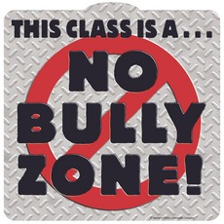
Rules About Bullying
- We will not bully others.

- We will try to help students who are bullied.

- We will try to include students who are left out.

- If we know that someone is being bullied, we will tell an adult at school and an adult at home.

