Classroom Supplies

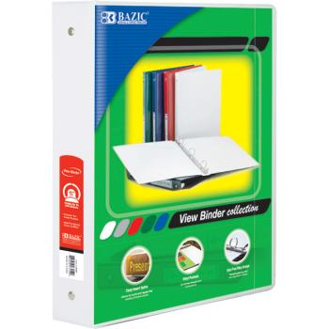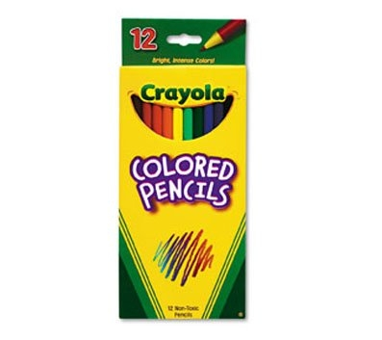
(4) Three Ring Binders Insertable Tab Dividers Colored Pencils
(One 2” and three 1 ½“) (4 packs of 5) (1 box)

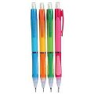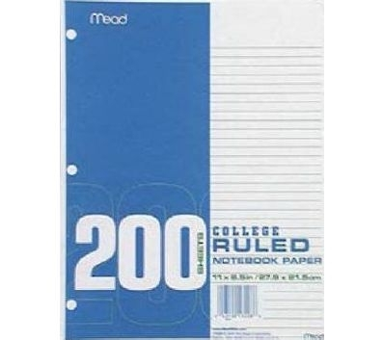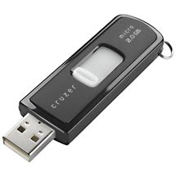
Optional
Flash Drive
Pencils/ Erasers Loose Leaf Paper
(Wooden or Mechanical) (College Ruled)

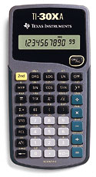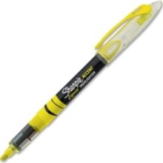
Protractor
Highlighter
Optional
TI 30XA

Optional Supplies
1 Box of Kleenex Tissues, 1 Roll of Paper Towels, and 1 Container of Clorox Wipes.

