Jump-Start Kindergarten
at
Joppa School
Begins March 9, 2020 at 6:00 p.m.
Kindergarten Registration will be March 19, 5:30-6:30
There will be 3 additional meetings March 17th, 24th, and 26th
Please plan to attend these meetings with your child
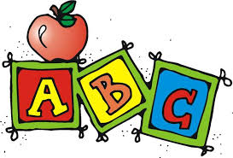
For children who will be entering Kindergarten at Joppa School during the 2020 – 21 school year.
(turning the age of 5 on or before August 15, 2020)
For more information, please call (865)828-5721
The Grainger County Board of Education does not discriminate on the basis of age, race, color, creed, religion, national origin, marital status or disability in the operation of its educational programs and activities including employment practices.

