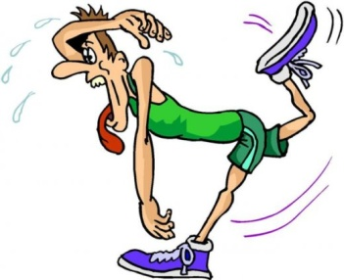2016 APISON ELEMENTARY CROSS-COUNTRY TEAM

SOFIA LIMA
EMMA CRANE
KAMI CUTLER
LAILA REED
HAYLEE WAGES
IZZI MATTHEW
MADI FLEMING
BRENNAN ECKERT
JOSIAH ELLINGTON
JACK PENDLETON
RYAN SPENCER
LANDON TURNER
BRADEN WILSON
BLAKE KILGORE
YOSHIO MAYER
JACK MAUSER

KENDALL OLSON
GEORGIA DOBSON
ELLA GRACE LAZENBY
EVA MAXWELL
ANNABELLE GOSS
DALLAS HOGAN
ADDISON CHASTAIN
MORGAN PRICHARD
CALEB GRISWOLD
CANNON CHRISTENSEN
REID CONLEY
NICHOLAS THOMPSON
DAVIS WHITENER
HAYDEN SARCHET
ELI JOHNSON
BEAU RATCHFORD

JENNA MIZE
SIYEON MUN
MIA CUTLER
MONICA TRUJILLO
CADYN CAHILL
CHLOE SHANNON
LUCIA CONNOR
MAGGIE RICKERD
BRIDGER CHRISTENSEN
NATHAN ALCOCK
MADDOX SEAL
CANNON FAUER
MADDOX BOHANON
SAM RIDDLE
JACK WHITENER
CONNOR SHANNON
LIAM WISE
DYLAN PETERSEN

