Name___________________________ Date_______________________

Introduction

What was the European Renaissance?

The word “Renaissance” means “rebirth”. “Rebirth” is when something is reborn - it used to exist, and now it’s back. In the European Renaissance, the thing that was reborn was cultural advancement similar to Ancient Greece and Rome, like math, science, medicine, art, literature, philosophy, and architecture. But why was Europe not advancing before this time?

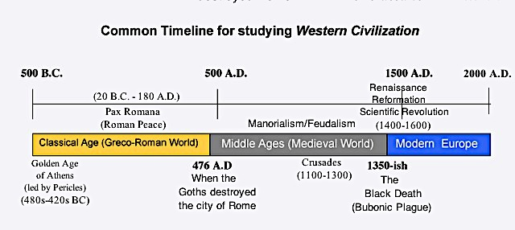

Vocabulary – while reading, define these words whenever you see them show up.

Fall of Rome:
Goths:
Catholic Church:
Byzantine Empire
Muslim Caliphate:
Islamic Golden Age:
Pope Urban II:
Crusades:
Jerusalem:
Italian City-States:
Commercial Revolution:
Guild:
Hanseatic League:
Ottoman Empire:
Renaissance:
Scientific Revolution:
Protestant Reformation:
Chapter 1

From the Classical Age (Greco-Roman World) to The Middle Ages (Medieval World)

When the Goths invaded Rome in the 400s, they destroyed cities, schools, libraries, and government buildings. The fall of Rome in the 400s meant that most Western Europeans could not learn to read or write and there was no central government protecting merchants, building roads, or enforcing laws, so trade declined. The only powerful institution was the Catholic Church. Since most manors had a church, that’s where people got knowledge. The priest would tell people what to believe, and they accepted it. Only priests or monks could read and write – in Western Europe there weren’t scientists, lawyers, doctors, bankers, or writers. Most people lived their whole lives in a small town or manor, owned by a lord, and protected by a group of knights. It was definitely not lit. It was dark.

Nearby civilizations that had education, trade, science, and inventions were not in Western Europe. In Eastern Europe, the Byzantine Empire (the half of Rome that didn’t fall) was one place. And starting from Spain and then stretching across North Africa, the Middle East, and Persia, the Muslim Caliphates were the other places. Muslims and Byzantines preserved Greco-Roman books and ideas, but also made their own discoveries in science, medicine, and engineering, and traded across Africa and Asia. For Muslims, this was the Islamic Golden Age. They were crushing it. For example:

- Ibn al-Haytham’s Scientific Method of question, observation, and experiment to solve problems.
- Ibn al-Haytham’s experiments and proving Greek theories of light, vision, and eye sight
- Muhammad al-Khawarizmi developing algebra to calculate math when a variable is not known
- Improving the astrolabe, a Greek invention to measure longitude, latitude, and positions of the sun, moon, & stars
- Al –Zahrawi (from Muslim Spain) writing about medicine, anatomy, surgery, and inventing dozens of medical tools for doctors
- Universities that gave degrees to students in Egypt, Baghdad (Iraq), and Mali

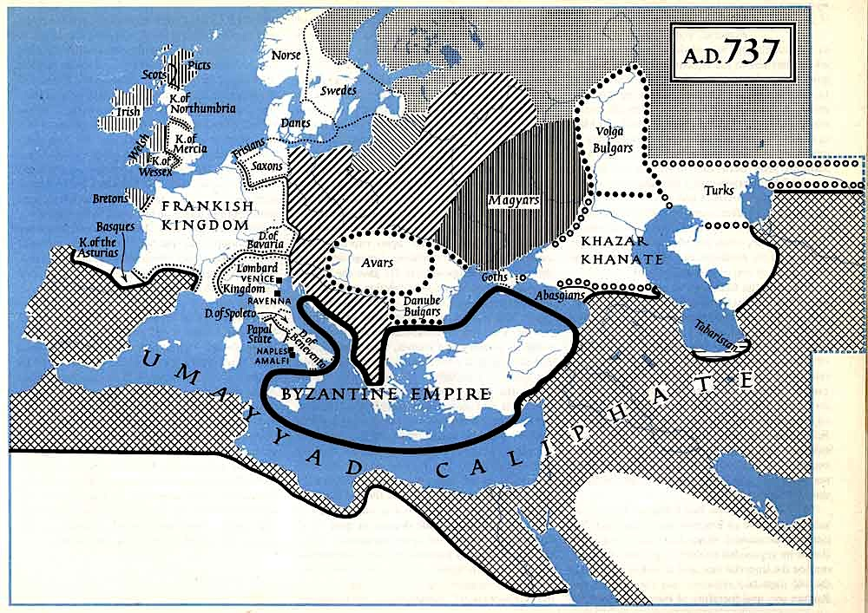
Chapter 2

How Europe emerged from the Medieval Age: The Crusades and Commercial Revolution

In 1095, Pope Urban II called for a Crusade (a holy war). The purpose was for European Christians to conquer the holy city of Jerusalem - in the Middle East - from the Muslims who controlled it. Thousands of Europeans obeyed the Pope (and God, they thought) and left their towns and manors to go fight. They actually won at first, by murdering every Jew and Muslim in Jerusalem (40,000 people) and then controlled it for the next 90 years. But Muslim armies invaded and took it back, and no matter how many more Crusades the Christians fought, they kept losing. But some of these Europeans from Italian city-states like Venice and Genoa who shipped people to the holy land began trading with the Muslims, to make money on these trips. This trade grew more profitable and over years developed into a Commercial Revolution in Europe. Europeans were trading again! Rich nobles created banks to give loans to people as investments, groups of workers who made the same products formed guilds (so they follow similar rules, measurements, and prices for their products) and Europe was back in the game, son! The Commercial Revolution was making sweet cash money for the Italian city-states.

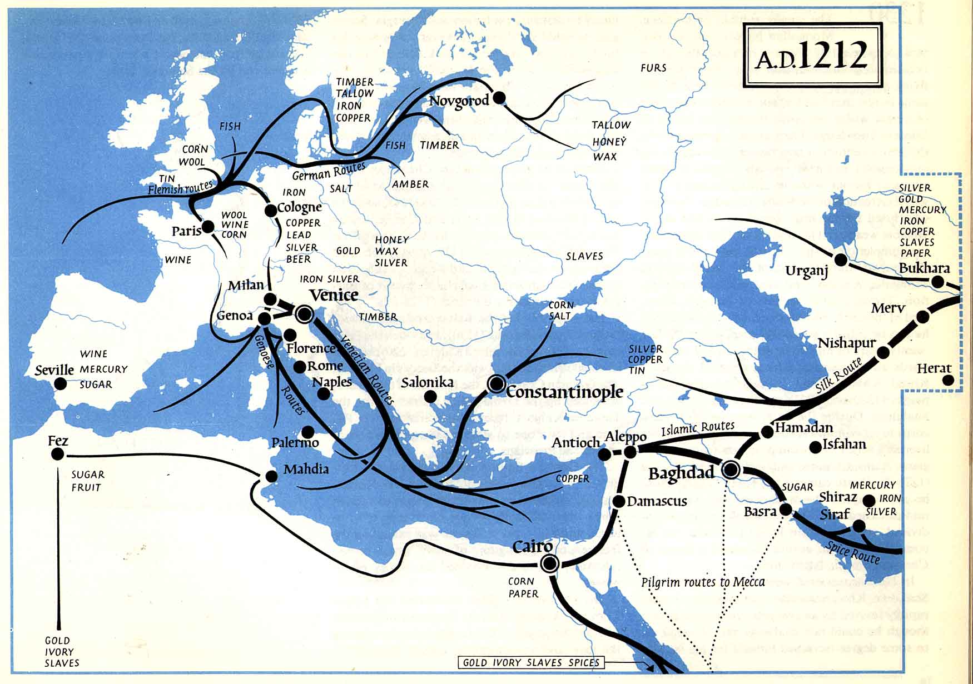

With the merchants of Venice, Genoa, Florence, Pisa, and Rome making fat stacks in the 13th and 14th centuries, they started buying art, books, education for their kids, larger houses, better food and clothes - and where did they get these ideas and products from? Muslims! Italians started seeing and buying Muslim, Indian, and Chinese products, while also reading Greek and Roman literature and art. All this cultural advancement in Europe created jobs for people who could move to cities and find work. And this was almost the start of the Renaissance (some scholars call it the Renaissance of the 12th century). But then the Bubonic Plague hit Europe in 1347. It was carried by rats (who were in boats and caravans of merchants moving along Mongol trade routes). But fleas were actually the ones who transmitted the plague to humans. In Europe, it was so bad that it became known as the Black Death. From 1347 to 1351, over 1/3 of Europe’s population was killed by this epidemic disease.
Chapter 3

The Effects of the Black Death and the Resurgence of Europe in the Renaissance

By the 1400s, the spread of the Bubonic plague had changed the world. The Mongols lost their empire, the Chinese Ming Dynasty rose to power and dominated East Asian trade, the Ottoman Empire established a new Muslim caliphate in the Middle East, and the Songhai Empire in West Africa conquered Mali. In Europe, the survivors of the Black Death had new reasons to appreciate life and live it to the fullest. Thousands of peasants left their tiny manors and moved to towns and cities looking for better paying work. Some got jobs of people who had died. Some found work making products to export or working for merchants who began trading again. The most successful merchants were in Italian city-states (who traded with Muslims) and also in Northern European city-states that were on the coast of the North Sea and Baltic Seas. Those city-states had formed a group called the Hanseatic League, so Italians now had even more trading partners than before the plague.

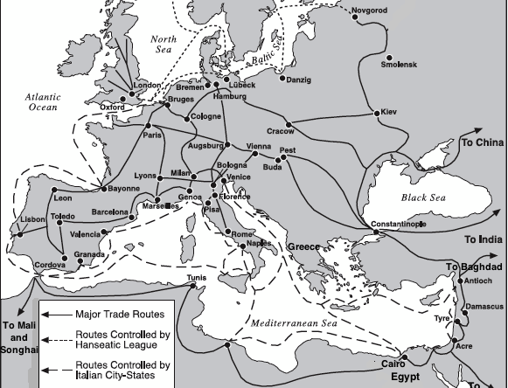

Lastly, in 1453 the Ottoman Empire conquered the Byzantine Empire’s capital, Constantinople. And all the scholars who had lived in Constantinople left, took Greek, Roman, Muslim, Persian, and Indian books with them, and went to Italian city-states. The Renaissance got its final shot of inspiration from all these new ideas. The Renaissance can be broken into three main movements.

1) The “Renaissance” usually means the revival of Greco-Roman styles of art, philosophy, architecture, and literature that Europeans copied and improved on. Because the Greeks and many Romans were not Christian, the Renaissance was partially a secular movement (not religious).

2) The Scientific Revolution was the period when European scientists like Nicolai Copernicus, Galileo Galilee, Isaac Newton, Rene Descartes, and Francis Bacon were learning from Muslim, Persian, and Indian scientists and making new discoveries in math, science, astronomy, and medicine.

3) The Protestant Reformation (1517-1648) when figures like Martin Luther, John Calvin, and Henry VIII protested and reformed the Catholic Church, but ended up creating new types of Christianity.

