8th Grade Science is a high school level, “Physical Science” course and does average into the student’s high school G.P.A. There is no longer an end of course test from the state; it was discontinued about four years ago. In the past 8th graders have been exempted from taking the 8th grade science T-CAP.

Teacher: Jim Hunt
Email hunt_jim@hcde.org

Grades
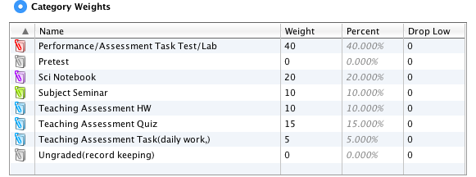

Tutoring available, Morning: Monday, Thursday and Friday from 8:15 – 8:45 AM After school: Tuesday & Thursday 4:00 – 5:00 PM

Lab reports are due one week after we complete the lab. I will proof the labs but they must be turned in two days before the due date. Ten points per day will be deducted after the due date for three days. After day three I will not take the papers. Labs must be printed and turned in to me. Electronic problems with computers or printers are not excuses for late work. Printing is available in the library for 10 cents per page.

There is no extra credit with the exception of bonus points on lab reports for the research section with proper M.L.A. formatting and bonus questions on chapter tests when given.

