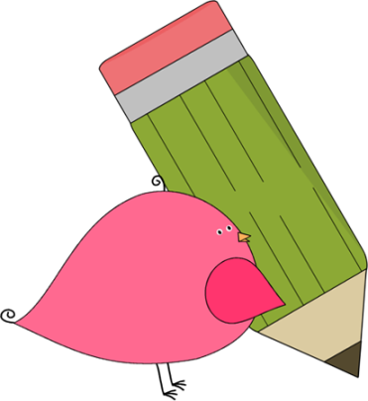

First Grade

News

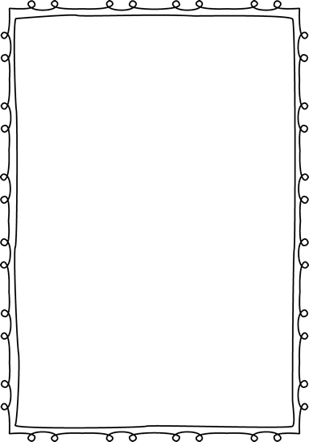

**Reminders:**

COUPON BOOKS are for sale! They cost $10 and our school gets to keep $7 per book. (If you send in money, please write a note stating that the money is for coupon books).

Children need to wear close toed shoes every day for recess and P.E.!

If you have not already paid your child’s school supply fee, you may pay

any time! The fee is $20 and you

can pay in cash, check, or online.

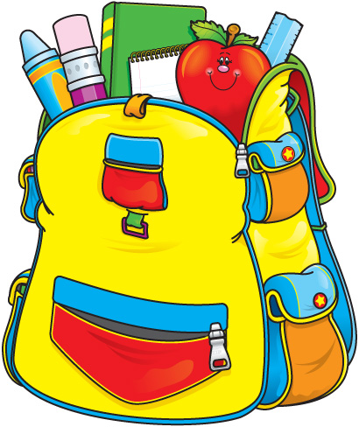



**Contact Information:**

If you have any questions, feel free to write a note, call and leave a message at the office, or email. We will get back to you as soon as possible!

Ms. Murray: [Murray_Jen@hcde.org](mailto:Murray_Jen@hcde.org)

Mr. Descalzo: [Descalzo_D@hcde.org](mailto:Descalzo_D@hcde.org)

Miss Burns: [Burns_M@hcde.org](mailto:Burns_M@hcde.org)

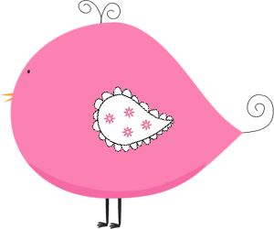

Important Dates and Upcoming Events:



No School

Friday, October 7th

Fall Break

October 10th-14th

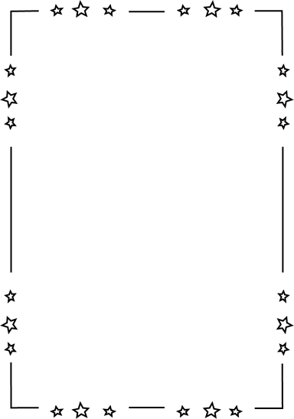



Read for at least 20 minutes every night!

C:\Documents and Settings\Jac\Local Settings\Temporary Internet Files\Content.IE5\OGYR678X\MC900391164[1].wmf