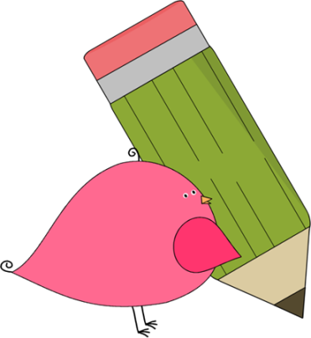

First Grade

News



**Reminders:**



Our 1st Field trip is scheduled for Tuesday, November 1st. We would like for all of the 1st graders to wear the light blue DuPont dolphin shirt. If your child does not have a shirt, please consider purchasing one from the PTA. Kid’s sizes are $5! You can send the money to your child’s teacher. Please write that the money is for a shirt and put what size you want. Chaperones are also encouraged to purchase a shirt. Adult sizes

are $8. Thank you for your

support!



**Contact Information:**

If you have any questions, feel free to write a note, call and leave a message at the office, or email. We will get back to you as soon as possible!

Ms. Murray: [Murray_Jen@hcde.org](mailto:Murray_Jen@hcde.org)

Mr. Descalzo: [Descalzo_D@hcde.org](mailto:Descalzo_D@hcde.org)

Miss Burns: [Burns_M@hcde.org](mailto:Burns_M@hcde.org)



Important Dates and Upcoming Events:

*No School: Friday, Oct. 7th

*Fall Break: Oct. 10th-14th

*Report Cards & (K-2)Awards Assembly: Oct. 21st @ 2:15

*Book Fair: Oct. 24th-28th

*Conferences: Oct. 25th (3:30-7:00)

*(K-2) Goodies with Grandparents: Oct. 27th





Read for at least 20 minutes every night!

C:\Documents and Settings\Jac\Local Settings\Temporary Internet Files\Content.IE5\OGYR678X\MC900391164[1].wmf