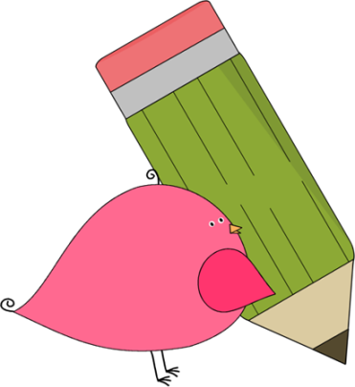

Kindergarten

Weekly News

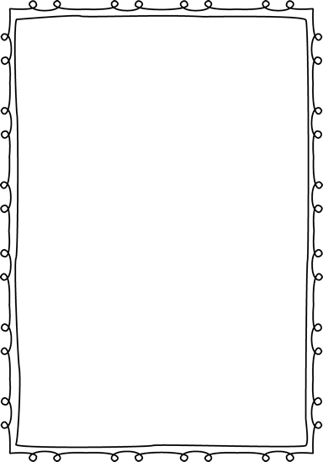

**Reminders**

Please put an extra pair of clothes inside your child’s book bag in case there are any accidents.

If you send in any money, please write a note stating what the money is for. Please send in ice cream money only on Fridays.

Children need to wear close toed shoes every day for recess and P.E.!

If you have not already paid for your child’s school supply fee, you may pay

any time! The fee is $20 and you

can pay in cash, check, or

online!



**Announcements**

Welcome back to school! We are excited to start the school year with your child! Your child will have an amazing year becoming a reader, writer, and mathematician! If you ever have any questions, feel free to write a note, call and leave a message at the office, or email. We will get back to you as soon as possible!

Ms. Murray: murray_jen@hcde.org

Ms. Johnston: [Johnston_dena@hcde.org](mailto:Johnston_dena@hcde.org)

Mrs. Ludwick: Ludwick_r@hcde.org

Mrs. Slaughter: [slaughter_arlene@hcde.org](mailto:slaughter_arlene@hcde.org)



Important Dates and Upcoming Events:

Open House

Tuesday, August 23rd

6:00-7:15 p.m.

Pizza and drinks will

be provided☺



**Weekly words**

Your child will soon be working on sight words. Please practice the sight words every night!

C:\Documents and Settings\Jac\Local Settings\Temporary Internet Files\Content.IE5\OGYR678X\MC900391164[1].wmf