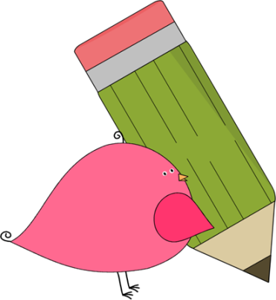

Kindergarten

Weekly News

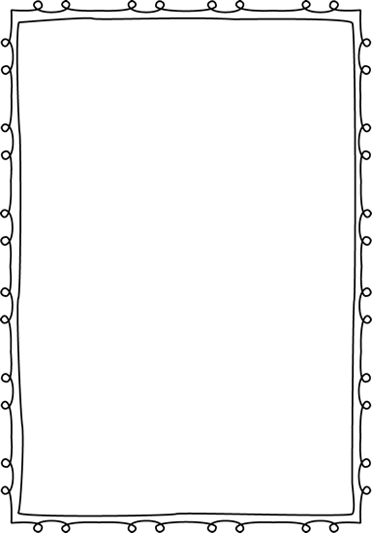

**Reminders**

**Please put an extra pair of clothes inside your child’s book bag in case there are any accidents.**

If you send in any money, please write a note stating what the money is for. Please send in ice cream money only on Fridays.

Children need to wear close toed shoes every day for recess and P.E.!

If you have not already paid for your child’s school supply fee, you may pay

any time! The fee is **$20** and you

can pay in cash, check, or

online!

**We will be sending a note home about our homework policy. Please check your child’s folder for the note.**



**Announcements**

Your child will be given a lunch number to use when they eat at school. We will be sending home a lunch number sheet for your child to practice “punching in” the number. It is important for your child to remember his/her number! This allows the lunch line to go faster and for Mrs. Sain to easily identify your child.

Contacts:

Ms. Murray: murray_jen@hcde.org

Ms. Johnston: Johnston_dena@hcde.org

Mrs. Ludwick:ludwick_r@hcde.org

Mrs. Slaughter: slaughter_arlene@hcde.org



Important Dates and Upcoming Events:

September 5th

Labor Day

No school

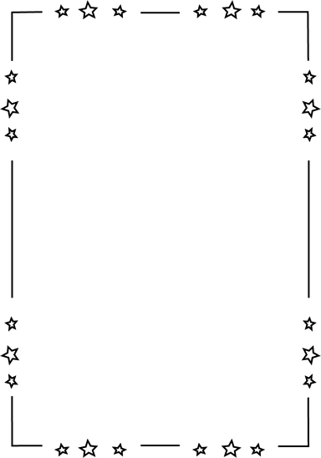

**Weekly words**

**can see**

Please practice these words with your child! You can practice spelling it and putting it in a sentence.

C:\Documents and Settings\Jac\Local Settings\Temporary Internet Files\Content.IE5\OGYR678X\MC900391164[1].wmf