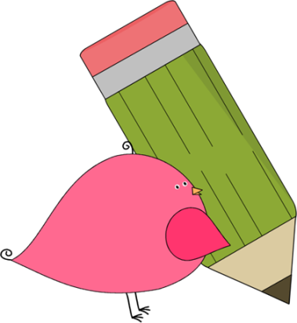

Kindergarten

Weekly News

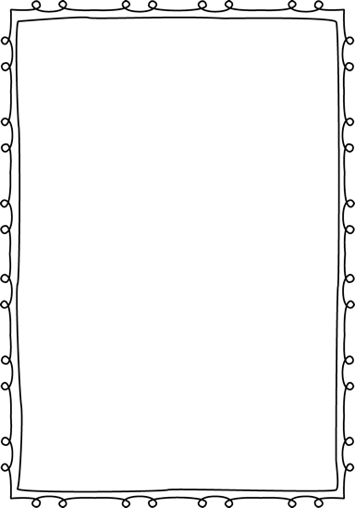

**Reminders**

Now that the weather is getting cooler, please send a jacket with your student every day for recess and PE.

**Please put an extra pair of clothes inside your child’s book bag in case there are any accidents!**

If you send in money, please write a note stating what the money is for. Please send in ice cream money only on Fridays.

**Children need to wear tennis shoes EVERY day for recess and P.E.!**

Please make sure that you are reading with your child every night!



**Announcements**

Contacts:

Ms. Johnston: johnston_dena@hcde.org

Mrs. Ludwick:ludwick_r@hcde.org

Mrs. Slaughter: slaughter_arlene@hcde.org

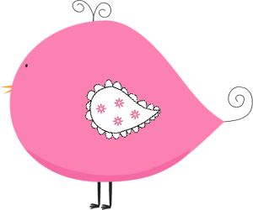

Important Dates and Upcoming Events

December 19-January 3:

NO SCHOOL!

Students return January 4, 2017!



**Weekly words**

**play you**

Please practice these words with your child! You can practice reading it, writing it and putting it in a sentence.

C:\Documents and Settings\Jac\Local Settings\Temporary Internet Files\Content.IE5\OGYR678X\MC900391164[1].wmf