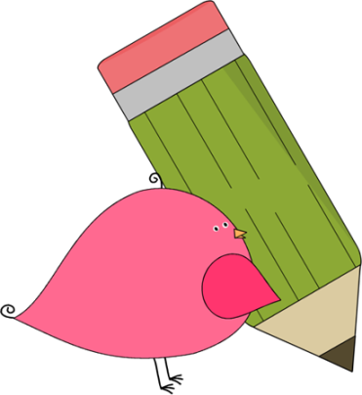

Kindergarten

Weekly News

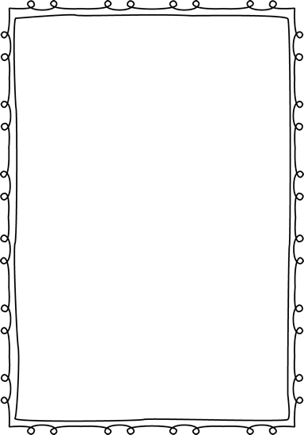

**Reminders**

**Please put an extra pair of clothes inside your child’s book bag in case there are any accidents!**

If you send in money, please write a note stating what the money is for. Please send in ice cream money only on Fridays.

**Children need to wear tennis shoes EVERY day for recess and P.E.!**

Remember, if your child wants to eat breakfast, he/she must come before 8:10!

The cafeteria door closes at 8:10.

**Please make sure that you are reading with your child every night!**

**If your child does not know his/her lunch number yet please continue to practice.**



**Announcements**

**This week is Red Ribbon Week! Students are encouraged to follow the dress up schedule to bring awareness to the importance of a healthy lifestyle.**

**(See attached schedule)**

Contacts:

Ms. Johnston: johnston_dena@hcde.org

Mrs. Ludwick:ludwick_r@hcde.org

Mrs. Slaughter: slaughter_arlene@hcde.org

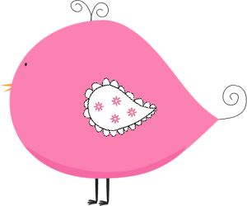

Important Dates and Upcoming Events:

**October 24-28: Book Fair and Red Ribbon Week**

**October 25:**

**Parent/Teacher conferences**

**October 26:**

**“Goodies with Grandparents” for K-2. Grandparents are welcome to bring their student to the book fair and enjoy a treat together!**



**Weekly words**

**up we**

Please practice these words with your child! You can practice reading it, writing it and putting it in a sentence.

C:\Documents and Settings\Jac\Local Settings\Temporary Internet Files\Content.IE5\OGYR678X\MC900391164[1].wmf