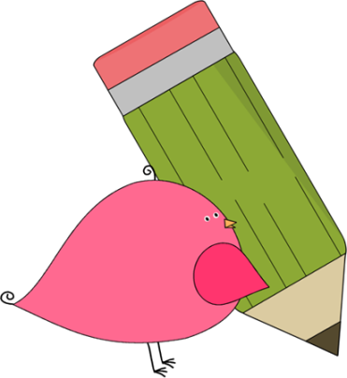

Kindergarten

Weekly News



**Reminders**

Now that the weather is getting cooler, please send a jacket with your student every day for recess and PE.

**Please put an extra pair of clothes inside your child’s book bag in case there are any accidents!**

If you send in money, please write a note stating what the money is for. Please send in ice cream money only on Fridays.

**Children need to wear tennis shoes EVERY day for recess and P.E.!**

Remember, if your child wants to eat breakfast, he/she must come before 8:10!

The cafeteria door closes at 8:10.

**Please make sure that you are reading with your child every night!**

**If your child does not know his/her lunch number yet please continue to practice.**



**Announcements**

**Thursday, November 3 will be our Math Night at 6:00!**

**Please plan on attending so you can learn different ways to help your student at home!**

Contacts:

Ms. Johnston: johnston_dena@hcde.org

Mrs. Ludwick:ludwick_r@hcde.org

Mrs. Slaughter: slaughter_arlene@hcde.org



Important Dates and Upcoming Events:

November 3 – Math Night at 6:00!

November 11 – Progress Reports

go home

November 11-30 – PTA fundraiser

(America’s Finest Chocolate)

November 23-25 – NO SCHOOL!

Thanksgiving Break



**Weekly words**

**he in**

Please practice these words with your child! You can practice reading it, writing it and putting it in a sentence.

C:\Documents and Settings\Jac\Local Settings\Temporary Internet Files\Content.IE5\OGYR678X\MC900391164[1].wmf