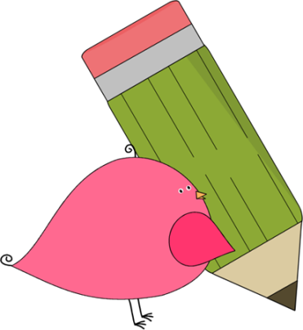

Kindergarten

Weekly News

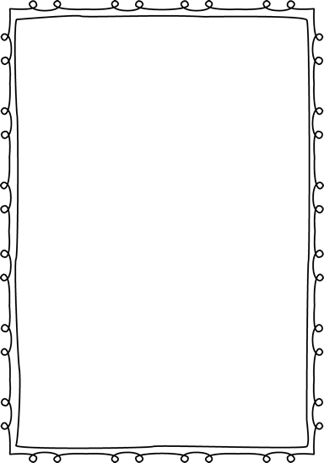

**Reminders**

**Please put an extra pair of clothes inside your child’s book bag in case there are any accidents.**

If you send in any money, please write a note stating what the money is for. Please send in ice cream money only on Fridays.

**Children need to wear tennis shoes every day for recess and P.E.!**

Remember, if your child wants to eat breakfast, he/she must come before **8:10**! The cafeteria door closes at **8:10**!

**Please have your child work on his/her**

**lunch number! We sent a lunch sheet home for them to practice.**



**Announcements**

Field trip form and money were due today, October 3rd. If you have not paid, please send in the form and the **exact** amount of $14.00 **tomorrow!**

Contacts:

Ms. Johnston: Johnston_dena@hcde.org

Mrs. Ludwick:ludwick_r@hcde.org

Mrs. Slaughter: slaughter_arlene@hcde.org

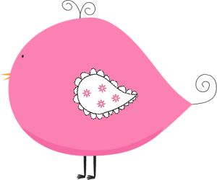

Important Dates and Upcoming Events:

Fall break is coming up. Please continue to work on letters, beginning sounds, and your child’s name over the break. We need **ALL** students to know at least 35 letters after fall break!

October 6th – Old McDonald Farm field trip

October 7th – NO SCHOOL

October 10th-14th – FALL BREAK

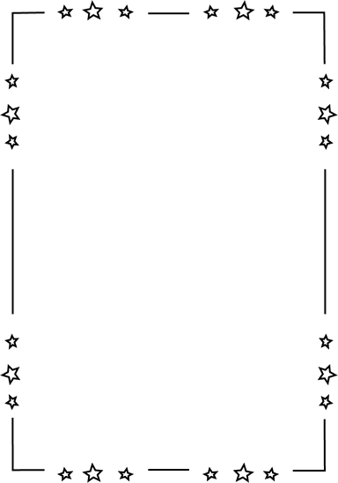

**Weekly words**

**go**

Please practice this word with your child! You can practice spelling it and putting it in a sentence.

C:\Documents and Settings\Jac\Local Settings\Temporary Internet Files\Content.IE5\OGYR678X\MC900391164[1].wmf