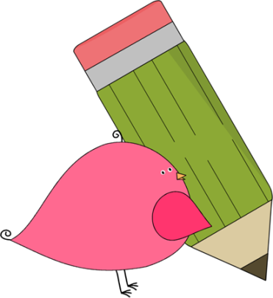

Kindergarten

Weekly News

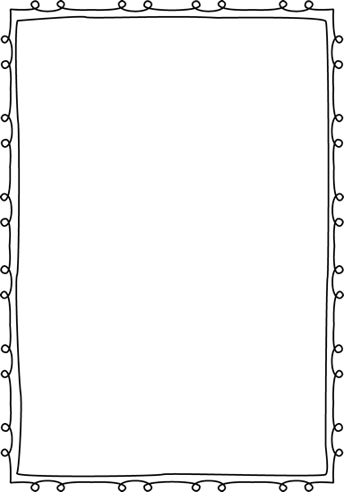

**Reminders**

**Please put an extra pair of clothes inside your child’s book bag in case there are any accidents.**

If you send in any money, please write a note stating what the money is for. Please send in ice cream money only on Fridays.

**Children need to wear tennis shoes every day for recess and P.E.!**

Remember, if your child wants to eat breakfast, he/she must come before **8:10**! The cafeteria door closes at **8:10**!

**Please have your child work on his/her**

**lunch number! We sent a lunch sheet home for them to practice.**



**Announcements**

Please know that when your child brings money in for ice cream or snack, we send the money to the cafeteria labeled with your child’s name. The money gets put into their lunch account. Mrs. Sain will ask if they want a snack throughout the week or ice cream on Fridays.

Contacts:

Ms. Johnston: Johnston_dena@hcde.org

Mrs. Ludwick:ludwick_r@hcde.org

Mrs. Slaughter: slaughter_arlene@hcde.org

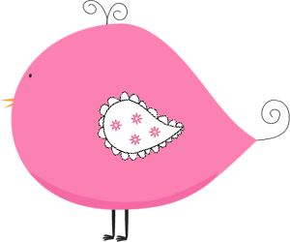

Important Dates and Upcoming Events:

**Coupon books are on sale now**! Please help us raise money for our school! Our goal is to have each student sell **1** coupon book! The coupon books are $10. Send the money in first, then we will send the coupon books home with your child!

We are working hard in Kindergarten! Please have your child practice writing his/her name and recognizing upper/lowercase letters! The students are doing an incredible job☺



**Weekly words**

**am, at**

Please practice these words with your child! You can practice spelling it and putting it in a sentence.

C:\Documents and Settings\Jac\Local Settings\Temporary Internet Files\Content.IE5\OGYR678X\MC900391164[1].wmf