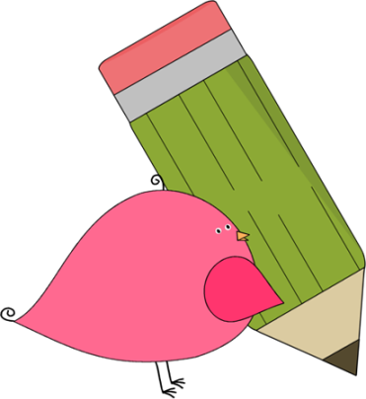

Kindergarten

Weekly News

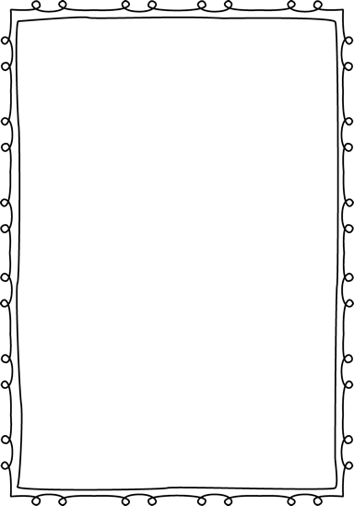

**Reminders**

**Please put an extra pair of clothes inside your child’s book bag in case there are any accidents.**

If you send in any money, please write a note stating what the money is for. Please send in ice cream money only on Fridays.

**Children need to wear tennis shoes every day for recess and P.E.!**

Remember, if your child wants to eat breakfast, he/she must come before **8:10**! The cafeteria door closes at **8:10**!

**Please have your child work on his/her**

**lunch number! We sent a lunch sheet home for them to practice.**



**Announcements**

**Coupon books are on sale now**! Please help us raise money for our school! Our goal is to have each student sell **1** coupon book! The coupon books are $10. Send the money in first, then we will send the coupon books home with your child!

**Coupon book sale ends on 9/26**!

Contacts:

Ms. Johnston: Johnston_dena@hcde.org

Mrs. Ludwick:ludwick_r@hcde.org

Mrs. Slaughter: slaughter_arlene@hcde.org

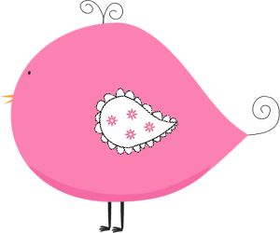

Important Dates and Upcoming Events:

We will be having a field trip on **October 6th** to the Old McDonald Farm. Please be on the lookout for your child’s permission slip!

Please keep working on letters, initial sounds, and sight words. They need to know all the uppercase and lowercase letters by **fall break**!



**Weekly words**

**like, to**

Please practice these words with your child! You can practice spelling it and putting it in a sentence.

C:\Documents and Settings\Jac\Local Settings\Temporary Internet Files\Content.IE5\OGYR678X\MC900391164[1].wmf