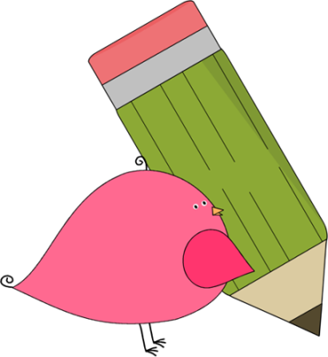

Kindergarten

Weekly News

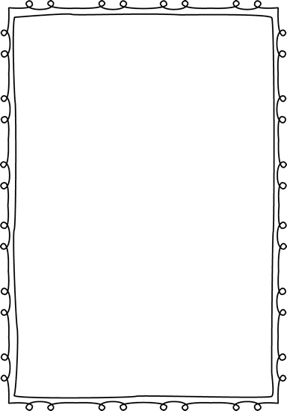

**Reminders**

**Please put an extra pair of clothes inside your child’s book bag in case there are any accidents.**

If you send in any money, please write a note stating what the money is for. Please send in ice cream money only on Fridays.

**Children need to wear tennis shoes every day for recess and P.E.!**

If you have not already paid for your child’s school supply fee, you may pay

any time! The fee is **$20** and you

can pay in cash, check, or

online!

**Please have your child work on his/her**

**lunch number! We sent a lunch sheet home for them to practice.**



**Announcements**

We are very excited to have new students in our room. The student numbers in Kindergarten were low, so Ms. Murray had to move grade levels to help out other grades whose numbers were high. We will miss Ms. Murray in Kindergarten, but hope the children she had will have an easy transition into his/her new room!

Contacts:

Ms. Johnston: Johnston_dena@hcde.org

Mrs. Ludwick:ludwick_r@hcde.org

Mrs. Slaughter: slaughter_arlene@hcde.org



Important Dates and Upcoming Events:

No important dates

Remember, if your child wants to eat breakfast, he/she must come before 8:10! The cafeteria door closes at 8:10!



**Weekly words**

**the**

Please practice this word with your child! You can practice spelling it and putting it in a sentence.

C:\Documents and Settings\Jac\Local Settings\Temporary Internet Files\Content.IE5\OGYR678X\MC900391164[1].wmf