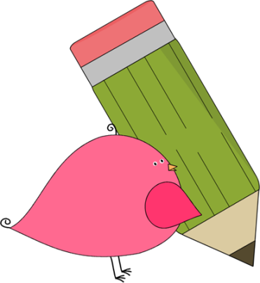

Kindergarten

Weekly News

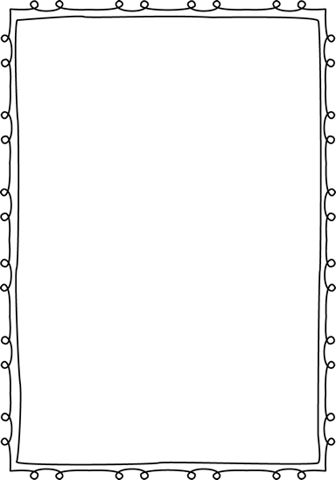

**Reminders**

**Please put an extra pair of clothes inside your child’s book bag in case there are any accidents.**

If you send in any money, please write a note stating what the money is for. Please send in ice cream money only on Fridays.

**Children need to wear tennis shoes every day for recess and P.E.!**

Remember, if your child wants to eat breakfast, he/she must come before **8:10**! The cafeteria door closes at **8:10**!

**Please have your child work on his/her**

**lunch number! We sent a lunch sheet home for them to practice.**



**Announcements**

The students are working real hard in Kindergarten! Please continue to work on your child’s name, letters, letter sounds, and sight words! We want **ALL** students to know **all** letters and sounds by fall break!

Contacts:

Ms. Johnston: Johnston_dena@hcde.org

Mrs. Ludwick:ludwick_r@hcde.org

Mrs. Slaughter: slaughter_arlene@hcde.org

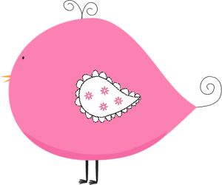

Important Dates and Upcoming Events:

We sent home permission slips for our field trip on **October 6th**. Please make sure you sign and return the field trip form along with the $14.00 by October 3rd.

October 7th – NO SCHOOL

October 10th-14th – FALL BREAK

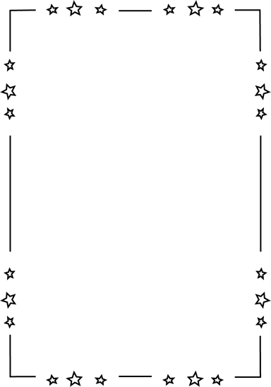

**Weekly words**

**is,me**

Please practice these words with your child! You can practice spelling it and putting it in a sentence.

C:\Documents and Settings\Jac\Local Settings\Temporary Internet Files\Content.IE5\OGYR678X\MC900391164[1].wmf