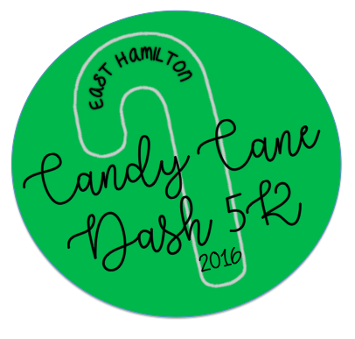
Registration forms with payment may be sent in with your child or dropped off in the front office at East Hamilton. For more information contact Tracy Walsh at (423-903-2262).

East Hamilton’s 4th Annual
Candy Cane Dash
5k Walk/Run
December 10th, 2016
@East Hamilton School

Saturday December 10th ● 9am Registration ● 10 am Candy Cane 5K Begins
Fees: $20 includes t-shirt** Day of Fees will be $25
Awards: Top Ten Male and Top Ten Female (all ages) will receive an award.

**Free Shirt is guaranteed ONLY if registered and paid by Tuesday, November 29th deadline.

The Dash serves as the PTA’s Fall Fundraiser. If you are unable to attend but would like to make a donation, please make checks payable to East Hamilton PTA. Thank you!

Parents, Students, Families, are all welcome to participate! Come join us!
Please fill out an individual form for every participant.
---------------------------------------------------------------------------------------------------------------------------------------------
NAME: ______________________________________________

PHONE NUMBER: ____________________________________

GRADE: _____________________________________________

EMAIL: ______________________________________________
In consideration of the acceptance of this entry, I hereby waive, release and discharge the East Hamilton PTA and persons connected with this event for illness, injuries, and damages suffered as a result of participation in this event. This entry form must be signed.

X__________________________________________
PARTICIPANT SIGNATURE:

X__________________________________________
PARENT/GUARDIAN SIGNATURE (IF UNDER 18):

FREE T-SHIRT (with early reg.) ADULT SHIRT SIZE: S M L XL XXL
(Please circle one)
You can purchase additional shirts for $10.00 each if registered by November 29th
Additional Shirt Quantity/Size: _______________ (adult sizes are S M L XL XXL)

Total Amount Paid: _______________

