States take aim at heat stroke, other serious high school sports injuries

ATHENS, Ga. — When Georgia schools were asked to come up with rules for sports teams playing in the heat, one school promised to cut down on workouts when the heat index reached 140. Experts weren’t sure whether to be shocked or amused.
“If you hit a heat index of 140, you’d basically be sitting in the Sahara Desert," said Bud Cooper, a researcher at the University of Georgia. The heat index is combination of air temperature and humidity. It reflects how hot people actually feel.
In some places, state, school and sports officials are recognizing that a "no-pain, no-gain" way of thinking must come second to safety. Increasingly, they are seeking to protect student athletes from what happens when they're pushed to their physical limits — or beyond.

Protecting Heads And Hearts
Since 2009, every state requires that athletes be removed from games or practices if it's thought they may have a concussion. A concussion is a type of brain injury. It occurs when someone gets hit in the head or falls on his or her head.
In addition, as heart attacks are a leading cause of death in young athletes, many states now require that schools have automated external defibrillators. They can restart the heart. Also, a number of Southern states have adopted strict rules to avoid heat-related illnesses and deaths. And some schools now try to prevent overuse injuries. They are caused by repeating the same motion over and over, such as pitching a baseball or softball.
But no state requires that every high school have a full-time sports trainer. Sports medicine experts believe this would be the most important step to keep student athletes safe.

More Trainers Needed
The Korey Stringer Institute, a research center at the University of Connecticut, studies how to keep student athletes safe. According to the institute, only 39 percent of public high schools have full-time athletic trainers.
The institute was named for Korey Stringer, a Minnesota Vikings football player who died of heat stroke in 2001. Stringer’s death brought attention to the issue of heat-related illnesses in athletes.
In 2011, Ralph Sweargin, then head of the Georgia High School Association (GHSA), decided to address heat-related deaths in football. At the time, Georgia had the most heat-related football deaths in the country. Eight players in Georgia died of heat between 1980 and 2011. In Georgia, schools were starting earlier and earlier, which meant football practices began in mid-July, the hottest days of summer.
Sweargin concluded that a sports health policy was needed for schools statewide. Sweargin also realized that schools weren't making decisions based on scientific information. Instead, they were "relying on best guesses and assumptions and copying what other people were doing.”

When It Heats Up
Sweargin asked a team of researchers at the University of Georgia to study the impact of heat on high school football players.
They found that players were particularly at risk for heat-related illnesses in the first days of practice. Bud Cooper believes it's clearly important for players to gradually get used to the hot weather.
Cooper said that researchers knew that using just the heat index was not enough. It ignored the “radiant temperature,” or the temperature on the ground. Certain surfaces, like concrete or a football field, retain and intensify the heat.
The new GHSA policy requires all high schools to use a special calculator that measures temperature, humidity and radiant temperature. When readings reach certain levels, football coaches must act. A reading above 82 requires coaches to provide at least three breaks an hour of four minutes or longer. Higher readings mean shorter practice sessions and players must wear shorts, instead of football pants. For readings above 92, outdoor practices are stopped.

Adults Have To Change
Cooper insists that Northern states also need statewide heat policies. Temperatures in the North are also high when football players begin practicing. On the day Stringer died of heat stroke in Minnesota, the heat index hit 110.
Head injuries and extreme heat have drawn the most attention in high school sports. Yet they are not the only dangers to young athletes, he said.
Overuse injuries are also taking many students off the playing field. The increasing number of student athletes playing certain sports year round leads to serious injury from overused joints and muscles. For pitchers, there are elbow and shoulder injuries. In soccer, players risk knee injuries. In volleyball and swimming, it’s often the shoulder.
Many schools limit the number of pitches baseball and softball pitchers are allowed to throw. Some schools force sports teams to stop training for a while. Halting practice gives athletes time to recover. Many parents and coaches, though, are pushing kids to be "better, faster and stronger," said Jeffrey Dugas, a sports medicine surgeon in Birmingham, Alabama.
Mark Hyman is a sports journalist. His book, “Until It Hurts,” is about the rise in youth sports injuries. Hyman said that the more adults — coaches and parents — have become involved in youth sports, the more injuries there are. “Before, when kids played sports and they knew their elbow or knee hurt, they stopped playing,” Hyman said. “With adult involvement, parents and coaches have been the ones to push them beyond physical limits.”
For the injuries to stop, the adults have to change, he said.

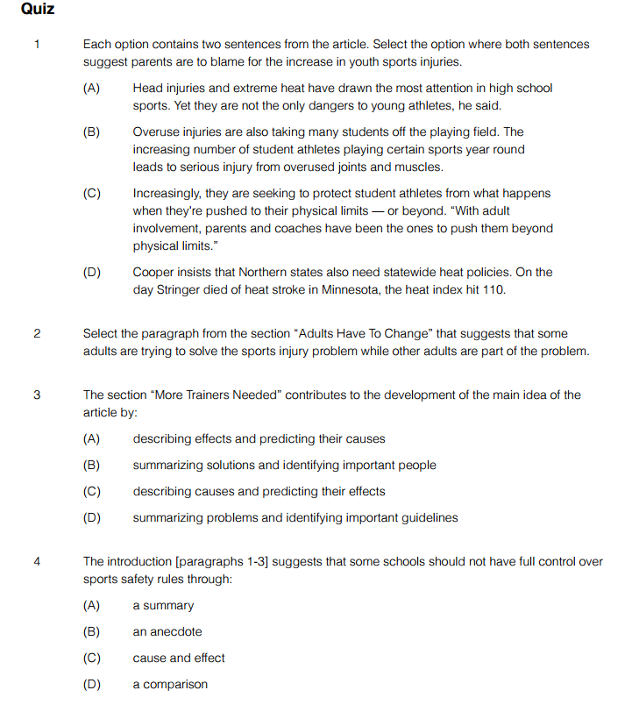
5 List your 3 key words for each section:
1)
2)
3)
4)
5)
Write a 2-3 sentence summary of the article’s main idea using ALL of your keywords.

