Bessie Smith Biography
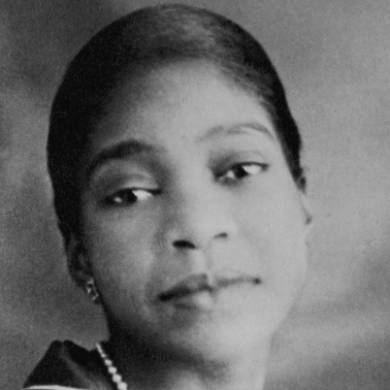
Bessie Smith earned the title of “Empress of the Blues” by virtue of her forceful vocal delivery and command of the genre. Her singing displayed a soulfully phrased, boldly delivered and nearly definitive grasp of the blues. In addition, she was an all-around entertainer who danced, acted and performed comedy routines with her touring company. She was the highest-paid black performer of her day and arguably reached a level of success greater than that of any African-American entertainer before her.
Smith was born in Chattanooga, Tennessee, in 1894. Like many of her generation, she dreamed of escaping a life of poverty by way of show business. As a teenager she joined a traveling minstrel show, the Moss Stokes Company. Her brother Clarence was a comedian with the troupe, and Smith befriended another member, Gertrude “Ma” Rainey (a.k.a. the “Mother of the Blues"), who served as something of a blues mentor. After a decade’s seasoning on the stage, Smith was signed to Columbia Records in 1923. Her first recording - “Down Hearted Blues” b/w “Gulf Coast Blues” - sold an estimated 800,000 copies, firmly establishing her as a major figure in the black record market. Smith sang raw, uncut country blues inspired by life in the South, in which everyday experiences were related in plainspoken language - not unlike the rap music that would emerge more than half a century later. She was ahead of her time in another sense as well. In the words of biographer Chris Albertson, “Bessie had a wonderful way of turning adversity into triumph, and many of her songs are the tales of liberated women.”
Some of her better-known sides from the Twenties include “Backwater Blues,” “Taint Nobody’s Bizness If I Do,” “St. Louis Blues” (recorded with Louis Armstrong), and “Nobody Knows You When You’re Down and Out.” The Depression dealt her career a blow, but Smith changed with the times by adapting a more up-to-date look and revised repertoire that incorporated Tin Pan Alley tunes like “Smoke Gets in Your Eyes.” On the verge of the Swing Era, Smith died from injuries sustained in an automobile accident outside Clarksdale, Mississippi, in September 1937. She left behind a rich, influential legacy of 160 recordings cut between 1923 and 1933. Some of the great vocal divas who owe a debt to Smith include Billie Holiday, Dinah Washington, Sarah Vaughan, Aretha Franklin and Janis Joplin. In Joplin’s own words of tribute, “She showed me the air and taught me how to fill it.”
In 1989, Smith was awarded a Grammy Lifetime Achievement Award, and in 1994, the U.S. Postal Service issued a commemorative Bessie Smith postage stamp. Smith's song "Downhearted Blues" has also received numerous awards. In 2001, it was named one of the Songs of the Century by the National Endowment for the Arts. In 2002, it was placed on the National Recording Preservation Board by the Library of Congress, and in 2006 it was placed in the Grammy Hall of Fame.
Source: Rock and Roll Hall of Fame

