Production Possibilities Curve- a graph that shows alternative ways to use an economy’s resources
Production Possibilities Frontier- the line on a production possibilities graph that shows the maximum possible output using all resources for two specific products
**Example of p. 14
Efficiency- using resources in such a way to maximize the production of goods and services
Underutilization- using fewer resources than an economy is capable of using
Law of Increasing Costs- states that as we shift factors of production from making one good or service to another, the cost of producing the second item increases
Ex: A restaurant A restaurant may have the following costs to consider:
-$15/hr for a chef that can cook 9 filet mignons per hour
-$5 per filet mignon
-$10 in overhead costs (electricity, ingredients, etc.) per hour
The total cost per hour is $30
**However, if one more steak were produced, the company would need to hire another chef and pay for more overhead costs, thus increasing the total cost.

Name: __________________

Production Possibilities Frontier Worksheet

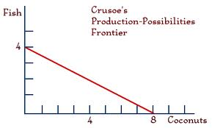
- The opportunity cost of increasing coconut production from 7 units to 8 units is the loss of _____ units of fish.
- The opportunity cost of increasing production of coconuts from 2 units to 6 units is the loss of ____ units of fish.
- Draw a point on the graph that shows the production of 3 coconuts and 2 fish. Label it “A”. This is an example of (circle one of the following): efficiency/underutilization. This point is (circle one of the following): attainable/unattainable.
- Chart the following information onto a production possibilities graph. Then, graph a point (label it point “A”) that depicts an example of underutilization. Then, graph another point (label it point “B”) that depicts a production level which is unattainable for this economy.
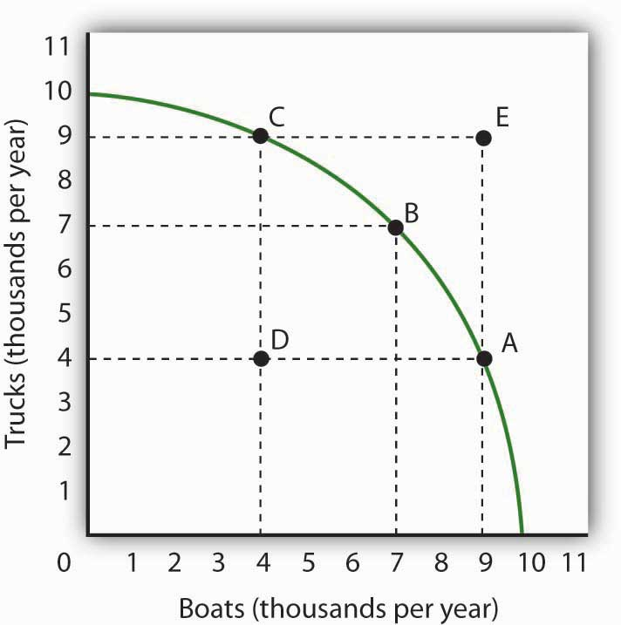
- The opportunity cost for increasing the production of boats from 3,000 to 7,000 is the loss of _______ trucks per year.
- Point D is an example of (circle one of the following): maximum output/underutilization/efficiency.
___________________________________________________________________________
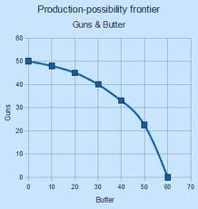
- Use the information on the graph to complete the chart below. Pick any four points you want to complete the chart.
Guns | Butter
50
 | 60

