Propaganda Activity
Directions: You & your partner will create a WWI-era propaganda poster. Your group will be assigned a topic from the list below. You will need to research the topic. The poster should include an image or images and should be completely colored. Your poster needs a clever catch phrase (do not write a paragraph on the poster) to get your message across. This is a test grade.
Topics: Unrestricted submarine warfare, Assisting the Allies, American isolationism, Enlisting in the military, Purchase liberty bonds, Chemical Warfare, Conserve resources, Zimmerman Note
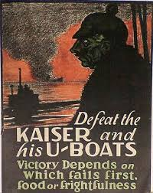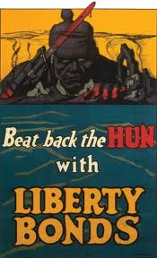

Propaganda Activity
Directions: You & your partner will create a WWI-era propaganda poster. Your group will be assigned a topic from the list below. You will need to research the topic. The poster should include an image or images and should be completely colored. Your poster needs a clever catch phrase (do not write a paragraph on the poster) to get your message across. This is a test grade.
Topics: Unrestricted submarine warfare, Assisting the Allies, American isolationism, Enlisting in the military, Purchase liberty bonds, Chemical Warfare, Conserve resources, Zimmerman Note

