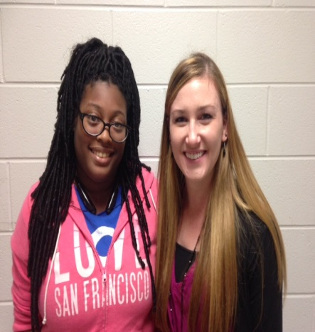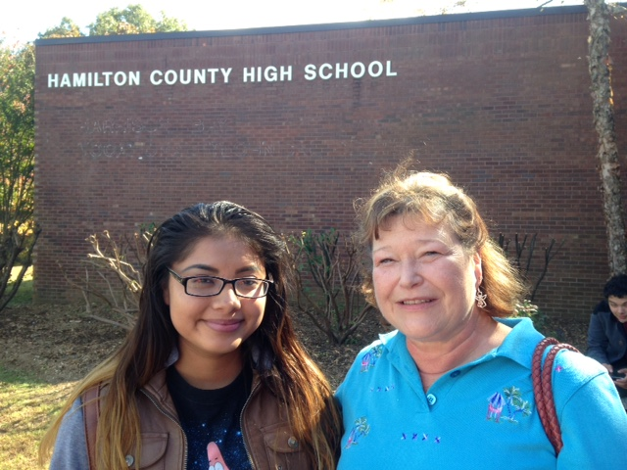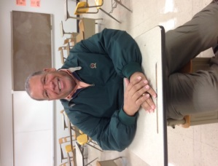

**Mentor Deanna Duermit and mentee Kiarah Capers share a quick hug!**

**Mentor Pam Stuart picked up her mentee, Norma Jimenez, from school so they could go eat at a local restaurant.**

**Congratulations,**

**Mr. Haliburton!**

We would like to congratulate

our wonderful math teacher,

Marvin Haliburton, for being

nominated for the National Life

Group’s Life Changer of the Year Award!! He was nominated for his dedication to his students and his willingness to help them excel outside of the classroom. The Grand Prize winner will receive a $5,000 award, and their school will also receive a $5,000 award! You can view Mr. Haliburton‘s nominee profile at [www.LifeChangeroftheYear.com](http://www.LifeChangeroftheYear.com) .

**Good luck, Mr. Haliburton!**

**Mentor Sally Payne met Senior Kellina Felts for a little coffee and girl talk.**

Please join us to celebrate the successes of our Seniors at our December graduation ceremony on Tuesday, December 15th at 6PM! The ceremony will take place at Bayside Baptist Church (6100 Highway 58, Harrison, TN 37341). We hope to see you there!

**Meet & Greets!** 

**‘Tis the Season!**

**Mentee of the**

**Month**

**Mentor of the**

**Month**

Help Us Help Them!

Mentees & Mentors, please copy the following URL in your web browser and complete this short (only 5 questions!!), anonymous survey! We will use your suggestions to improve the mentoring program next semester!

**https://www.surveymonkey.com/r/GWHQY6R**

Skiye House

Skiye is a December graduate at

HCHS. She plans to enroll in classes

at Chattanooga State in the Fall of

2016. Skiye enjoys cooking and

Couponing. She was nominated by her

Mentor, Carol Mahan, who says “Skiye has a great sense of humor and her future is very bright”.

“I enjoy the mentoring program that my school put together,” says Skiye. “My mentor came to eat lunch with me and was very sweet. I am glad to have a mentor that I can look up to and talk to. She is always available when I need her”.

Carter Paden

Carter was nominated by his

mentee, Kevin Diaz, who said

he really enjoys Carter’s visits

to HCHS.

Carter is a former teacher who has

a passion for continuing education

(he holds degrees from Vanderbilt, the University of Wales, and the University of the South!). He is now retired and volunteers for the Victim Offender Reconciliation Program at the Hamilton County Juvenile Court. He enjoys spending time with his wife, whom he met in Wales, and four children.