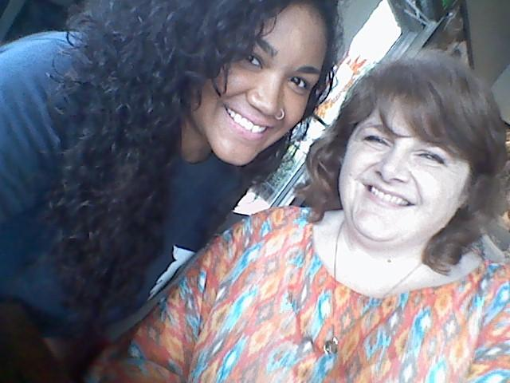
Graduation Gurus Kicks Off!!

Student Alyia Bradford (left) and her mentor Kelley Carver (right) met up at Starbucks for a little coffee and a lot of chit chat! Alyia is a Senior at HCHS. She graduates in December and hopes to study marine biology or cosmetology. Kelley Carver, a teacher at Lookout Valley, hopes to help her achieve her goals.

T
hanks to the help of YOU, our new mentoring program, Graduation Gurus, is off to a great start! Approximately one third of our student population voluntarily requested a mentor and are already reporting exciting things about the program!
Our School is Doing Great Things!
In the 2014-2015 school year, HCHS:

*performed higher in all state-tested subjects
*saw an increase in ACT scores
*improved graduation rates
*was one of two school in Hamilton County to meet all targets

While we are improving at an impressive rate, we still fall behind in several areas. This is why we need YOU to help us achieve our goals!
This monthly newsletter is intended to share information about the program, as well as experiences shared by mentors and students. Please feel free to share your own stories to be featured in this newsletter!
Mentoring Facts:
*95% of students with mentors report the relationship as helpful

*Students with mentors are 20% more likely to continue their education after high school and 52% less likely to skip school

*9/10 students with mentors express interest in becoming mentors themselves.

*Source: Civic Enterprises & Hart Research Association

.

Mentee of the
Month!

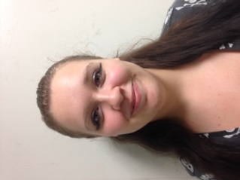
Denise Miller
Denise was nominated
by her mentor, Carolyn
Marshall. Denise
graduates in December
and hopes to study video
editing or photography.
In her spare time, Denise loves
to sing. Carolyn says Denise has
been an eager participant in the program. “She’s sweet and funny,” says Carolyn, “and she has a lot of potential to make it big. We are working on a plan to get her enrolled in college so she can begin after she graduates.“

To share your experience or photos, to nominate a mentee or mentor of the month, or if you know someone who is interested in mentoring, please contact Rachel Turner at turner_r@hcde.org
Mentor of the
Month!

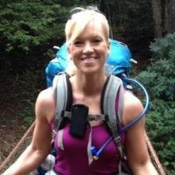
Shout Out to Mentors Who Have Met with Their Mentees in Person!
Ronnie Ables, Carmen Carson, Paden Carter, Kelley Carver, Niki Chambers, Jason Clark, Deanna Duermit, Emily Gaffin, Megan Genter, Ezra Harris, Adam Johnson, Alberta & Bob Keylon, Heidi King, Lindsay Prater, Suzanne Smith, Sam Turner, & Ivette Youngberg
Niki Chambers
Niki was nominated by by her mentee, HCHS
Senior Katelynn Elsea.
Niki invited Katelynn to
her business earlier this month
so they could get to know each
other better. “She’s a really cool person,” says Katelynn, “and I think this is a perfect match!” Read more about Niki and her business below!

Hello, my name is Niki Chambers. Like many other women, I am a woman with many titles and responsibilities; wife, mother, full-time trainer, business owner, friend, sister, daughter, and so on. I understand how hard it is to find time for eating healthy and exercising. However, just like you, I am designed to do both. My desire is to help each person find their way to a healthier lifestyle.
I have 20 + years of experience in resistance training, coaching, and one-on-one personal training. God has given us a passion for exercise and health so we can serve others; my husband, John, and I are blessed to have Chattanooga Fitness & Nutrition as our business.
At Chattanooga Fitness & Nutrition we offer one-on-one personal training , group training, nutritional guidelines, and accountability. We teach and encourage you to exercise according to your needs.
You can feel stronger, leaner, and more energized.
We want to educate, motivate, and support you in attaining YOUR goals!
(423) 499-2250

