Hixson Middle School Reading Fair

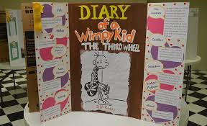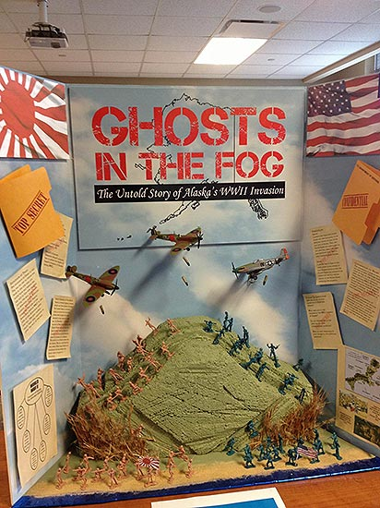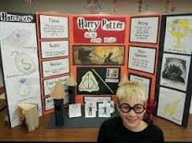

Due: Tuesday, October 25th
The purpose of the Reading Fair is to give students an opportunity to share and celebrate reading. Students may work in pairs or individually. Partnerships will have to be from the same grade level. Project must be on a standard tri-fold project board that unfolds to be 36” H x 48” W.
Use the checklists as a guide to help when creating the project. Identifying information (name of the student, student’s grade level, and RLA teacher’s name) should be labeled on the back of the storyboard. Projects will count as an assessment grade in Reading Language Arts class.

Reading Fair Project Checklist for Fiction Project has the following:
________ Title
________ Author
________ Additional titles by the same author or book recommendations that are similar to this book
________ Publisher and Publication Date
________ Main Characters- only those important to the story line
________ Setting - place and time of story
________ Plot Summary - brief summary (not a retelling) of what the story is about and what takes place
________ Conflict - the problem in the story
________ Solution or Resolution - how the problem is resolved
________Tone and Mood -Tone is the author’s attitude toward the topic and mood is how the reader feels while reading.
(Each of the items above are worth 5 points each.)
Writing: Writing is neat and inviting. Writing is easily understood.
Creativity: Project is original. Project demonstrates imagination. Unique materials are used to express ideas.
Quality of Project: Project follows the guidelines.
Thoroughness of Written Information: Project captures the most important information. Project captures the concept/point the author made in the book.
Interest Evoked: Project demonstrates student’s ability. Project encourages others to read the book. Project attracts others and makes them interested in the work.
(Each of these items are worth 10 points each.)
Additional Points:
Presenting storyboard at Literacy Night (October 25 from 6:00-7:30)
Dressing in character for presentation (potential dress code issue)
Having a “take away” item (bookmark, handout, etc.)
Interactive display
3-D component
Technology
Additional Points, cont.
Related Arts connection--art, drama skit, Spanish, Italian, music
Library connection: Bookmark contest: Design a bookmark that advertises your book. The bookmark must include the following: color, original work of art, title and author of the book, and your first, last name and grade level. The winning bookmark will be printed and distributed in the library for free throughout the year.

Reading Fair Project Checklist for Non-Fiction Project has the following:
________ Title
________ Author
________ Additional titles by the same author or book recommendations that are similar to this book
________ Publisher and Publication Date
________ Student prediction based on events and facts presented (before and after reading)
________ Structure(s) in the text (chronological/sequence, problem/solution, cause/effect, description, compare and contrast)
________ Use of graphic organizers to capture the main idea and/or points important to the text
________ Brief summary about the book
________ Facts and Opinions from the text
_________ Follow-up questions to the author after reading the non-fiction text
Writing: Writing is neat and inviting. Writing is easily understood.
Creativity: Project is original. Project demonstrates imagination. Unique materials are used to express ideas.
Quality of Project: Project follows directions from the guidelines.
Thoroughness of Written Information: Project captures the most important information. Project captures the concept/point the author made in the book.
Interest Evoked: Project demonstrates student’s ability. Project encourages others to read the book. Project attracts others and makes them interested in the work.
Additional Points:
Presenting storyboard at Literacy Night (October 25 from 6:00-7:30)
Dressing in character for presentation (potential dress code issue)
Having a “take away” item (bookmark, handout, etc.)
Interactive display
Related Arts connection--art, drama skit, Spanish, Italian, music
Library connection: Bookmark contest: Design a bookmark that advertises your book. The bookmark must include the following: color, original work of art, title and author of the book, and your first, last name and grade level. The winning bookmark will be printed and distributed in the library for free throughout the year.

