Hixson Middle School Reading Fair

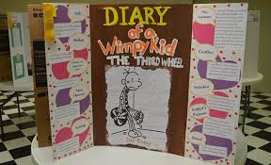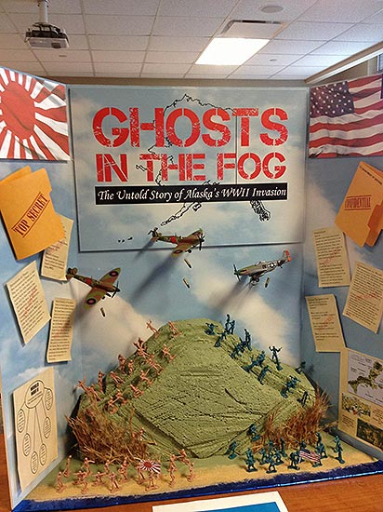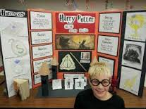

Due Date: Tuesday, October 25th, 6-7:30
Purpose: To give students an opportunity to share and celebrate reading. Students may work in pairs or individually. Partnerships must be from the same grade level.
Product: Project must be on a standard tri-fold project board that unfolds to be 36” H x 48” W. The name of the student(s), student’s grade level, and RLA teacher’s name should be labeled on the back of the storyboard. Projects will count as an assessment grade in Reading Language Arts class.

Fiction Reading Fair Project Checklist / Each item is worth 5 points
Make sure to describe, summarize, or explain when writing about characters, setting plot, conflict, solution, tone, and mood. Always use text evidence for support when appropriate. This project should demonstrate your knowledge and understanding of these story elements.
________ Title
________ Author
________ Additional titles by the same author/
book recommendations similar to this book
________ Publisher and Publication Date
________ Main Characters- only those important to the story line
________ Setting - place and time of story
________ Plot Summary - brief summary (not a retelling)
*what the story is about and what takes place
________ Conflict - the problem in the story
*include who or what the main character is struggling against
________ Solution/Resolution - how the problem is resolved
________ Tone (author’s attitude toward the topic) and
Mood (how the reader feels while reading)

Quality/Creativity Points: (Each item is worth 10 points)

________Writing: Neat and inviting; easily understood; follows basic writing guidelines and rules of grammar
________Creativity: Project is original; imagination; Unique materials are used to express ideas
________Quality of Project: Project follows all guidelines.
________Thoroughness of Written Information: Captures the most important information and the
concept/point the author made in the book.
________Interest Evoked: Project demonstrates student’s ability, encourages others to read the book, is attractive to others
and makes them interested in the work.

Additional Points:
*Presenting storyboard at Literacy Night *3-D component
*Dressing in character for presentation (must be school appropriate) *Use of Technology
*Have a “take away” item (bookmark, handout, etc.) *Art, drama, skit, foreign language, music
*Interactive display

Bookmark contest: Design a bookmark that advertises your book. It must include color, original artwork, title and author of the book, and your first, last name and grade level. The winning bookmark will be printed and distributed in the library for free throughout the year.

Hixson Middle School Reading Fair

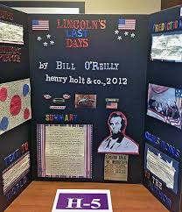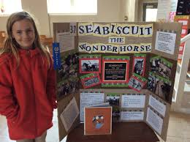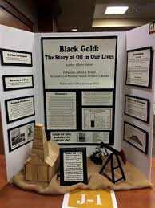

Due Date: Tuesday, October 25th, 6-7:30
Purpose: To give students an opportunity to share and celebrate reading. Students may work in pairs or individually. Partnerships must be from the same grade level.
Product: Project must be on a standard tri-fold project board that unfolds to be 36” H x 48” W. The name of the student(s), student’s grade level, and RLA teacher’s name should be labeled on the back of the storyboard. Projects will count as an assessment grade in Reading Language Arts class.

Non-Fiction Reading Fair Project Checklist / Each item is worth 5 points

________ Title
Make sure to describe, summarize, or explain when writing about predictions, text structure, and summary. Always use text evidence for support when appropriate. This project should demonstrate your knowledge and understanding of these book elements.
________ Author
________ Additional titles by the same author/
book recommendations similar to this book
________ Publisher and Publication Date
________ Student predictions based on events and facts
presented (before and after reading)
________ Structure(s) in the text (chronological/sequence,
problem/solution, cause/effect, description, compare and contrast)
________ Use of graphic organizers to capture the main idea and/or points
important to the text
________ Brief summary of the book
________ Facts and Opinions from the text
________ Follow-up questions to the author after reading the nonfiction text

Quality/Creativity Points: (Each item is worth 10 points)

________Writing: Neat and inviting; easily understood; follows basic writing guidelines and rules of grammar
________Creativity: Project is original; imagination; Unique materials are used to express ideas
________Quality of Project: Project follows all guidelines.
________Thoroughness of Written Information: Captures the most important information and the
concept/point the author made in the book.
________Interest Evoked: Project demonstrates student’s ability, encourages others to read the book, is attractive to others
and makes them interested in the work.

Additional Points:
*Presenting storyboard at Literacy Night *3-D component
*Dressing in character for presentation (must be school appropriate) *Use of Technology
*Have a “take away” item (bookmark, handout, etc.) *Art, drama, skit, foreign language, music
*Interactive display

Bookmark contest: Design a bookmark that advertises your book. It must include color, original artwork, title and author of the book, and your first, last name and grade level. The winning bookmark will be printed and distributed in the library for free throughout the year.

Reading Fair FAQ
- This project is due during class on October 25th. Students will be able to set their project up during class. Presentations will be only during Literacy Night.
- Students may NOT dress in character during school hours on October 25th. However, when they dress in character during Literacy Night, it must still be school appropriate dress.
- Complete sentences must be used on their project board.
- Students may type or write this information, but it needs to be done neatly.
- If a student is unable to purchase a project board, the student needs to notify Mrs. Birch 1 week before it is due (October 18th).
- Any object brought to enhance the project must be school appropriate (i.e. no weapons of any kind).
- If the student is working with a partner and only one person presents during Literacy Night, only the person presenting will earn the additional points.
- If the student is working with a partner and only one person dresses as the character during Literacy Night, only the one person in costume will earn the additional points.
- Additional points (extra credit) may be earned (see the handout). The points earned will depend on effort, creativity, and the story link. The point range will be from 2-5 points for each item.
- If there is a particular food item that the student would like to display or distribute for their additional points for having a handout or 3D object, they may, but only at Literacy Night. We are not permitted to leave food in the gym all day.
- Please be aware that Hixson Middle School and the teachers are not responsible for any item you bring to represent your project. Please bring them at your own risk. There will be classes in the gym throughout the day.

Reading Fair FAQ
- This project is due during class on October 25th. Students will be able to set their project up during class. Presentations will be only during Literacy Night.
- Students may NOT dress in character during school hours on October 25th. However, when they dress in character during Literacy Night, it must still be school appropriate dress.
- Complete sentences must be used on their project board.
- Students may type or write this information, but it needs to be done neatly.
- If a student is unable to purchase a project board, the student needs to notify Mrs. Birch 1 week before it is due (October 18th).
- Any object brought to enhance the project must be school appropriate (i.e. no weapons of any kind).
- If the student is working with a partner and only one person presents during Literacy Night, only the person presenting will earn the additional points.
- If the student is working with a partner and only one person dresses as the character during Literacy Night, only the one person in costume will earn the additional points.
- Additional points (extra credit) may be earned (see the handout). The points earned will depend on effort, creativity, and the story link. The point range will be from 2-5 points for each item.
- If there is a particular food item that the student would like to display or distribute for their additional points for having a handout or 3D object, they may, but only at Literacy Night. We are not permitted to leave food in the gym all day.
- Please be aware that Hixson Middle School and the teachers are not responsible for any item you bring to represent your project. Please bring them at your own risk. There will be classes in the gym throughout the day.

