North Hamilton County Elementary School

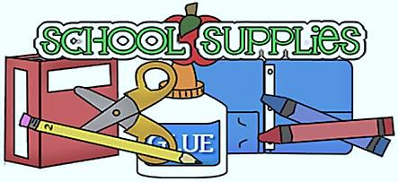
2nd Grade Supply List

2018-2019 School Year

1 pair of headphones
4 wireless composition books
1 pack of wide ruled notebook paper
3 reams of copy paper
1 1 1/2 -inch 3-ring binder
1 3-holed zipper pencil pouch for the binder
2 Poly portfolio folder with pockets and 3 prongs
2 pack of FINE POINT Expo whiteboard markers
2 packs of post-it notes (1 regular, 1 small size)
1 pair of Fiskars brand scissors
1 pack of Crayola Markers
- pack of 24 Crayola Crayons
1 pack of 24 Yellow pencils sharpened
2 glue sticks
1 box of band-aids
4 boxes of Kleenex Tissues
3 packs of disinfecting wipes and/or baby wipes
1 box of quart or gallon size bags
2 rolls of paper towels
Wish List
*Colored copy paper *Mr. Clean Magic Erasers
*extra reams of paper *file folders (manila or colored)
*pre-sharpened pencils *Sheet Protectors
*Teachers may need to ask students to replace items as needed.

