North Hamilton County Elementary
1st Grade Supply List

Backpack (no wheels)
Headphones
2 boxes of 24 pack crayons
4 black dry erase markers (standard size)
2 black & white composition books
3 plastic folders with prongs (orange, green, blue)
1 clear plastic 3-hole punch zipper pouch
6 small glue sticks
2 boxes tissues
2 pink erasers
2 reams of copy paper
1 child size scissors

BOYS: 1 Quart size bags (slider lock) & Box of Band Aids
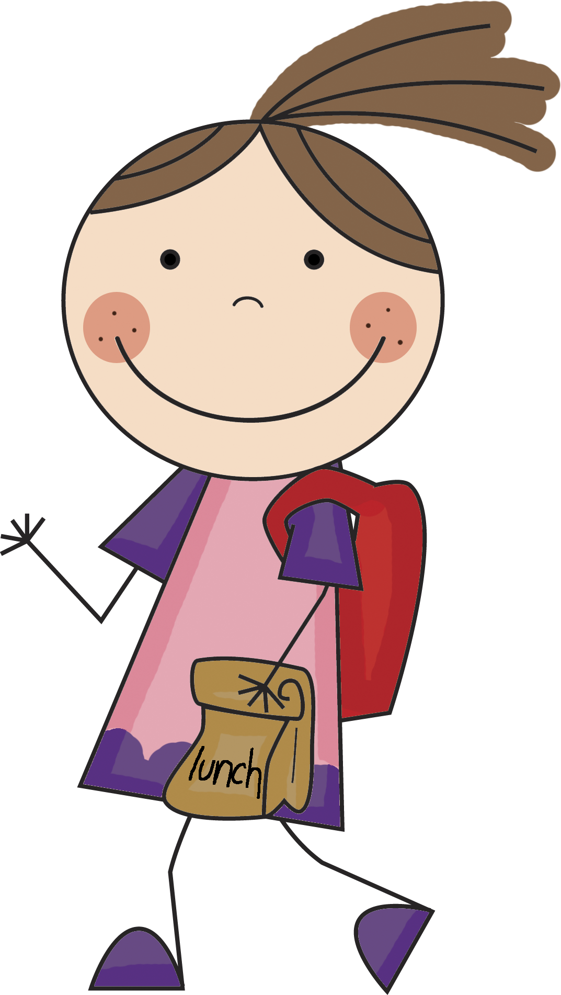
GIRLS: 1 Gallon size bags (slider lock) & Lysol Wipes

WISH LIST
Baby Wipes Expo Markers
Paper Towels Post-its
Colored Cardstock White Cardstock
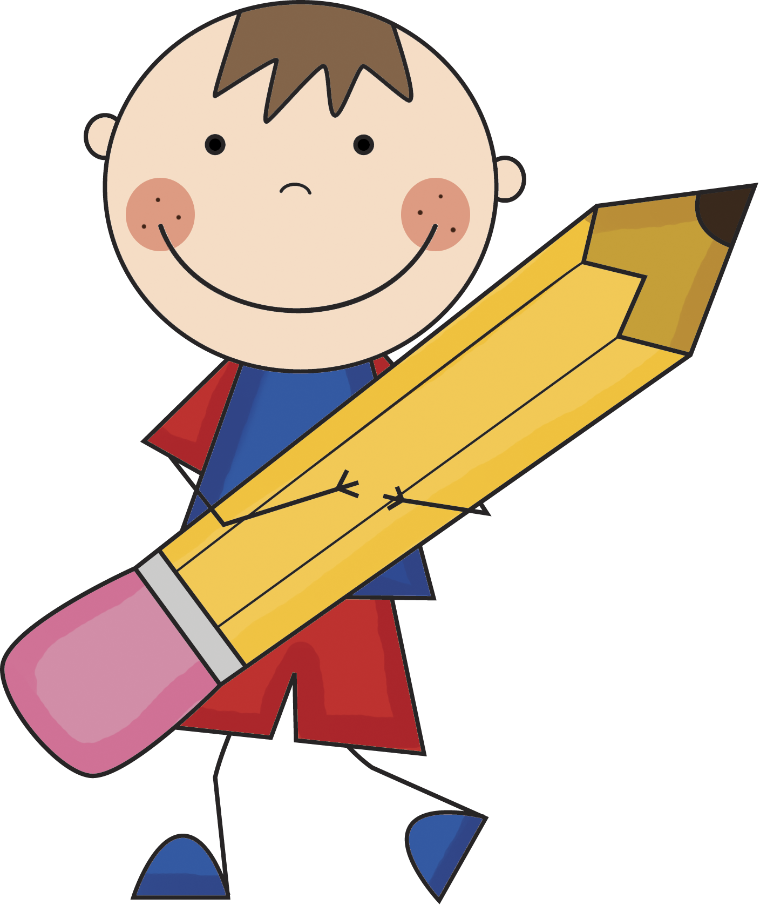
Please DO NOT label individual supplies with your child’s name. Put ALL supplies in ONE or TWO large garbage bags and label the OUTSIDE of the bag with your child’s name. Bring supplies on registration day.

