North Hamilton Basketball League
2nd and 3rd Grade Boys and Girls
4th and 5th Grade Boys and Girls

It is basketball time in North Hamilton County! The eighth year of North Hamilton Basketball League is getting ready to start. Teams from all the area elementary schools in North Hamilton County are establishing their teams. If your child is interested in participating for NHCE, please fill out the information at the bottom of the sheet and return it to the school office.

What makes North Hamilton Basketball League stand out from the rest?
- All games are officiated by TSSAA high school referees
- Official scorekeepers and statisticians working every game
- Team and player statistics published weekly on the league website for 4-5th grades
- Players outfitted with Dri-FIT uniforms with school colors and name
- A single-elimination, post season tournament
- Individual and team awards at the conclusion of the championship competition
- A jamboree on November 19, 2016 to tip off the season
Tryouts will be held October 17 – October 21
Monday – 17  3:30-4:30  4th-5th grade girls  4:45-5:45  4th-5th grade boys | Tuesday – 18  3:30-4:30  2nd-3rd grade girls  4:30-5:30  2nd-3rd grade boys  5:30-6:30  4th-5th grade girls | Wednesday – 19  No  Tryouts | Thursday – 20  3:30-4:30  2nd-3rd grade girls  4:30-5:30  2nd-3rd grade boys  5:30-6:30  4th-5th grade boys | Friday – 21  Teams will be posted
Every student MUST be present at both tryout dates

The students will be scored during tryouts on shooting, handling the ball, rebounding, speed, and attitude. The top ten players will be chosen. There will also be a $60 (approximately) fee that must be paid before your child will receive their uniform.
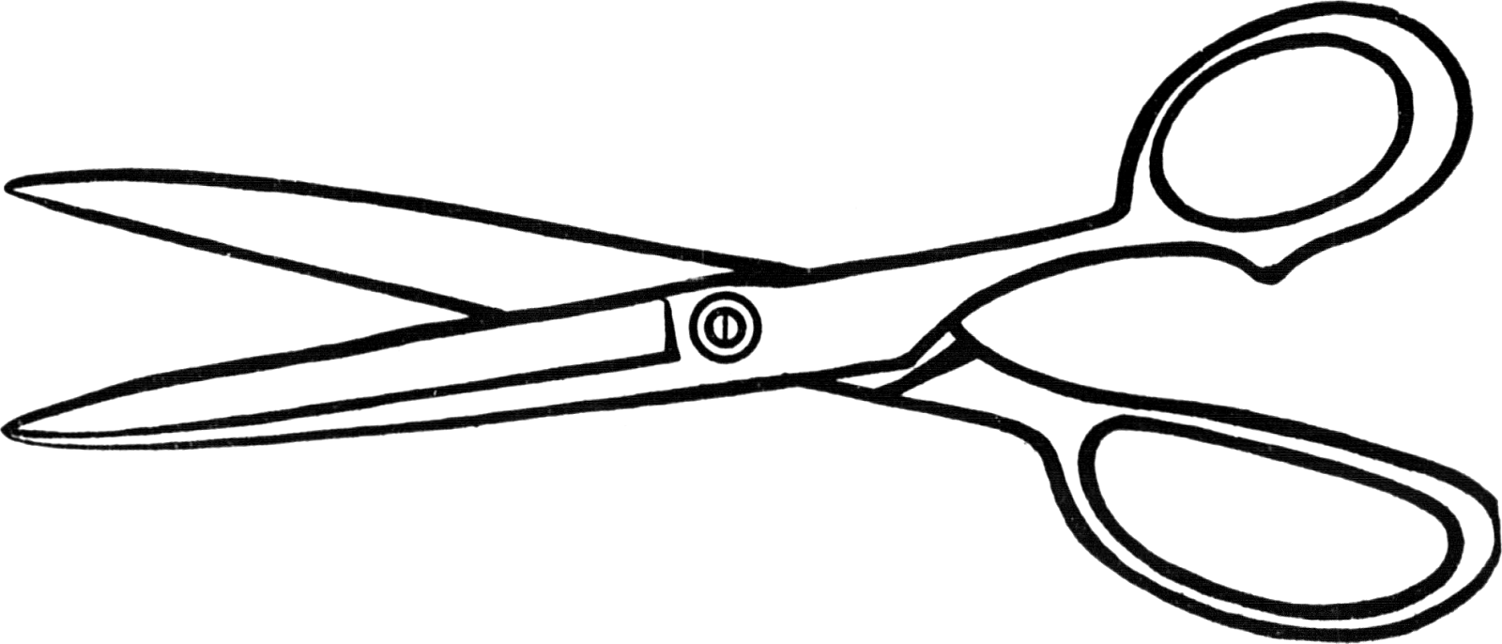-----------------------------------------------------------------------------------------------------------------------------------------

Child’s Name_______________________________________ Grade______________ Circle one: Boy / Girl

Uniform Size: YS YM YL YXL AS AM AL

Allergies:_______________________________ Health Concerns:____________________________________

Parent’s Name:______________________________________ Phone:_____________________________

Email address:___________________________________________________________________________
~~~~~~~~~~~~~~~~~~~~~~~~~~~~~~~~~~~~~~~~~~~~~~~~~~~~~~~~~~~~~~~~~~~~~~~~~~~~~~~~
______ Yes! I am interested in coaching. Please send me a coach’s application.

Coach applications MUST be returned by September 27, 2016! These will be reviewed and a coach will be selected.
~~~~~~~~~~~~~~~~~~~~~~~~~~~~~~~~~~~~~~~~~~~~~~~~~~~~~~~~~~~~~~~~~~~~~~~~~~~~~~~~~
I give ___________________________________ permission to stay after school to try out for basketball.

Parent/Guardian signature________________________________________________

